Windows Demos Style Guidelines
Table of Contents
Introduction 1
Overview 1
Developing Content for Windows Demos 2
Demos: Tone and Style 2
Visuals: Conventions for the Beginning and Ending of Demos 3
Writing Help and Support Topics for Windows Demos 4
Example: Demo Help and Support Topic as it Appears on the Client 6
Example: Demo Help and Support Topic as it Appears on Windows Online Help 7
Code Samples 7
Preparing Transcripts for Windows Demos 8
Example: Windows Online Help Demo with Transcript Shown 9

Introduction
Use this style guide to:
- Develop content for Windows demos.
- Write the Help and Support topics that launch the Windows demos.
- Prepare the transcripts of the demos that are included in the Help and Support topics.

Overview
Windows demos are short videos (2-5 minutes) intended to help users understand:
- How their computers work.
- How the Windows operating system works.
- How to accomplish common computing tasks.
Users access Windows demos by clicking a link that launches a .wmv file in Windows Media Player. This link appears within a Help and Support topic that briefly describes the demo. This topic is called the “wrapper” topic. Each demo has its own Help topic.
Scripts for demos are included in Windows Help and Support topics as transcripts. Currently, the demos do not include closed captioning, so transcripts are included in Help topics to help meet the accessibility requirements of our users.
For demos—including the Help topics and the transcripts—the following style guidelines take precedence over other guidelines in the AST Style Guide. Where neither this style guide nor the AST Style Guide provide specific guidance, follow the style guide escalation path.

Developing Content for Windows Demos
AST produces task-based and overview-style demos that focus on using Windows.

Demos: Tone and Style
In almost all cases, the tone and style used for Windows demos should follow the style guidelines described in the AST Style Guide. But because the demo format is a little different than other Windows Help content, there are some additions and exceptions to the AST Style Guide rules:
- Because the user is busy watching and listening, make your key points clear and memorable. Don’t say or show more than the viewer can easily take in. To help the viewer understand the material, the tone for demos is usually conversational, and the audio typically features:
  - Simple, direct sentences and words.
  - Active verbs.
  - Present tense.
- The titles of the demos should clearly indicate the content of the demo. For example, if a demo is titled “Demo: How to send an e-mail message using Windows Mail,” but the content is mostly about configuring TCP/IP, the user will likely be confused and disappointed.
- The demo should tell a story with a beginning, middle, and end about a task or a feature. Simple narratives are best. For example, a good beginning includes a brief statement of what the user should expect to learn by watching the demo. The “Working with programs” demo begins: “To get the most out of your software programs, you should know how to find, start, install, and remove them from your computer.” A good ending to a demo should leave the user feeling empowered to try the new task or feature. The “Learning to use the mouse” demo concludes with, “Remember: point and click. That's all you need to master the mouse. Give it a try.” The end doesn’t need to specifically restate what the user just learned, but it should suggest what the user can now do.
- The pace of the audio and video of a demo should be consistent, as should the ratio of audio to video. For example, rushing through seemingly simple procedures can frustrate the viewer; so, too, can long audio-only preambles to any video action.
- Avoid references to earlier parts of the demo, unless references are essential. People should be following along, not trying to remember what they saw or heard before. They can always replay the video. If you must refer to earlier parts, do so generally, without details. For example, “Earlier, we showed you how to add X to Z. Here’s something else you can do with X….”
- For the purposes of sustained engineering, avoid references to the titles of the demos. Titles are written for their effectiveness in other contexts, not to be read aloud, and they might change if search-result statistics make change advisable.
- The audio does not need to explain every action that appears on screen. The visual images can often communicate common actions such as clicking OK, especially if those actions have already appeared in the demo.
- Use the second person where appropriate. When writing procedural information, AST guidelines call for using the imperative voice: “Click X, and then click Y.” This approach is appropriate for demos, as well. With demos, however, you can also use the second person and be less specific about what is being clicked because you can rely upon the visuals to provide the specific information for the user. For example, the script can read, “To do this, you click it,” where “this” refers to a task mentioned earlier and “it” refers to the UI element that the cursor is pointing at or hovering over.
Tip: Read your script aloud or have someone read it to you so you can identify awkward constructions and fix them early. Read it at a slower pace than regular conversation to simulate how it will sound in the final audio and to estimate the finished run time.

Visuals: Conventions for the Beginning and Ending of Demos
Each Windows demo begins and ends the same:
- Each demo (.wmv file) begins with the demo title superimposed over the default desktop background. The icon for and name of the current OS release is included at the bottom of the screen. The title does not include the “Demo:” prefix that appears in the Help and Support topic title:
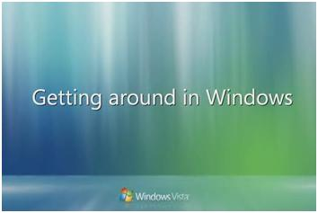
Figure 1: Title screen
- For branding purposes, each demo ends with the same animated “pearl” image and its accompanying sound. When the narration ends, the screen (dramatically) fades to black, and then the “pearl” appears:
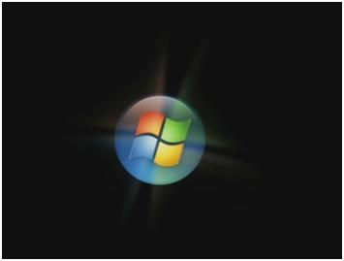
Figure 2: Windows "pearl" at end of demo

Writing Help and Support Topics for Windows Demos
The Help and Support topics (the “wrappers” for the video) have the same basic structure, content, and appearance for all demo types. To create a new demo, you need to create a new task bug in the same way that you would for any other Help file.
- The MAML content type used is “Procedural.” This content type is known as “Instructions” in the AST Style Guide.
- The titling convention is to begin the title with the word “Demo” and a colon. The first word after the colon is capitalized, but the rest of the title is sentence capped. For example, “Demo: Printing.”
- The left-justified, stock image of a movie reel appears at the beginning of the introduction paragraph. See Code samples for specific information about how to include this image.
- The single introduction paragraph should provide the briefest overview of the demo’s content and set expectations for what the user will learn or gain by watching the demo. The suggested word limit for introduction paragraphs is 50. Because the intro paragraph isn’t an abstract or summary, the emphasis is always on the benefit to the user: increased knowledge, enhanced productivity, greater awareness of attractive features or content.
As an example of a well-written introduction, here is the paragraph from “Demo: Working with files and folders:”
Knowing how to find and organize your files and folders is essential for using your computer successfully. This demo takes you through the basics. You'll learn how to get to frequently used folders, create new folders, save files to folders, and find your files quickly.
- The introduction paragraph is followed by an image (see the example Client and Windows Help and How-to sections below to view the images):
  - For Windows Help and How-to, the image is the Play button used in Windows Media Player 11.
  - For Windows Client, the image is a green arrow.
The Play button in Windows Help and How-to is hard-coded by the writer, while the green arrow in the Client Help file is created automatically, so you don’t have to add it to the Help topic.
- The image is followed by this link text: “Watch the demo”. Note the absence of a closing period. The alt text is “Click to watch the demo” (also no ending punctuation). The markup for launching the demo is described in detail below.
- The demo link is followed by a collapsed section named “Read the transcript”. Expanding this section shows the written transcript of the demo. See Preparing Transcripts for Windows Demos for more information about creating transcripts.
- The last item in the Help topic is the “See also” section. This section is required. Links should be provided to any relevant Help topics or demos. The last link in each See also section should be to the signpost topic: Windows Vista demos.
- As with all other Help topics, asset descriptions are required for demo wrapper topics.

Example: Demo Help and Support Topic as it Appears on the Client
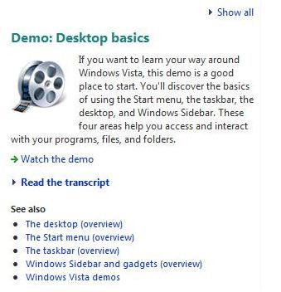
Figure 3: Client demo wrapper topic

Example: Demo Help and Support Topic as it Appears on Windows Help and How-to
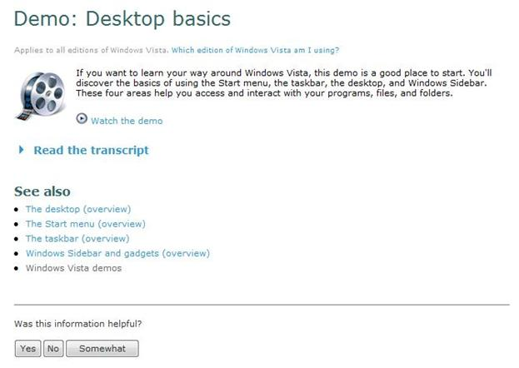
Figure 4: Windows Help and How-to demo wrapper topic

Code Samples
Important: Copying and pasting text in XMetaL from any text editor (especially Word), HTML, or other source can introduce errors into your code. As a result, don’t copy these code snippets directly into XMetaL. Type them directly into XMetaL or paste them into Notepad first, and then copy them into XMetaL. Then, carefully check spacing issues in a client and online build.
The code for inserting the picture of a movie reel is:
<quote><embedObject targetVerification="false"><objectUri href="mshelp://windows/?id=dc8c41e7-921d-4b9b-85dc-bbbd120dbbea" mimeType="image/png"><summary>Picture of a movie reel</summary></objectUri></embedObject></quote>
The code for inserting the Play button and the link to open the video on Windows Help and How-to, and for inserting the green arrow and the link for the client Help is:
<para condition="IsDisplayedInBrowser">
<embedObject targetVerification="false"><objectUri href="mshelp://windows/?id=745c7204-cf9f-46fb-a86c-98d4b9c644cf" mimeType="image/png"><summary>Picture of a Play button</summary></objectUri></embedObject><navigationLink targetVerification="false"><linkText>Watch the demo</linkText><uri href="http://go.microsoft.com/fwlink/?linkid=70514"><summary>Click to watch the demo</summary></uri></navigationLink>
</para>
<para>
<shellExecuteLink>
<linkText>Watch the demo</linkText>
<command>getWmvMuiPath navigate.wmv</command>
<summary>Click to watch the demo</summary>
</shellExecuteLink>
</para>
Note that the linkid value used in the fwlink is dependent on the video you are linking to. Read more about inserting fwlinks.

Preparing Transcripts for Windows Demos
The transcripts are the complete and exact written version of the narration that appears in each demo. The transcripts do not include descriptions of the visual elements of the demo (that is, “stage directions,” as in a screenplay).
The transcript appears in a collapsed section titled “Read the transcript”. Transcripts require no special structure, format, or MAML elements. Generally, you’ll find that paragraphs are the only structural elements needed, and that only common MAML inline elements are used (<ui>, <notLocalizable>, <newTerm>, etc.).

Tip: Don’t copy the transcript text into the Help topic until after the voiceover narration has been finalized and recorded. This will help ensure that the voiceover narration and the transcript are synchronized. Always double-check the transcript by reading along with the voiceover narration after it has been recorded.

Example: Windows Online Help Demo with Transcript Shown
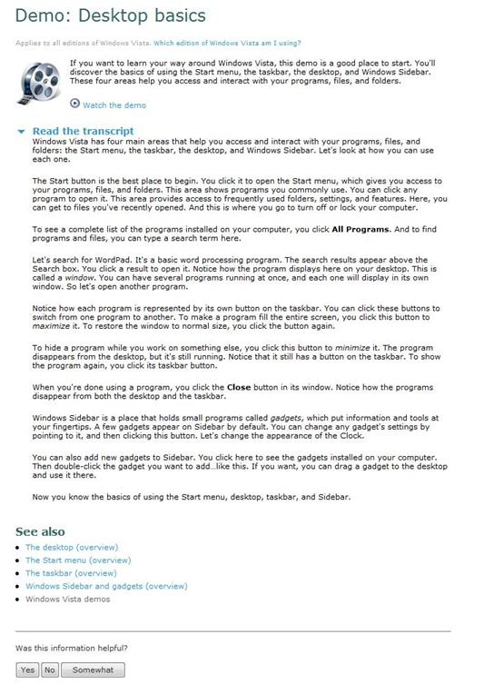
Figure 5: Windows Help and How-to demo wrapper topic showing the transcript

