Published topic page text and images

September 3 – September 10
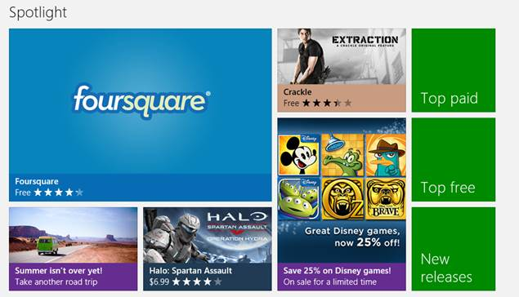
If all games are 25% off
Market | Title | Subtitle | Title on page | Description
EN-US | Save 25% on Disney games! | On sale for a limited time | Disney games on sale for a limited time | Get these great games from Disney for a great price. Have some fun and solve puzzles, smash blocks, and go for a run with some of your favorite Disney characters.
EN-US | Save 25% on Disney games! | On sale for a limited time | Disney games on sale for a limited time

If all games are 50% off
Market | Title | Subtitle | Title on page | Description
EN-US | Save 50% on Disney games! | On sale for a limited time | Disney games on sale for a limited time | Get these great games from Disney for a great price. Have some fun and solve puzzles, smash blocks, and go for a run with some of your favorite Disney characters.
EN-US | Save 50% on Disney games! | On sale for a limited time | Disney games on sale for a limited time

If there’s a mixture of price for games (i.e. some are 50% off, while others are Free)
Market | Title | Subtitle | Title on page | Description
EN-US | Save on Disney games! | Limited time offer | Disney games on sale for a limited time | Get these great games from Disney for a great price. Have some fun and solve puzzles, smash blocks, and go for a run with some of your favorite Disney characters.
EN-US | Save on Disney games! | Limited time offer | Disney games on sale for a limited time

If all games are free
Market | Title | Subtitle | Title on page | Description
EN-US | Free Disney games! | Limited time offer | Disney games on sale for a limited time | Get these great games from Disney for a great price. Have some fun and solve puzzles, smash blocks, and go for a run with some of your favorite Disney characters.
EN-US | Free Disney games! | Limited time offer | Disney games on sale for a limited time

August 28 – September 3
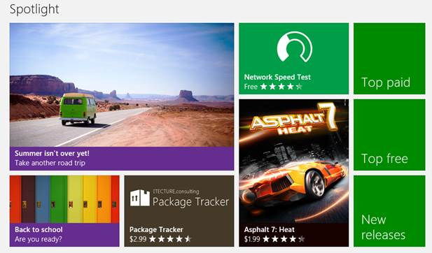
Title | Subtitle | Title on page | Description
Summer isn’t over yet! | Take another road trip | Apps to help plan a road trip | Take advantage of the last days of summer and hit the road one more time. These apps will help you before, during, and after your trip. Plan your route, explore local attractions, listen to your favorites tunes, and share photos from your trip.
Summer isn’t over yet! | Take another road trip | Apps to help plan a road trip

August 23 – August 29
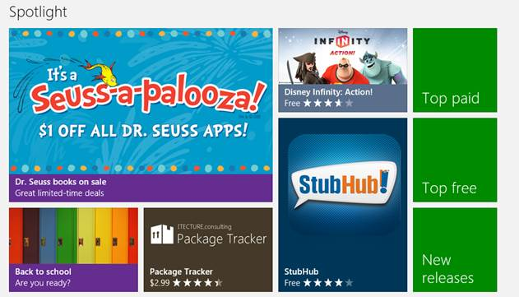
Title | Subtitle | Title on page | Description
Dr. Seuss books on sale | Great limited-time deals | Great limited-time deals | Take advantage of special offers on some of Dr. Seuss’s most beloved books. A cat in the hat, some colorful fish, the Lorax, the Grinch, and a delectable dish of green eggs and ham are all waiting for you!
Dr. Seuss books on sale | Great limited-time deals | Great limited-time deals

August 16 – August 22
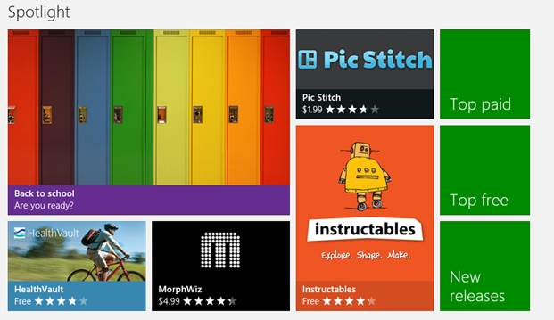
Title | Subtitle | Title on page | Description
Back to school | Are you ready? | Back to school | Summer is almost over, which means the days are getting shorter and it’s almost time to head back to school. Get ready for class with these apps and make this your best year yet.
Back to school | Are you ready? | Back to school

July 26th – August 2
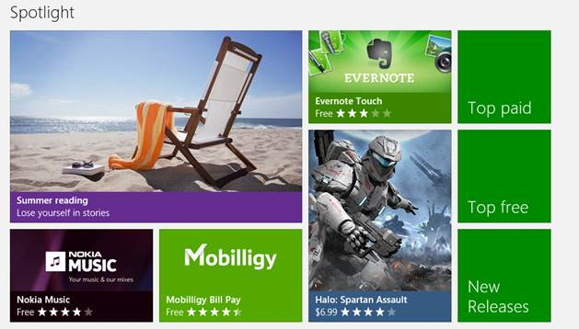
Title | Subtitle | Title on page | Description
Summer reading | Lose yourself in stories | Reading apps for summer vacations | Nothing beats lounging around on a summer day, catching up on some reading. Whether you enjoy novels, magazines, comics, audiobooks, or newspapers, these apps will keep you entertained on the beach, by the pool, or under a shady tree.
Summer reading | Lose yourself in stories | Reading apps for summer vacations

June 27 – July 5
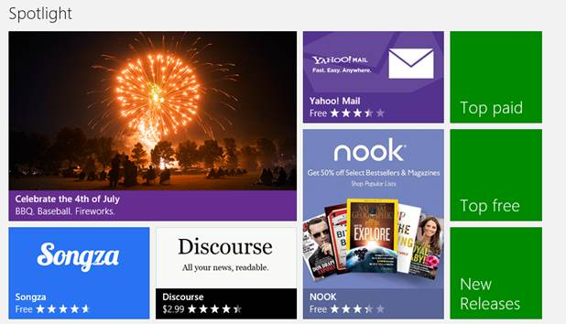
Title | Subtitle | Title on page | Description
Celebrate the 4th of July | BBQ. Baseball. Fireworks. | Celebrate the 4th of July | Discover a recipe for a tasty pie, find a park with a grill for a family picnic, create an all-American playlist, and be sure to edit your fireworks photos before sending them to your friends. An app can’t win a pie-eating contest or hit a home run, but there are plenty that’ll help you celebrate our nation’s independence and have an amazing day.
Celebrate the 4th of July | BBQ. Baseball. Fireworks. | Celebrate the 4th of July

June 21 – June27
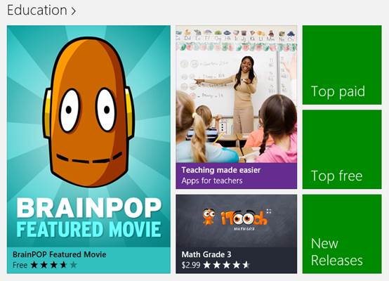
Title | Subtitle | Title on page | Description
Teaching made easier | Apps for teachers | Teaching made easier | We know it’s summer, but we also know that amazing teachers never rest and are dedicated to discovering things that will make their jobs easier and help their students achieve. Engage your students with content from top-notch providers, or start planning for the next school year with these apps.
Teaching made easier | Apps for teachers | Teaching made easier

June 14 – June 20
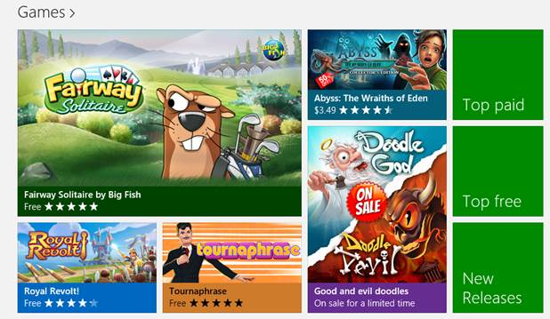
Title | Subtitle | Title on page | Description
Good and evil doodles | On sale for a limited time | On sale for a limited time | These great puzzle games by JoyBits are on sale until June 20th, 2013. Combine different elements to create an entire universe in Doodle God … or discover the seven deadly sins and destroy the world in Doodle Devil. Good or evil – the sale prices mean you don’t have to choose!
Good and evil doodles | On sale for a limited time | On sale for a limited time

June 7 – June 16
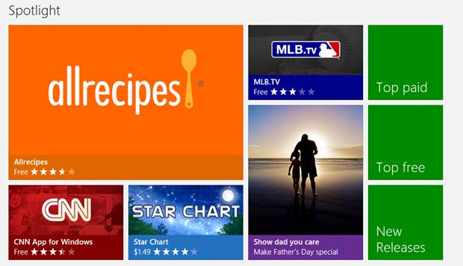
Title | Subtitle | Title on page | Description
Show dad you care | Make Father’s Day special | Make Father’s Day special | Show dad how much he means to you this Father’s Day. Search for the perfect gift, make him dinner (or take him out), let him kick back and relax with some TV shows or a movie, or use Skype to give him a call.
Show dad you care | Make Father’s Day special | Make Father’s Day special

May 28 – June 4
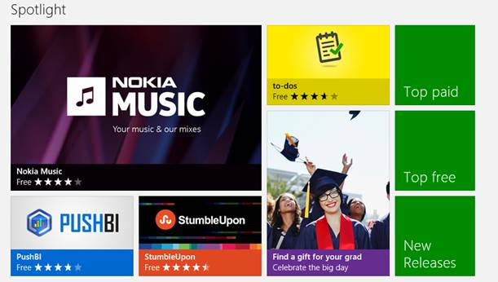
Title | Subtitle | Title on page | Description
Find a gift for your grad | Celebrate the big day | Find the perfect gift for your grad | Congratulate your grad with the perfect gift! Whether they’re leaving home for the first time or just starting a new career, you can find them a gift that will celebrate their big accomplishment and help them take that next big step.
Find a gift for your grad | Celebrate the big day | Find the perfect gift for your grad

May 17 – May 28
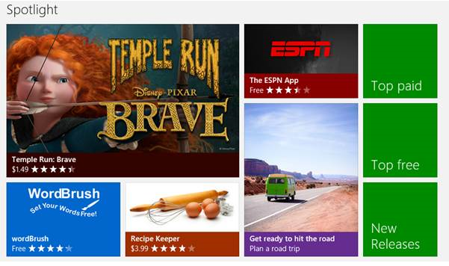
Title | Subtitle | Title on page | Description
Get ready to hit the road | Plan a road trip | Apps to help plan a road trip | Getting ready for a road trip with family or friends? These apps will help you before, during, and after your trip. Plan your route, explore local attractions, listen to your favorites tunes, and share photos from your trip.
Get ready to hit the road | Plan a road trip | Apps to help plan a road trip

May 3 – May 12
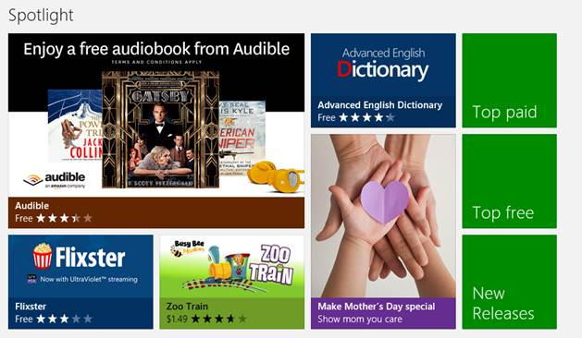
Title | Subtitle | Title on page | Description
Make Mother’s Day special | Show mom you care | Make Mother’s Day special | Let your mom know how much she means to you this Mother’s Day. Book a surprise visit, treat her to a special dinner, find the perfect gift, or use Skype to give her a call (if you can’t see her in person).
Make Mother’s Day special | Show mom you care | Make Mother’s Day special

April 26 – May 2
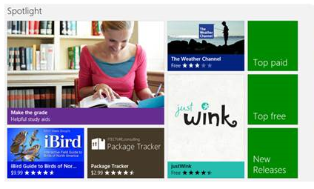
Title | Subtitle | Title on page | Description
Make the grade | Helpful study aids | Apps to help you study | Whatever the school year throws at you – exams, homework, pop quizzes, extra credit – you’ll be ready to make the grade with these study aids.
Make the grade | Helpful study aids | Apps to help you study

April 19 – April 25
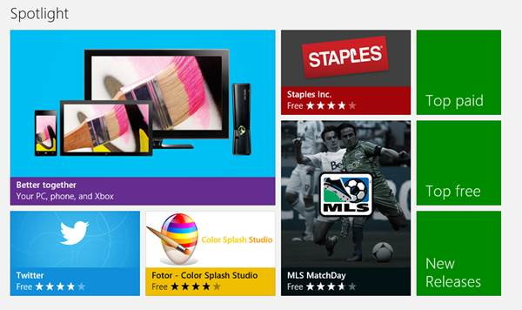
Title | Subtitle | Title on page | Description
Better together | Your PC, phone, and Xbox | For Windows, Windows Phone, and Xbox 360 | These apps are designed to give you a great experience across Windows, Windows Phone, and Xbox 360. Start reading a book on your Surface and pick up where you left off on your phone, or play a game on your PC against someone on an Xbox.
Better together | Your PC, phone, and Xbox | For Windows, Windows Phone, and Xbox 360

April 12 – April 18
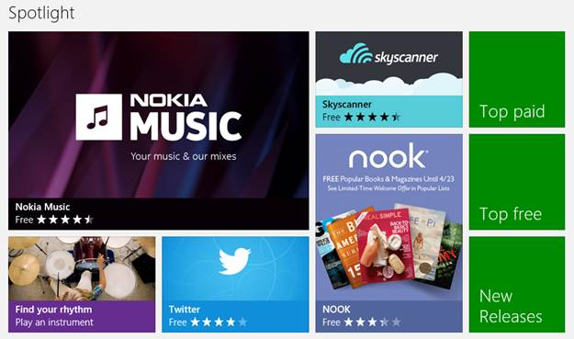
Title | Subtitle | Title on page | Description
Find your rhythm | Play an instrument | Play an instrument | Find your rhythm. With a little practice and some help from apps, you can learn to play guitar, bass, drums, accordion, and other instruments in time and in tune. Start a band and you’ll be entertaining your family and friends before long!
Find your rhythm | Play an instrument | Play an instrument

April 9 – April 15
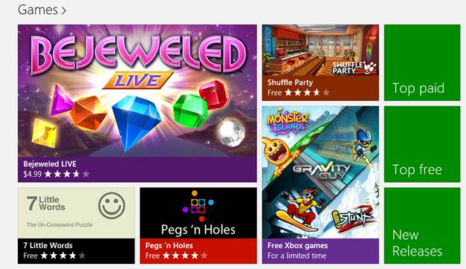
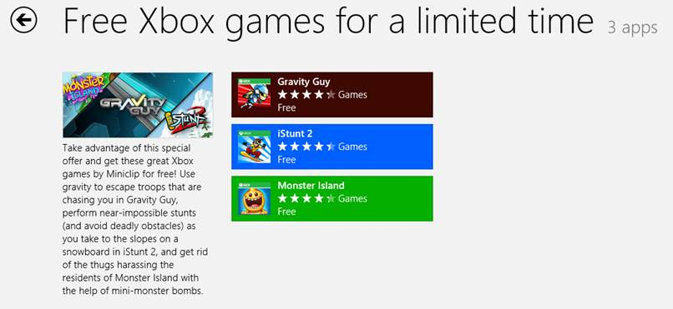

April 4 – April 9
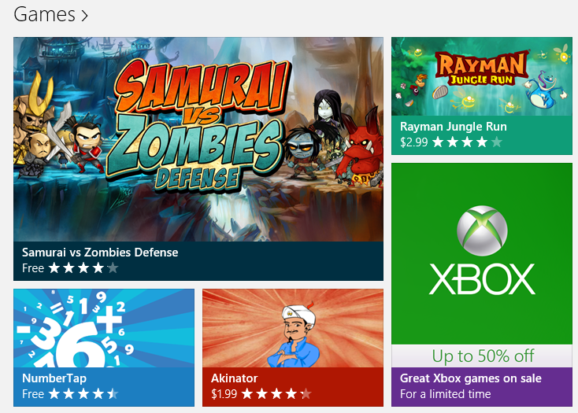
Title | Subtitle | Title on page | Description
Great Xbox games on sale | For a limited time | Great offers for a limited time | Take advantage of savings up to 50% on select Xbox games until April 8th. Get ready to set out on an adventure to help rebuild a crumbling kingdom, strap into a high-powered speedboat for a race to the finish line, test your wits against the mindless (but persistent) zombie horde, and more!
25-character title | 25-character subtitle | Great offers for a limited time

April 1 – April 9
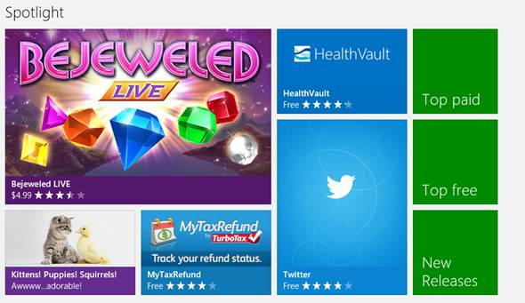
Title | Subtitle | Title on page | Description
Kittens! Puppies! Squirrels! | Awwww…adorable! | Adorable animals in awesome apps | No one can resist kittens, puppies, big-eyed squirrels, baby turtles, piglets, and narwhals. Go ahead. Just try.
Kittens! Puppies! Squirrels! | Awwww…adorable! | Adorable animals in awesome apps

March 22 – March 28, 2013
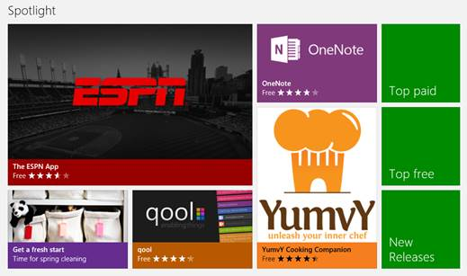
Title | Subtitle | Title on page | Description
Get a fresh start | Time for spring cleaning | Your fresh start begins here | Spring cleaning means getting rid of what’s old and organizing what’s left. These apps offer smart solutions for clearing out and cleaning up. Take advantage of their tips and spring cleaning won’t be so tough.
Get a fresh start | Time for spring cleaning | Your fresh start begins here

March 15 – March 21, 2013
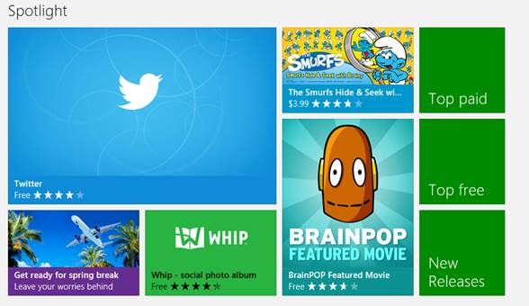
Title | Subtitle | Title on page | Description
Get ready for spring break | Leave your worries behind | Get ready for spring break | It’s still cold outside, so why not plan a getaway for spring break? Find great deals on flights, book hotels, and get travel tips about your destination.
Get ready for spring break | Leave your worries behind | Get ready for spring break

March 8 – March 15, 2013
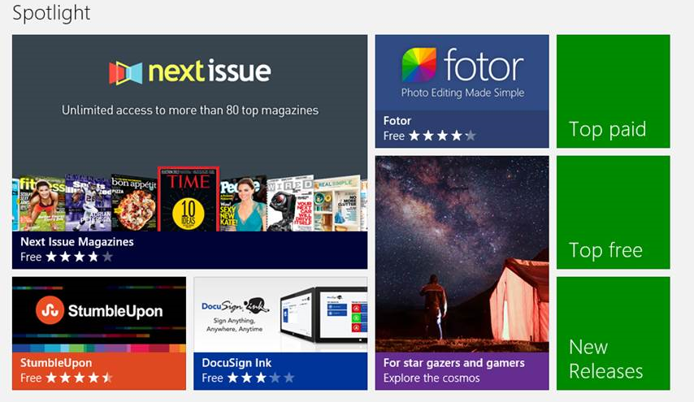
Title | Subtitle | Title on page | Description
Signaling all star gazers and gamers | Explore the cosmos with space-related apps | Apps for exploring the universe | Discover new planets, map the constellations, and learn what lies beyond our galaxy.
For star gazers and gamers | Explore the cosmos | Apps for exploring the universe
NOTE: Original title was “Signaling all star gazers and dreamers,” but our “preview” system failed us and SM had to change it to “gamers” to get the text to fit on small screen and/or low-res screens.

March 4 – March 7, 2013
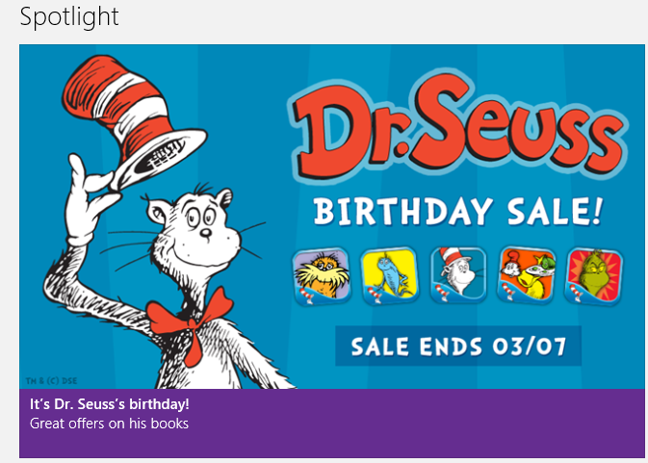
Title | Subtitle | Title on page | Description
It’s Dr. Seuss’s birthday! | Great offers on his books | Great offers for a limited time | Help celebrate Dr. Seuss’s birthday and take advantage of special offers on some of his most beloved books. A cat in the hat, some colorful fish, the Lorax, the Grinch, and a delectable dish of green eggs and ham are all waiting for you!
It’s Dr. Seuss’s birthday! | Great offers on his books | Great offers for a limited time

February 8 – February 14, 2013
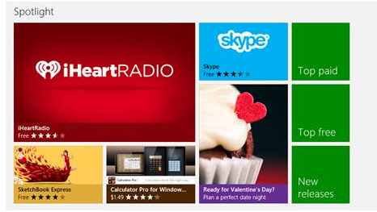
Title | Subtitle | Title on page | Description
Ready for Valentine’s Day? | Plan a perfect date night | Apps for Valentine’s Day | This Valentine’s Day, plan a night to remember. Use these apps to help you cook a romantic dinner, search for the perfect gift, or get ready for a night on the town.
Ready for Valentine’s Day? | Plan a perfect date night | Apps for Valentine’s Day

February 8, 2013
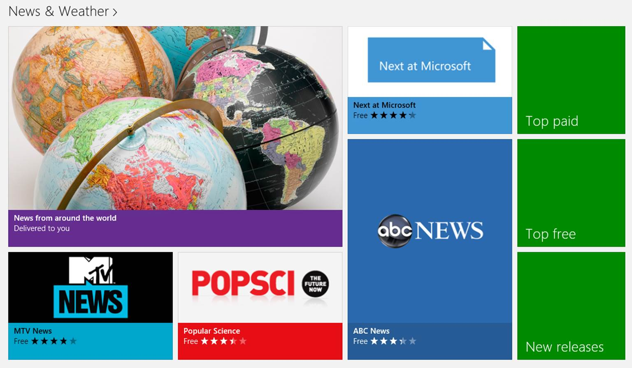
Title | Subtitle | Title on page | Description
News from around the world | Delivered to you | Breaking news from around the world | Getting news delivered straight to your PC has never been easier. Keep an eye on what’s going on around the globe and get updates about breaking stories.
News from around the world | Delivered to you | Breaking news from around the world

February 8, 2013
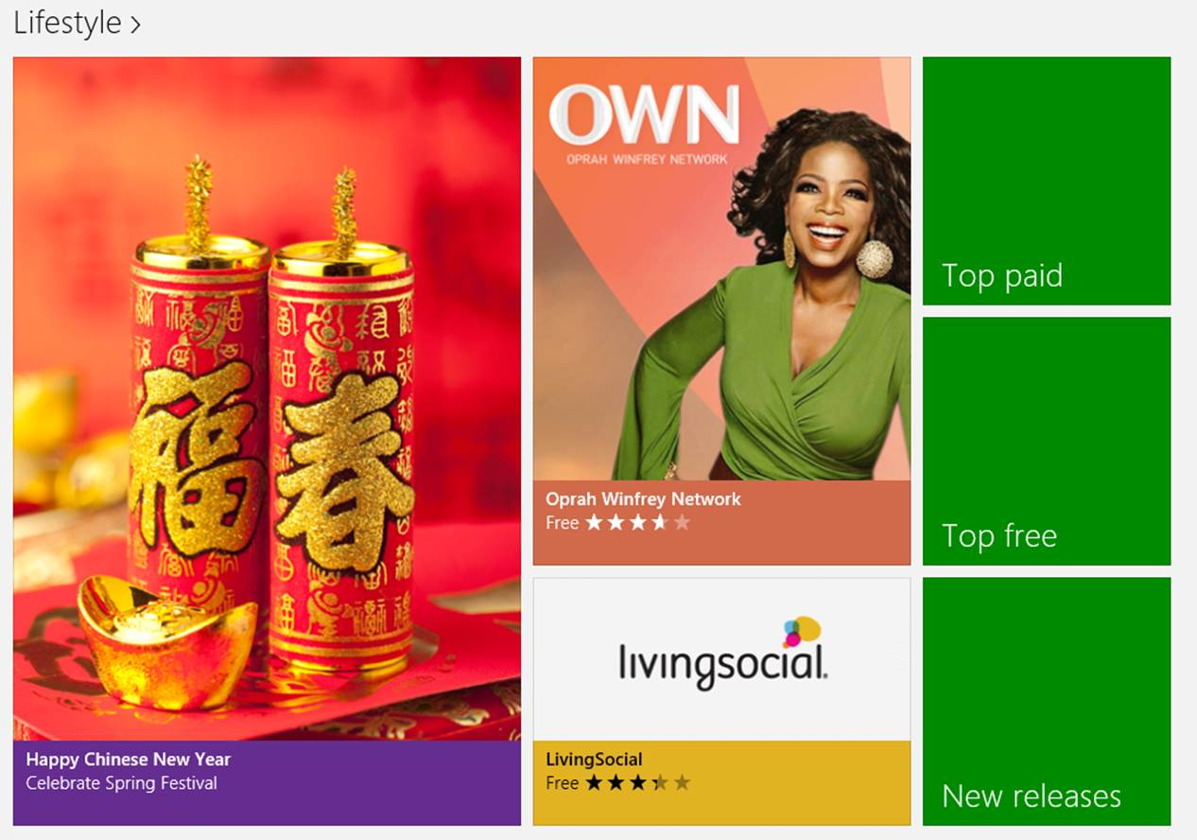
Title | Subtitle | Title on page | Description
Happy Chinese New Year | Celebrate Spring Festival | Happy Chinese New Year | Get ready to enjoy a long and relaxing holiday! Celebrate the Spring Festival with apps that help you keep in touch with family and friends, play games, and create a delicious feast.
Happy Chinese New Year | Celebrate Spring Festival | Happy Chinese New Year

February 8, 2013
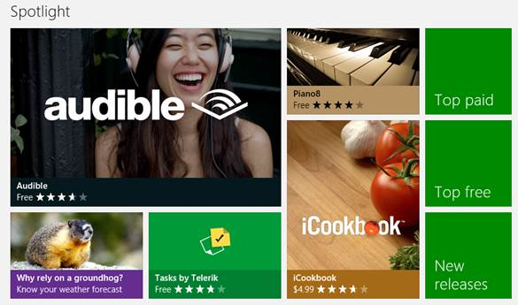
Title | Subtitle | Title on page | Description
Why rely on a groundhog? | Know your weather forecast | More reliable than a groundhog’s shadow | Why count on a groundhog to tell you if there’ll be six more weeks of winter? Get up-to-date info on whether it’ll stay cold or warm up.
Why rely on a groundhog? | Know your weather forecast | More reliable than a groundhog’s shadow

January 25, 2013

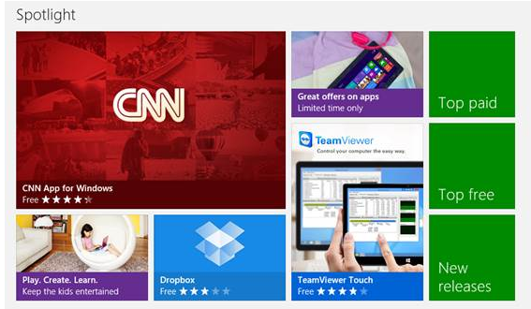
Title | Subtitle | Title on page | Description
Play. Create. Learn. | Keep the kids entertained | Apps for kids | Need help keeping the kids busy while they’re stuck indoors? There won’t be any time for boredom once they get their hands on these apps.
Play. Create. Learn. | Keep the kids entertained | Apps for kids

Title | Subtitle | Title on page | Description
Great offers on apps | Limited time only | Great offers for a limited time | Check out these offers and save some money. You’ll find great apps, subscriptions, and premium services for a reduced price or, in some cases, for free!  The fine print: Offers valid through January 31, 2013, in the Windows Store, in the United States only, and made available by the app publishers, not Microsoft.
Great offers on apps | Limited time only | Great offers for a limited time

January 9, 2013
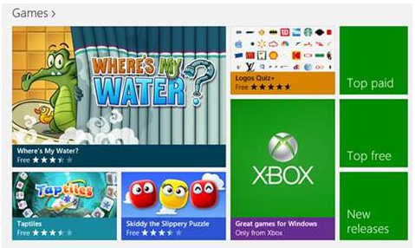
Title | Subtitle | Title on page | Description
Go beyond the console | Xbox games for Windows | Xbox games for Windows | Take a closer look at some of the great Xbox games currently available, including action, adventure, puzzle, and word games.
Go beyond the console | Xbox games for Windows | Xbox games for Windows

December 27, 2012
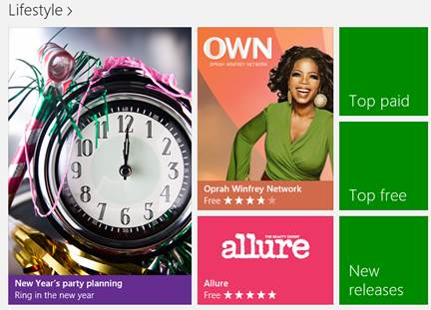
Title | Subtitle | Title on page | Description
New Year’s party planning | Ring in the new year | Plan a fantastic New Year’s party | Because no celebration is complete without great food, music, and drinks, here’s a little help to get you ready for your year-end bash.
New Year’s party planning | Ring in the new year | Plan a fantastic New Year’s party

December 27, 2012

Title | Subtitle | Title on page | Description
Get ready for 2013 | Make it the best year ever | Make 2013 your best year | Now is the time to start thinking about how to make this year your best year! Whether you want to commit to a healthier, productive, or more organized life, these apps will get you started.
Get ready for 2013 | Make it the best year ever | Make 2013 your best year

December 20, 2012
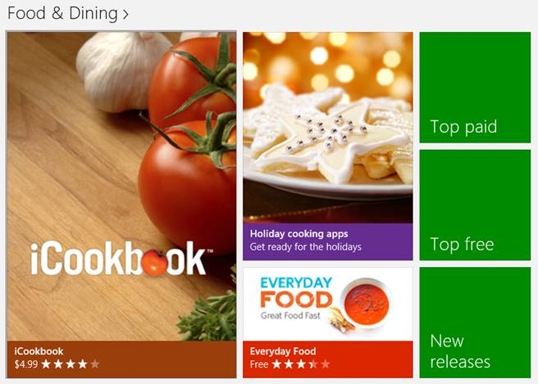
Title | Subtitle | Title on page | Description
Holiday cooking apps | Get ready for the holidays | Cooking apps for the holidays | Create the perfect holiday meal to share with family and friends. Find great recipe ideas for main dishes, delicious sides, and decadent desserts.
Holiday cooking apps | Get ready for the holidays | Cooking apps for the holidays

December 20, 2012
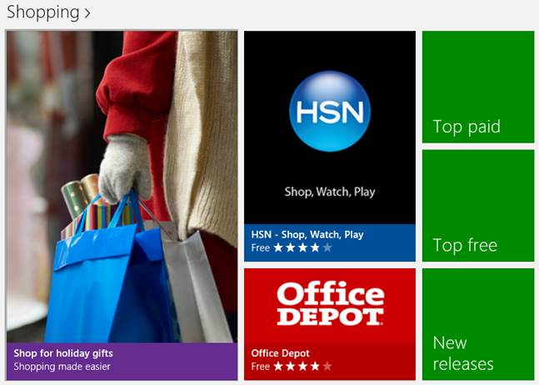
Title | Subtitle | Title on page | Description
Shop for holiday gifts | Shopping made easier | Holiday shopping made easier | Make shopping for gifts this holiday season a little easier with these helpful apps.
Shop for holiday gifts | Shopping made easier | Holiday shopping made easier

December 20, 2012

Title | Subtitle | Title on page | Description
Explore. Discover. | Apps to get you started | Apps to get you started | Unsure about which apps to install? Start with these apps and discover how apps work better together in Windows.
Explore. Discover. | Apps to get you started | Apps to get you started

