Windows 8.1 Store style guide
Owners: Tom Olsen and Tatsuo Yamada
Revised: 8/7/2013

1. Introduction
If you need to create content for the Windows 8 version of the Store, refer to the Windows 8 Store Style Guide.
This guide describes how to create engaging content in the two locations where customers see it:
- On the “spotlight” and category landing pages of the Windows Store
- In the “live tile” for the Store on their Windows 8.1 Start screens.
The Store is a highly visual experience, and similar to an irresistible advertisement, the words and images in the Store work together to help customers discover the best apps the Store has to offer.
There are three main customer scenarios, and the content we create content addresses two of them:
- I know exactly what I want. This scenario isn’t covered in this guide because if customers know the exact app they want, they’ll use search to find it (and won’t be directly influenced by our content). For example, they search for the Netflix app, find it, and install it.
- I have an idea about what I want. If customers aren’t sure about which individual app they want, our content will help them quickly discover the right app for them. For example, a parent wants to get a game for their kid, but they’re not sure which one. They browse to Games, read our “Best games for kids under 12” topic, and choose to install Cut the Rope.
- I’m browsing and don’t know what I want. If customers don’t know what they’re looking for, our content will entice them to discover new and interesting apps. For example, a customer is sitting in a waiting room, opens the Store, sees a striking image of a lemon cake, and is intrigued. They can see the app’s title and a text “label,” such as “Staff pick,” that indicates why the app is being featured. In some markets, they’ll also see a customized description of the app written by the Content team. The intent of the customized image and text is to pique the interest of the customer and entice them to tap (or click) the app and acquire it.
To effectively write for these scenarios, the Windows Store follows the guidelines, including voice and style, in the Windows Consumer Content Style Guide and this supplementary document. The difference between the Windows Consumer Content Style Guide and this guide is a matter of emphasis rather than philosophy. In short, the goal of Store content is to promote great third-party apps and developers, and the focus of Consumer content is to promote, help customers learn about, and get the most from, PCs running Windows. This difference is subtle by design: the transition from a customer’s experience of Windows outside the Store to being presented third-party apps within the Store should appear seamless. That is, the transition to content in the Store, including words, images, and apps, should never feel jarring or unnatural.

2. Editorial content
There are three significant differences between Store content and the more traditional types of support content written by the WWS team:
- Our intent. The text we create for the Store often reads like a magazine or newspaper headline, or an engaging advertisement (see Voice, tone, and style and the Examples sections below). We grab the customer’s interest by creating engaging text to match an image that results in the customer clicking on a featured app (see the Content types section below for definitions). In this way, we reach the business goals of increasing the visibility of great apps and increase the acquisition of those apps.
- Voice, tone, and style. Store text aligns with the voice and tone principles used throughout Windows 8. When the customer considers and is engaged by the promotional image and text we’ve written and clicks an individual app featured on a landing page, we’ve achieved our primary goal of providing visibility to the apps and their developers and increasing acquisitions.
We make a point of not going overboard with any rhetorical techniques. The Store should feel balanced with text and images that are straightforward, user-centric, and upbeat. For example, if there are too many questions (“Do you love music?” “Are you into books?”) in our descriptions, the voice of the Store will feel repetitive to customers. And if there’s too much humor, the focus will be on us rather than on the apps. We won’t overuse parenthetical statements, em-dashes, and other tricks of the trade because they can quickly lose their effectiveness.
- Character limits. The Store has significantly fewer characters to work with than other Windows content types. The character limits differ depending on which template was chosen by Site Management team. Specific character limits are provided in the following sections.

3 Content types
We write three types of content, each with its own unique requirements.

3.1 Labels
“Labels” appear as part of the text that describes most featured apps, and the labels can also appear in live tile text. The purpose of labels is to quickly explain to customers why an app is being featured.
The number and variety of labels is strictly controlled by Site Management. Here is the current list of labels used in the US market:
Staff pick (plural “Staff picks” for any topic page collection)
- New to the Store
- From Xbox
- New from Xbox
- On sale now
- Recently updated
- Special offer
- Limited time offer
- Free for a limited time
- New content
This image shows a label used on the spotlight landing page:
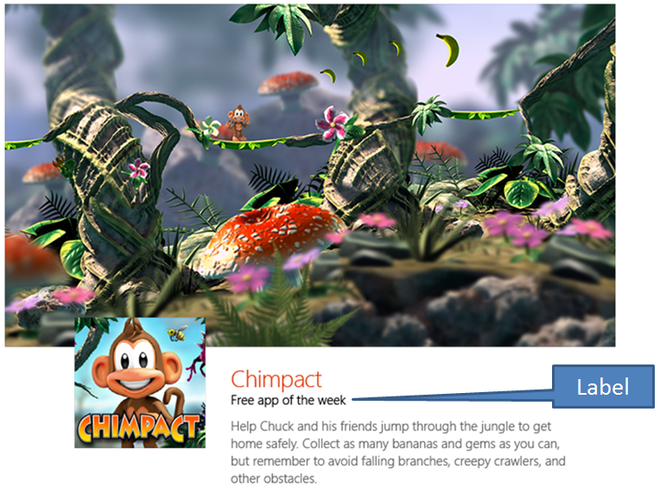
This image shows a label used on a live tile:
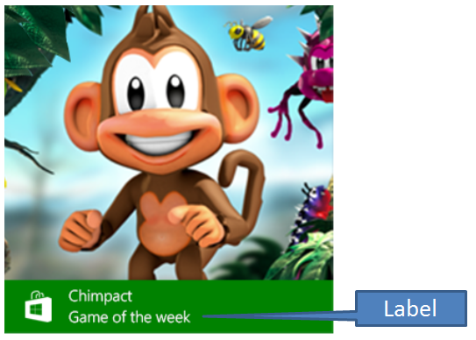

3.2 App promotional text (AKA “app descriptions”)
There are two kinds of app description: individual app promo text (the most common), and “collection” promo text (known as “topic pages” in Windows 8) that describe thematically related individual apps the Site Management team believes customers will find interesting. For example, every four years, we’ll create a collection that features the best apps for the Olympic Games and the World Cup.

3.2.1 Individual app promo text
In the Windows 8.1 version of the Windows Store, the Content team writes promotional descriptions for many—but not necessarily all—of the featured apps. “Featuring an app” means that it’s highlighted in the Store by showing it in the Store’s main spotlight or category pages. The Site Management team decides if an app it has chosen to feature would benefit from a promotional description (“promo text”), and that team chooses a template to format the image and text. Not all templates are available in all markets. This image shows where the promo text for an individually featured app appears:
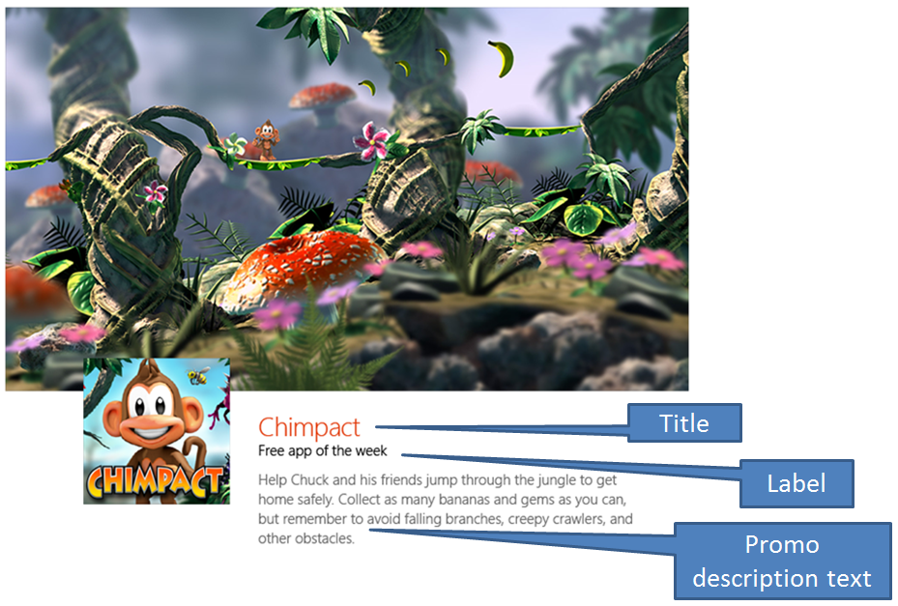
It’s important to understand that the promo text we write is different in three major ways than the full app description that the app publisher writes and submits as part of their app package:
- The promo text we write only appears when an app is featured. It never appears on the app’s product description page (PDP) where the full app description appears. But if the publisher’s description is excellent, then we can reuse their text for our promo text about their app.
- Our promo text has significantly shorter character limits.
- Our promo text has different quality criteria.
The rest of this document gets into the details of these differences and defines when we can and can’t reuse publisher-provided text.

3.2.2 Reusing, editing, or creating app descriptions
There are three options for creating promo text for featured apps. You can choose to:
- Reuse the publisher-provided app description (if it meets our quality and publishing criteria).
- Edit the publisher-provided app description (if it meets most of our quality and publishing criteria) solely to correct obvious spelling, grammatical, or typographical errors.
- Create a new, unique app description (if it doesn’t meet our quality and publishing criteria).
Determining which option you should choose begins with evaluating the publisher-provided description and determining if it meets the following criteria:
- There are no unusual, attention-grabbing fonts or formatting choices, such as ALL CAPS, multiple exclamation points (!!!!!!!!!!!!!!), and asterisks (***********).
- There are no references to limited-time special offers.
- There are no third-party references or endorsements, such as comparisons to other apps, or quotes from newspapers, blogs, or other information sources.
- It’s grammatically correct.
- There are no spelling errors.
- The first 235 characters of the description don’t truncate awkwardly (more about this publishing system limitation below).
- The voice and tone meet the Windows 8.1 guidelines. In short, meeting the guidelines means that the text sounds like it could’ve been written by the Windows Content team because it aligns with the text that customers find throughout the Windows operating system. The text is clear, straightforward, encouraging, vibrant, and uses the same words customers use. See the Content team’s Style Guide for more info.
If the text meets all of these criteria, you can reuse it for the promo text without making any changes to it. This is subject to the character limitations described below. If the publisher-provided app description is too long, end at a logical point and include ellipsis.
If the app description meets most, but not all, of these criteria, you need to determine if it can be edited to meet all of the criteria by correcting obvious spelling, grammatical, or typographical errors.
For example, if the text would meet all of the criteria by fixing a few common spelling errors, then the App Developer Agreement gives you permission to make these low-impact editorial changes and you can repurpose the text for the promo text.
But if you would need to change the description beyond what’s been described above for it to meet these criteria, then you’ll need to write your own original description. Examples of too much change include:
- Removing, recombining, or substituting words
- Removing or reordering sentences
- Combining your original text with the publisher’s text as though both were written by the same entity
When you write your own description, it’s OK to paraphrase the app publisher’s text, but it’s critical that you paraphrase rather than directly quote. Paraphrasing means “A restatement of a text or passage in another form or other words” (American Heritage Dictionary, 4th edition). Because the form the words take is basically the same on PDP pages and in promo text, it’s critical that the words be different from the original. For the purposes of our promo text, to “quote” means “to repeat or copy the words” (American Heritage Dictionary, 4th edition). Specifically, we define quoting as copying three or more significant words in a row, or writing text that when read side by side with the original is nearly indistinguishable from it. For more info about paraphrasing, consult the Successful vs unsuccessful paraphrasing page (on the Writing Center website for the University of Wisconsin—or check a similar site).
Better than paraphrasing, however, is simply writing your own unique promo text for an app and then comparing it with the publisher’s text so you’re sure that you haven’t coincidentally phrased the text in the same way about the same subjects.
If you’re not sure if you’re paraphrasing or quoting, you’re probably quoting, and you should ask a peer or your lead to review the two descriptions and give you their opinion before you publish the text.
Finally, the promo text for each app is limited to about 235 characters. This number is relative, and the size of the characters affects the total number available. The Store’s display system allows for truncation of the promo text, but truncation should be avoided because it can cause unfortunate and unintentional breaks in words and sentences. As a result, we have to try to make sure that when truncation happens, the remaining words don’t unintentionally spell words that would fail the Policheck test or which create the wrong impression about an app or a publisher’s brand. Because truncation is difficult to predict, keeping the character count well below 235 is recommended.
Here are examples of original promotional text created for individual apps:
App name | Description (235 characters)
Endless Skater | Break from the daily grind and pull an epic 50-50 grind, instead. Go big as Sean Malto, roll old-school as Christian Hosoi, or choose from other top pros as you explore endless gameplay and master 25 different tricks.
Vevo | What do more than 21,000 music artists have in common? They all have free, HD music videos available on VEVO. It’s where you’ll also find exclusives, world premieres, and live performances from your favorite artists in many genres.
Great British Chefs | If you think British food is all fried fish and mushy peas, think again! Get over 300 amazing recipes, video tips, and articles from famous, modern British chefs who've reinvigorated British cuisine.
Where's My Mickey | Mickey needs your help collecting water! Help him control the weather as you play your way through more than 100 levels of puzzles and fun, including extra-large levels available only on your bigger screen.
Vyclone | See what everyone else saw by mixing your footage with your friends’ videos of the same event. Vyclone does the multi-angle synchronizing and editing for you, and makes it easy to share your masterpiece.
Time Out New York | Need to know where to get the best cosmopolitan in the cosmos? Wondering which of the 101 things to do this summer you’ll do first? Get the Time Out app and don't miss a beat, bar, shop, or show.
BLINK Cliplets | Blow minds with just a short video clip plus the special effects of this app’s clever tools. Layer moving images over still pictures and the next thing you know your Facebook and Twitter friends will think your cat can levitate.
OpenTable | Pick a date, time, and the number of people in your party and quickly make a reservation at one of more than 20,000 restaurants. Check out restaurants in your neighborhood, browse menus, and read reviews.
Songza | Let Songza find the right soundtrack for what you’re doing. Tell the app what you’re doing, and it’ll figure out a playlist of free music for you.
eDJing | Learn to DJ and create a non-stop mix of your favorite songs with edjing. Pick the songs you want from your music collection, add scratches, loops, and other sound effects, and seamlessly transition to the next track.
Field & Stream Fishing | Try to catch the big one! Make use of different lures and bonuses to hook, fight, and land different fishes. Don’t forget to sign in to Xbox so you can prove your fish stories are true.
Rhapsody | Start a 14-day free trial today. Listen to full albums from your favorite artists, create custom playlists, and sync your music library between different devices.
Rockmelt | Rockmelt brings together the best of the Internet into a single, personalized newsfeed. You’ll know everything you need to about whatever interests you.
Discovery Channel | Watch full episodes and behind-the-scenes clips of your favorite shows, including Deadliest Catch, MythBusters, and Gold Rush. There’s also a helpful program guide so you’ll never miss an episode.
TLC | Watch full episodes and clips of your favorite shows, including Cake Boss, Here Comes Honey Boo Boo, and Say Yes to the Dress. There’s also a helpful program guide so you’ll never miss an episode.
Animal Planet | Watch full episodes and clips of your favorite shows, including River Monsters, Pit Bulls and Parolees, and Finding Bigfoot. There’s also a helpful program guide so you’ll never miss an episode.
eBay | Bought! Sold! Keep track of items you’re bidding on or things you’re selling. Get automatic notifications when you’re outbid, an auction is about to end, or you’ve made a sale.
Amazon | One-stop shopping made even easier for busy shoppers. Search, compare prices, read reviews, and quickly make purchases from Amazon.
Khan Academy | Got a big test or a tough question you need answered? With more than 3,800 videos that cover subjects like biology, history, science, and math, this is a great app for inquisitive minds.
Star Chart | Even your hard-to-impress friends will ooh and ahh once they see this app. No matter the time of day or where you are, you can see the exact location of different planets, stars, and moons.
Discourse | Create a personalized newspaper that uses your favorite news sources and RSS feeds to deliver the news that’s important to you.
Skype | Bring your conversations to life with Skype. Stay in touch with your friends and family using video, voice calls, and instant messages.
Wordbrush | Literally paint a picture with your words or add unique captions to your favorite photos. Choose from different backgrounds, fonts, and effects to make your words come alive!
Fotor | Picture-perfect photos are a snap with Fotor. Open your favorite photos, crop and adjust the image, and add special effects and frames to create masterpieces you can share with friends and family.
Comics (by Comixology) | Choose from over 30,000 comics and graphic novels from publishers like Marvel, DC, IDW, Image, and more. And if you’re not sure where to start, check out their recommended freebies.
Perfect365 | One touch is all it takes to create a great looking headshot. You can even fine-tune the details and give yourself a total virtual makeover.
Music Maker Jam | Create your own songs using different instruments, beats, and effects. When you’re done, and the app makes it easy to share them with friends and family.
Allrecipes | Search over 40,000 recipes based on the ingredients in your fridge, the type of dish you want to create, or for specific dietary preferences.
Cookbook | Browse over 300,000 different recipes to create the perfect appetizer, main dish, or dessert for any occasion, and save your favorite recipes to a personal recipe book.
iCookbook | Get great tasting and healthy meal ideas from the accredited nutritionists and food experts that choose the recipes in iCookbook. Everything you need to go from the kitchen to the dining room is right here.
Bing Translator | Translate text into over 40 different languages, hear translations read in a native accent, and use your webcam to translate signs, newspapers, or any printed text. You’ll never feel lost on your next trip abroad!
Yahoo! Finance | Want to know how your stocks traded today, whether it was on high volume, and if company news was behind the move? Quickly see and understand the data and events that affect the stocks in your portfolio and the market.
Yahoo! Mail | Yahoo! Mail is now integrated with Dropbox, so storing and sharing files is easier than ever. Other updates include quicker and more reliable performance, and the ability to sign out of individual accounts or all your accounts at once.
Calculator Pro for Windows 8 | Go beyond just adding, subtracting, multiplying, and dividing. Calculator Pro also provides a scientific mode to help you with more complex calculations, including calculating degrees and radians.
BrainPOP Featured Movie | BrainPOP teaches students about a wide variety of subjects using animated videos (featuring Tim and a robot named Moby) and interactive quizzes. There’s a lot of free content, or you can subscribe to get all of it.
Halo: Spartan Assault | Get ready for battle in this exclusive game for Windows. Become part of the Spartan Ops program and take on the Covenant forces in new, action-packed missions set in the Halo Universe.
Fresh Paint | Paint whenever inspiration strikes with Fresh Paint. Start with a blank canvas and create a masterpiece, or take one of your favorite photos and make it look like an oil painting.

3.3 “Collection” descriptions
A “collection” of apps (known as “topic pages” in the Windows 8 store) is a set of thematically related individual apps the editorial team believes customers will find interesting. For example, every four years, the Store team will create a topic page that features the best apps for the Olympic Games and the World Cup.
The themes and individual apps are chosen by Site Management, and the content team is responsible for creating a title that concisely captures the purpose and value of the collection, and descriptive promotion text that further explains the value of the collection and the apps in it.
A app collection title has a [NEED A NUMBER] character limit, and descriptive promotional text has a [NEED A NUMBER] character limit.
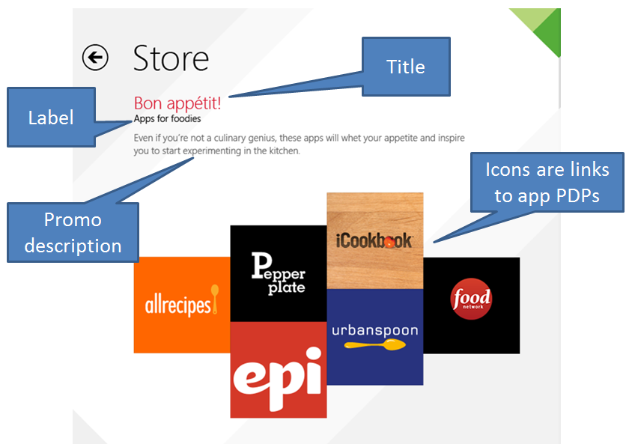

3.3.1 Examples
See this doc for a complete list of the collections (“topic pages”) that have been published for Windows 8. Here’s a shorter list:
Category | Title | Promo description
Entertainment | Watch TV shows, movies, and videos | Keep up with what your friends are talking about. Catch up on your favorite shows, see the blockbusters, and the little indie films, too.
Food & Dining | Be a better chef | Need a helping hand in the kitchen? About the only thing these apps won't do is help with the dishes.
News and weather | Get breaking news fast | Get the news delivered straight to your PC. Keep an eye on what's going on around the globe and get updates about breaking stories.
Travel | Plan your next vacation | Get started with your travel plans. The only thing you’ll need to do is pack your bags (because there isn’t an app for that … yet).
Photos | Picture-perfect photos | Whether you’re an amateur or a pro, you can edit your favorite photos, share them with your friends, and find stunning photos online.
Music and Videos | Experience new music | Find answers to your questions about music. Explore new genres, listen to broadcasts from around the world, and find something that’ll be music to your ears.
Books and reference | Apps for bookworms | Satisfy your passion for reading, and have handy resources at the ready, right at your fingertips.
Education | Earn better grades | Whatever the school year throws at you -- exams, homework, pop quizzes, extra credit -- you’ll be ready to make the grade with these study aids.

3.4 Live tile text
A “live tile” is the internal name given to a tile on the Start screen that features dynamic, updated content. The Windows Store tile for the 8.1 release features this dynamic content (the Windows 8 Store tile isn’t dynamic).
The content that appears in the tile, including app names, images, and text, is aligned with the apps that are featured in the spotlight landing page of the Store, but the two content surfaces are programmed separately, and they have different requirements.
Depending on how the customer has personalized their Start screen, tiles can appear in one of three sizes:
- Small (also known as “1x1”)
- Medium (also known as “2x1”)
- Large (also known as “2x2”)
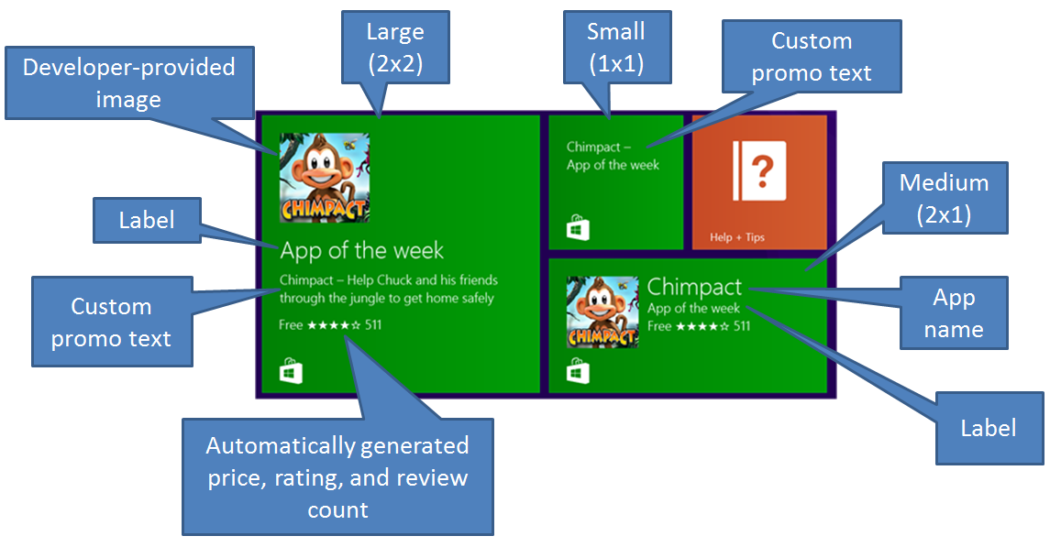
Figure 1 Three tile sizes as they would each appear on the Start screen
As mentioned earlier, templates are used to format images and text on the landing pages in the Store, and templates are also used to format the text and images (if present) for the live tiles. Each of the templates has requirements for text length and image size. All of the templates require some amount of custom content, while many templates automatically generate content by reusing developer-provided images (such as icons) and the text labels used in the landing page templates.

3.4.1 Text and image requirements for the Dublin live tile template
Content name | Portal content type | Required/  Not required | Specifications | Live tile size used in
Image | Image | Optional | 150x150 size | 2x2 & 2x1
Title | Title | Required | 15 Characters | 2x1
Label | Label | Required | 20 character count limit | 2X2, 2x1
Large Description | Subtitle | Required | 65 character count limit | 2X2
Small Description | Description | Required | 65 character count limit | 1x1

3.4.2 Text and image requirements for the Custom template
Content type name | Portal content type | Required/  Not required | Specifications | Live tile size used in
Image | Image | Required | 310x310 dimensions | 2x2
Image | Tile | Required | 310x150 dimensions | 2X1
Title | Title | Required | 35 character count | 2x2, 2x1
Label | Label | Required | 35 character count | 2x2, 2x1
Small Description | Description | Required | 65 max character count. | 1x1
2x2
2x2 image
Label
Title
2x1
2x1 image
Label
Title
1x1
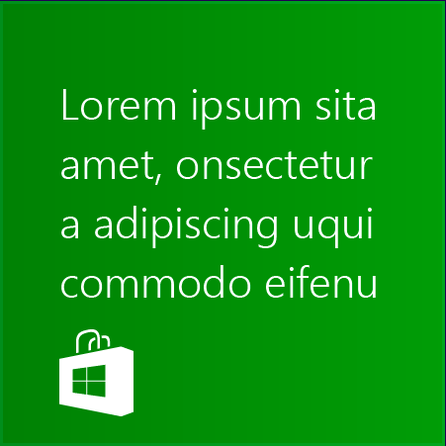
1x1 description

3.4.3 Text and image requirements for the Collection template
Content type/  text box name | Portal content type | Required/  Not required | Specifications | Live tile size used in
Page title | Title | Required | 24 character count | 2x2
Label | Label | Required | 20 character count | 2x1
Small description | Description | Required | 65 character count | 1x1
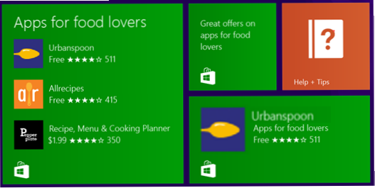
Small description
Label
Page Title

3.4.4 Text and image requirements for the Rio template
Order | Content type/  text box name | Required/  Not required | Specifications | Live tile size used in
1 | Image | Optional | 150x150 | 2x2, 2x1
1 | Title | Optional | 16 characters | 2x2, 2x1
1 | Label | Required | 32 characters | 2x2, 2x1
1 | Small Description | Required | 65 characters | 1x1
1 | Link | Required | App only | 2x2, 2x1, 1x1
2 | Image | Optional | 150x150 | 2x2
2 | Title | Required | 16 characters | 2x2
2 | Label | Required | 32 characters | 2x2
2 | Small Description | Required | 65 characters | 2x2
2 | Link | Required | App only | 2x2
3 | Image | Optional | 150x150 | 2x2
3 | Title | Optional | 16 characters | 2x2
3 | Label | Required | 32 characters | 2x2
3 | Small Description | Required | 65 characters | 2x2
3 | Link | Required | App only | 2x2

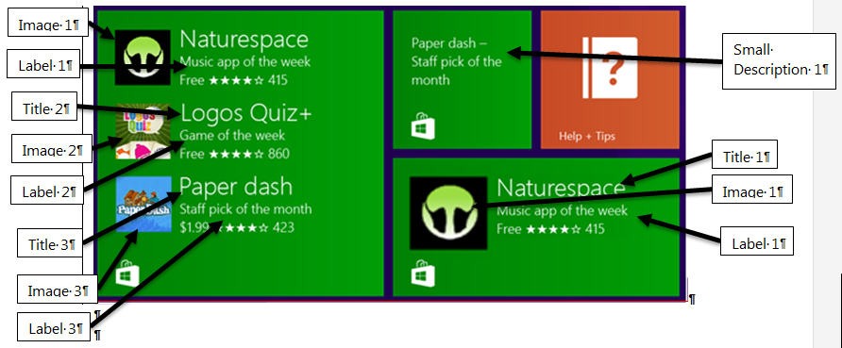

4. Words to be aware of
It’s easy to overuse the following words in Store text, so be conscious of them and use each sparingly and wisely:
- Easy
- Get (and “Get help”)
- Great
- Top
- Faster

