Windows® 7
Windows 7 End User Product Guide
Draft v 0.5
Last updated: 6/6/08
Windows 7

Introduction to Windows 7

Computers are an integral part of the everyday lives of billions of people. They come in more sizes and shapes, appear embedded in more devices—your car, watch, and even refrigerator, and are used for more purposes than anyone could have imagined just 10 years ago. Windows has become much more than the backbone of a PC. It’s the connective tissue that makes it easier for you to communicate with people, manage a busy schedule, be successful at school or work, and just have fun.
Inspired by what our billion different customers want, we designed Windows 7 to deliver personalized computing for everyone. We focused on big innovations, such as easy home networking, a great experience with all your devices, and built-in energy saving designs. But we also realize that you care about the little things – the attention to details – that really make the experience enjoyable, from the clean desktop of our new AERO design to the control you now have over gadgets and glass color.

A more responsive PC is a better PC, regardless of what you’re doing. You’ll quickly notice how Windows 7 improves the reliability and speed of your PC, especially when you start your computer, wake a hibernating laptop, play music and movies, search for a file, and connect to the Internet or a home network.

Now, you can do things on your computer by just touching the screen. You can still use a pen or your trusty mouse and keyboard, too. Voice activation and the latest accessibility technologies are available at your command.
When you’re on the go, Windows 7 has improved network connectivity that helps you quickly get to information and resources, wherever you are. Devices will connect easily, and built-in energy saving designs help you squeeze a little more time out of your batteries.
Windows 7 is about having fun, too. Amazing media and entertainment capabilities tie together all of your home electronic experiences. Media Center makes it easier than ever to record and watch TV shows or entertain guests with an variety of playlists during your next party. It’s never been easier to organize and edit photos, add music to a slideshow, and share them with family and friends.
All of these great experiences are enhanced by the rock-solid foundation and stable power of the Windows ecosystem. At home, at work, on your phone or music player, while you’re travelling--Window 7 is a rich and secure platform that creates a seamless online world for you. Windows® Live services extend your experience to the web, so your online world is always at your fingertips. Windows Live™ gives you instant access to mail and photo services. You can create your own personal webpage to reflect your style, stay in touch with your friends, organize parties, and share your memories. You can use the free storage space on Skydrive to save files and photos so you can access and share them anytime, anywhere, all over the world.

Personalized Experience

You own and control the Windows 7 desktop. You can easily make it look, feel, and behave the way you choose. Make it reflect your style, even on a shared PC, with themes that package together the most common customizations.
And now your fingers are your handiest tool for using your PC. New touch and multitouch capabilities put programs and activities right at your fingertips. If you have a computer with a screen that supports touch technologies, you can simply touch your screen to control and move around within programs. You’ll love how easy it is to view, arrange, organize, and tag your photos with just a touch or two of your computer screen.
Windows 7 remembers the everyday things you do on your computer so you can quickly get to things you like and use most often: recently used programs and documents, websites you visit, music you listen to, and web searches you do. The desktop reflects your style, and the new Windows Taskbar always shows your important activities. It’s easy to identify what’s open in multiple windows and switch to the program or website you need right away.


Clean Desktop
As you use your PC over time, you control what gets placed where, so Windows stays clean and always reflects your personal style. When you start Windows 7, you’ll be impressed by the clean and uncluttered desktop. The system tray in the lower right corner is streamlined so that only four icons are displayed by default. You’ll see the volume control, network status, battery meter, and health status. New icons don’t appear automatically when you install programs and you can choose which icons to display. Fewer notifications and alert pop-ups will distract you. User Account security notifications show up less often, and when they do, it’s easier to understand what you should do next. You can even choose to suppress User Account notifications for a short time while you personalize your PC.
Fewer icons mean less clutter

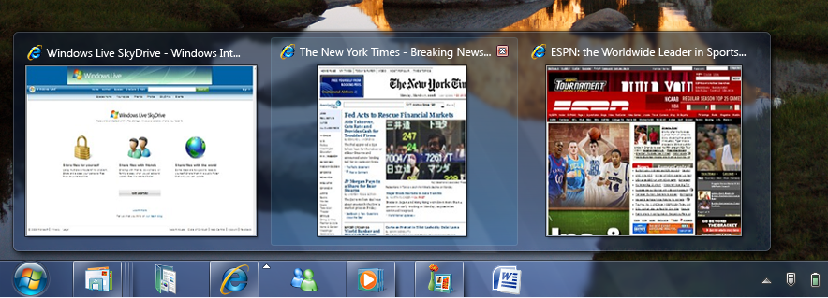
Windows Taskbar

The taskbar is changing for Windows 7. You can still easily switch between windows, and now you can open programs with just one click by pinning them to the taskbar. Each open window is represented as a rich graphic thumbnail. If you hover your mouse over the thumbnail, the window expands to full-screen preview. You can even close a window directly from the thumbnail. And if
you’re picky about the order of items on your taskbar, you’ll be especially pleased that you can now rearrange them as you like by simply dragging and dropping them. The icons are bigger, too, so it’s easier to use them with the new touch features in Windows 7.

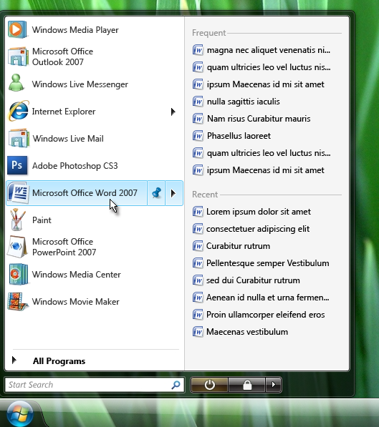
Destination Menus
Destination menus take you where you want to go faster. You’ll find one on the Start menu and another on the taskbar that will lead you to recently used files, folders, and websites. You’ll even have quick access in some programs to tasks that have typically only been available when you’re running the program. For example, your destination menu might provide a link to play a song or open a webpage. Instead of opening each program and starting these tasks, you can do it from a destination menu with just one click.

Window Arrangement

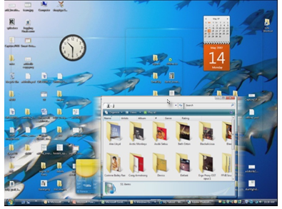
Working with multiple open windows gets even easier in Windows 7. You don’t have to click on tiny objects in the corner of windows because you can maximize a window by grabbing the border and dragging it to the top of the screen. Return it to the original size by grabbing the window and dragging it away from the top of the screen. If you want to make a window taller, grab the bottom frame and it will stretch vertically. You can also compare the contents in two windows by dragging each of the windows to opposite sides of the screen. When you do this, each window will resize to half of the screen.

Shake
Want to get all but one window out of the way? Grab the top of the window you’re working in and shake it. All of the other windows on the screen will minimize to the taskbar. You can bring them all back by shaking the window again.

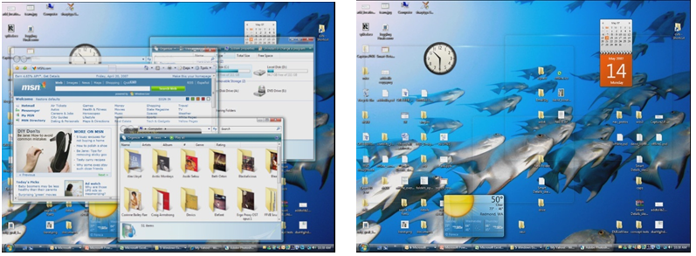
Peek

Maybe you like to quickly check the information on a gadget that’s on your desktop. Windows 7 lets you peek behind open windows to get a look at your desktop. When you hover your mouse over the far right side of the Taskbar,
all of the windows become transparent and you can see through all the way to your desktop. You can also peek at a specific window by hovering over its thumbnail in the Windows taskbar.

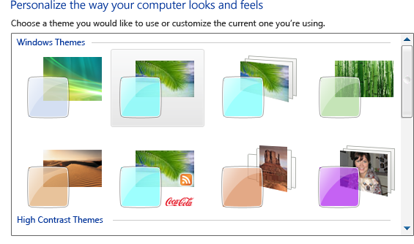
Themes
Windows 7 comes with many new themes, so you have more options for making your computer reflect your own personal style. Each theme package includes rich backgrounds, glass colors, a unique sound scheme, and a screensaver. You can also download new themes, including some that are customized for specific regions of the world. You can even create and save your own themes and share them with your friends and family.

Desktop Slideshow
Ever wanted to turn your desktop background into a photo slideshow? Then you’ll love the new feature in Windows 7 that lets you pull in photos from your photo gallery or even from a website and display them on your background. Choose where you want the photos to come from and how often you want them to change—your desktop background will light-up like a custom photo slide show.

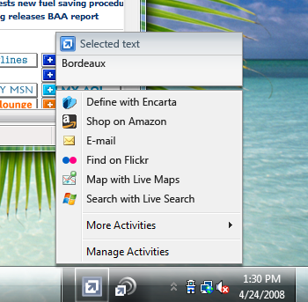
Activities Everywhere
Often, you see content on a webpage, in an e-mail message, or in a document and you want to use it to do something else – get a map, get a definition, convert a measurement, see a picture, do a search. You don’t have to go through the steps of copying it, opening other windows or websites, and then pasting or retyping the text anymore.
You can use a new Windows 7 feature called Activity Everywhere to ask your computer to retrieve more information about text you’ve selected on a page. You’ll have instant access to maps, definitions, and search engines. Just highlight text and you’ll see the activities available on that page.
You can customize the list of activities and providers you use for those activities. For example, if you have a favorite map provider, you can customize the map activity to use only that provider. You can also install new activities from the Microsoft online activity gallery. Some activities respond to touch or voice commands if your PC supports touch or has a microphone. For example, you can select an address with your finger and get a map for that location by simply saying “map.”

Touch Experience
Computers and devices come to life when you can use your finger to control what’s on the screen, and Windows 7 is designed to work well with multitouch hardware. The Start menu, Windows Taskbar, and other areas have larger icons so you can easily touch them. Common programs like Calculator, Paint, Windows Live services, and some 2007 Microsoft® Office system programs work well with touch. Browsing the web is easier, too. Just use your finger to scroll down a website or browse your favorite links. Rearranging photos is also faster and more fun. Use your fingers to flick through a photo album or quickly arrange and sort your images using your favorite photo software. You can even have fun with finger painting in Paint!

Multitouch Gestures
Gestures are touch actions you do with more than one finger. For example, when you bring your thumb and forefinger together as if you’re pinching something on the screen, a website will zoom in. Gestures like this allow you to use your fingers to zoom in or out, rotate images, and perform other fun and useful tasks with your PC. You can even customize your own gestures. New touch gestures in Windows 7 include:
Zoom out by moving two fingers closer together. This will make what you are viewing smaller.
Zoom in by moving two fingers apart. This will make what you are viewing on the screen bigger.
Pan by moving two fingers up or down to scroll vertically or side to side to scroll horizontally.
Rotate images or other objects on the screen by rotating one finger around another or by rotating both fingers around the center.
Right click –
Double click –

Gadgets
Do you love the ease of tracking weather or traffic information in a handy gadget on your desktop? Windows 7 makes gadgets even easier to access on your desktop and optimizes them for connected services. Now you can position gadgets anywhere on the desktop and make them smaller or larger. If you like gadgets to be at the edges of your screen, they will snap into place as if the edges of your screen were magnets. And the Peek feature lets you view your gadgets quickly, even when you have several windows open that block your view of the desktop.
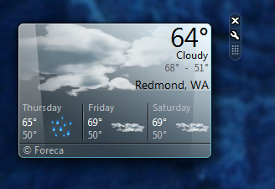

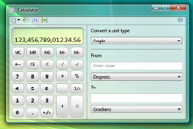
Refreshing Features
Some of the old favorites in Windows are getting a welcome makeover in Windows 7. Getting more than just a minor touch up, Wordpad and Paint now include the Scenic Ribbon, bringing the familiarity of 2007 Office system programs into Windows. The Ribbon makes it easier for you to find and use program features because these items are no longer hittden in menus. It also helps developers customize this area for new Windows programs.

Calculator
Calculator has a new look and some brand-new features in Windows 7. You’ll find calculation history, unit conversion, and calculation templates, and controls are optimized for touch so you can easily touch the screen to complete quick calculations.

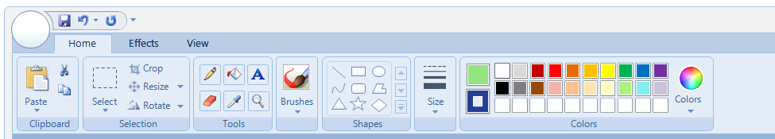

Paint
Paint glistens with the addition of the Scenic Ribbon. The natural media paint brushes are new, and it’s easier to pick colors and shapes. Fingerpaint all you want with controls enabled for touch and multitouch gestures.

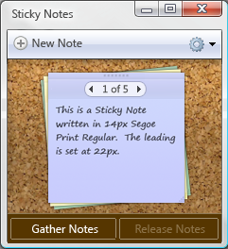
WordPad
As with Paint, the new Scenic Ribbon has been added to WordPad. New additions to this old favorite include highlighting, line breaks, additional text colors, bullets, indents, print preview enhancements, tables, picture insertion, and zoom.

Sticky Notes
Having a small piece of paper to jot down reminders or to-do lists is very helpful. Windows 7 enhances your PC sticky notes to give you a quick, effortless, and friendly way to take short notes. Your notes will have an auto-generated timestamp, and you can flip between them, collapse them, paste text into them, and resize them on the desktop.

More Accessible
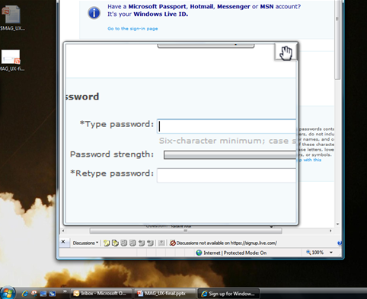
Windows 7 includes significant updates and improvements to accessibility features, making it easier to interact with your PC. Accessibility improvements include dramatically improved screen magnification for zooming in on certain parts of your screen, a new on-screen keyboard, and more personalized speech recognition. The on-screen magnifier makes it much easier to enlarge portions of your screen for enhanced readability. Text prediction within the on-screen keyboard means that it’s easier to write and interact with programs that run in Windows. As you type, the on-screen keyboard makes recommendations based on previous entries.

Magnifier
Magnifier is available whenever you need to magnify the entire screen or parts of it. It’s particularly helpful for people who have low-vision or difficulty seeing the screen, but it’s also useful for anyone who wants to view objects on the screen that are difficult to see. You can use full-screen mode to magnify the entire desktop or lens-mode to magnify only a portion of the screen. In Windows 7, Magnifier works with DirectX content, and it supports the use of a pen, touch, and keyboard shortcuts in full-screen magnification.

Speech
Windows Speech Recognition allows you to tell your computer what you want it to do. Windows 7 supports dictation in many more programs, such as Excel, PowerPoint, and Windows Live Messenger. Speech accuracy is also improved. Now you can easily dictate who you want to send an e-mail to and then speak the message of that e-mail. Screen readers that read commands and text aloud are nearly three times faster.

Global Windows
People all around the world use and enjoy Windows, and many cultures have unique requirements for making the Windows experience appropriate for their location and their specific needs. Windows 7 provides a locally relevant, culturally appropriate experience to a broad range of world-wide users. That means more fonts, languages, and relevant desktop themes wherever you live.

Culturally Relevant Desktop
Windows 7 has new desktop themes tailored to your language and location. These themes include special wallpapers, sounds, Aero Glass colors, user tiles, and sample images that are representative of local cultures. Also, Internet Explorer favorites and RSS feeds will be pre-populated with links to relevant local choices.

Seamless Cultural Conventions
Regional options, such as currency and date format, are appropriately set based on the locale you choose. World-wide script support is available independent of your locale, so multilingual browsing no longer requires font installation or settings updates.

Multilingual Experience and Deployment (Multilingual Family)

Windows 7 provides seamless multilingual capabilities if you use multiple languages at home or at work. You can easily select the language you prefer and culturally specific information is set for you automatically.

Language-Based Fonts
Windows 7 supports a broader range of scripts and fonts for more languages. People who use these scripts will benefit from these additions, which also help meet government requirements in countries that require support for national languages.

Language-Relevant Font Selection
Windows 7 fonts are now classified by the languages that they are associated with, so you’ll see the list of fonts that are relevant to you based on the languages you use. If you use multiple languages on your computer and want to switch the font in a program, the choices you see include only the fonts relevant to the language you are using.



Always Connected

Today’s world is a connected one—across the building or across the planet, people need to connect to each other, to other computers, and to the Internet. Whether you’re at home, traveling, or at the office, Windows 7 makes it easy for you to get connected and stay connected so that you have access to the sites, programs, photos, music, and information that matters the most to you. Whether it’s setting up a secure wireless network in your home with the press of a button or providing integrated support for mobile broadband Internet connections when you’re on the go, Windows 7 keeps you connected – even when the network you are using changes.

View Available Network (VAN)
Windows 7 makes it easy to view and connect to available networks. When multiple connections are available, you’ll see a consistent way to connect to one regardless of the network type. So everything will be easier whether you’re trying to connect to a wired, wireless, mobile broadband, or custom network.

Windows Connect Now (WCN)
Do you want to control who has access to your home wireless network? Windows 7 makes it easy to set up a secure wireless network. Windows Connect Now supports the Wi-Fi Protected Setup (WPS) standard and reduces the complexity for computers, mobile devices, and wireless access points to securely connect to each other and exchange settings. Use Windows 7 to request permission to join a home network, and then accept the request by pushing a button on the wireless access point. Your computer will automatically get the network settings from your wireless access point and set up a secure wireless connection – you won’t have to remember or type in a password every time to connect.

Soft Access Point
Windows 7 lets you use your wireless-enabled PC as a wireless access point. This means you can connect other wireless-enabled PCs or devices directly to your computer and still stay connected to the Internet. Or, if you’re traveling and need to connect a wireless-enabled device like a cell phone or a camera, you can connect it to your PC.

Mobile Broadband
It’s much simpler in Windows 7 to connect your computer to the Internet using a cellular provider, regardless of which cellular provider you use or what technologies the service provides. Connecting via your cell provider is similar to connecting to a home wireless network using a data card provided by your PC manufacturer or cellular service provider. That card allows your PC to connect to the Internet wherever you have cellular service.

Phone Tethering
Many cell phones today can be used as a modem to connect your PC to the Internet with broadband speed, but setting up this scenario has required technical expertise. Windows 7 streamlines this experience and makes it easy to use your data-enabled cell phone to connect your PC to the Internet. This is called phone tethering. When you want to connect to a network, check View Available Networks and you’ll see tethered phones along with available wireless or mobile broadband networks.

Direct Access
With Windows 7, your PC can always be connected to your work location, even when you’re not in the office. Your experience when you’re away from the office is the same as if you were in your office. If you need to use a work program, an internal website, or collaborate with others on a SharePoint project, these experiences are always available without establishing a VPN connection. And while Windows 7 ensures that you can stay connected to your work location, it also lets you browse the Internet independently from work resources. When you’re connected to work from home, you can access personal Internet sites without having to go through your work network.

VPN Client
If your company still uses a Virtual Private Network (VPN), Windows 7 makes sure that your PC stays connected to work even when the network you are using changes. For example, imagine you are at the airport using a public hotspot to connect to the Internet and then to your work network. If you move out of range of the public hotspot, Windows 7 can switch to your cellular network through a mobile broadband card. You’ll stay connected to your work network without needing to reestablish the connection.

Rich Remote Desktop Experience
If you like to connect directly to computers at your office via remote connections, you’ll find it easier to both connect and work productively using the Remote Desktop experience in Windows 7. You can use multiple monitors through a remote connection, and you’ll notice a higher fidelity graphics experience thanks to DirectX 10.1 and the new 2D Graphics (Direct2D) support. Audio and video content can be streamed in its original format so that the experience is similar to sound and video on your main computer.

Terminal Services Shell Integrated Workspaces
Many companies use Terminal Server to deliver certain business programs to their employee’s desktops. In Windows 7, programs that Terminal Services send to your computer will be available on the Start menu right alongside programs installed on your PC, and your experience using them will be remarkably similar.

Improved Offline Folders
When you don’t have access to a work or Internet connection, Offline Folders provides a great way for you to still have access to important documents and files. For example, when you’re travelling on a long flight, you can access your documents while in flight and any changes you make will automatically be synchronized when you reconnect to your network.

Organize, Find, and Share in the Home

Whether you want to share files with a roommate, a neighbor, a family member, or a coworker, Windows 7 gives you handy tools to help you organize and find the information that’s important to you, no matter where it might be. No more endless hunting around to find something. You can share files with all of the computers in your home and easily access those files and your favorite online services from them. And finding all your files is easy with new search filters and smart suggestions based on previous searches. Windows 7 brings it all together in your home.

Windows Explorer
Windows Explorer is the hub for where you organize and view the files on your PC, other PCs connected to your home network, and even files you have on Windows Live SkyDrive. Windows Explorer has a new navigation pane, so common tasks like moving and copying files is simple, easy, and fast. You can also see different views of your files spanning multiple storage locations.

Libraries
Libraries is a new way of viewing pictures, music, videos, and documents that might be located in different folders, on different hard drives, or even on different computers in your home. For example, you might have photos saved on several computers or devices. Windows 7 gives you an aggregated view of all of those photos in a single library folder regardless of where they are stored.

Views (Mixed Media, Preview, Top Views)
Windows 7 gives you many ways to view your files and folders. You can easily pivot data across multiple storage locations and use different different methods to view that data. For example, you can see documents or photos based on author, subject, date created, file type, or even storage location. The controls are easy to use, so previewing a file or changing the way you view it is just a click away.

HomeGroup
Having multiple computers in the home is an increasing trend--over 50% of the households in the United States have multiple PCs. However, setting up and sharing content across a home network is usually a difficult task. HomeGroup, a new feature in Windows 7, easily connects your computers securely, helping you share documents, photos, music, printers, and devices across your network. With HomeGroup, computers running Windows 7 automatically identify and connect with other connected devices in the home, such as printers. You can choose to keep data on a PC private, share content only with certain people, or share it with your entire network for quick and easy collaboration. For example, you can have digital photos stored on a computer in your den that you’ll be able to easily access from a laptop in your bedroom. Do you have multiple computers in the home but just a single printer? Use HomeGroup to share that printer with all the computers in your network.
Homegroup also helps you specify exactly what you want to share, so private files are kept private and others are available to people you choose. You can grant permissions to other people to view or change files by using their Windows Live ID or another web identity.

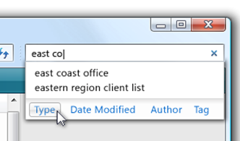
Smart Input and Recent Searches
Desktop search in Windows 7 helps you find the information that matters the most to you. It all starts with asking the right question: improved search input in Windows 7 helps you search smarter with input recommendations based on previous searches and dynamic filters to help narrow down results.

Remote Location Search
Very often, people have content and information located on multiple computers, servers, devices, and posted on multiple websites like popular photo sharing or document collaboration sites. In Windows 7, search expands beyond your computer. Just add your favorite locations to Windows 7 and one search hits them all. When you add online services like Windows Live SkyDrive, you have a unified view of your documents stored on your computer and those stored online. If you’re at work, you can set up Windows 7 to search content from popular programs and document management systems, such as Microsoft® Office SharePoint® Server.
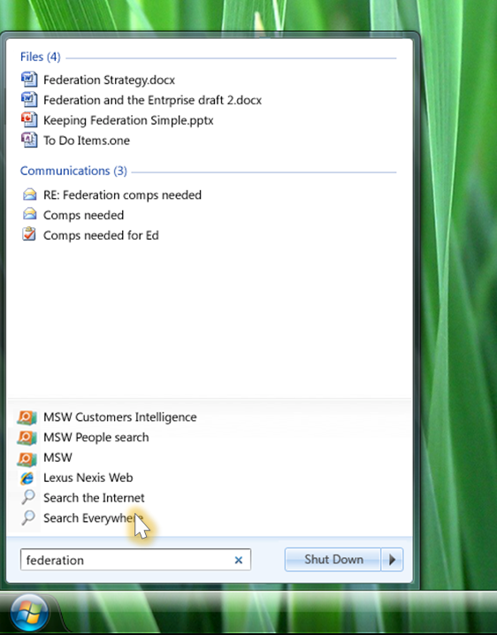

Improved Search Relevance
Windows 7 also makes search results more relevant and intuitive due to indexing improvements and easier scoping. It also includes tools like text snippets and hit highlighting to help narrow the result list, and 'try harder' re-scoping.

Search Federation
If you want to search across content on the Internet and remote programs, Windows 7 uses an existing public standard named Opensearch that provides the same rich search experience as when you’re looking for something on your own computer using Windows Explorer.

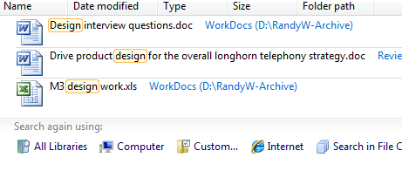
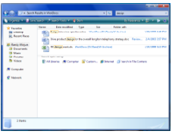

Do More with Devices

Windows 7 lets you connect more devices to your PC and makes it easier to use them. Device Center is the central place where you can see all of the devices that are connected to or associated with your PC. From this single location, you can interact with your devices, browse files, or manage settings.
Windows 7 has an enhanced experience for Windows logo devices, including many brand-name printers, cameras, phones, and other devices that you use at work and home. When Device Center recognizes one of these devices, it represents it with a unique photo image that you’ll quickly recognize. You’ll also see more details about that device and advanced options for managing it.

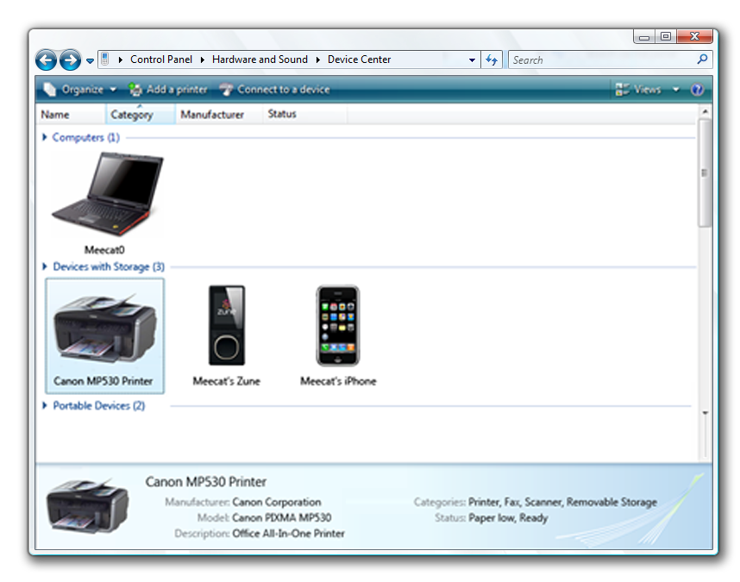
Device Center
Device Center is a central place where you can go to see all the external devices that are connected to or associated with your PC. Now you’ll see support for multifunction devices like printer/scanner/fax machines or cameras with built-in microphones. And you can easily manage all the various functions on these devices from this one location.

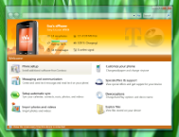
Premium Device Experiences

Windows 7 unites software and services to create a new experience for mobile phones, portable media players, cameras, and printers. This new experience makes it much easier for you to use and manage your devices directly from your desktop. You can connect devices to your PC using USB, Bluetooth, or Wi-Fi and you won’t need to install any additional software. Regardless of how you connect your device, Windows 7 will always recognize it, and when you first connect, any drivers or software needed for that device are automatically installed from Windows Update. Once your device is connected, you’ll see a variety of tasks that you can do with it listed in Device Center.

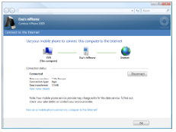
Internet Sharing
Internet Sharing lets you use a cellular data connection to connect your computer to the Internet. You can create a connection between the cell phone and your laptop, and then use Windows 7 or features on the phone to start an outbound connection to the Internet. You can browse the web, use e-mail, or start a VPN connection as you would if you were using a WiFi or LAN connection.

Launcher
Launcher gives you quick access to your device no matter what you’re doing on your PC. You can check the device’s status and perform the tasks you do frequently directly from the taskbar. Launcher runs automatically when a device is connected to your PC, and it offers separate experiences for each connected device. It shuts down automatically when the device is disconnected from the system, or you can manually close it using the taskbar.

Media Synchronization
Media Synchronization lets you easily synchronize important data and media between Windows 7 and a device, such as a cell phone or portable media player.

Photo Acquisition
When you connect a camera (or other device that can take photos) to your PC, you can choose to import photos and videos. You can start a photo import manually or set it to automatically launch when the device is connected to your PC. While you’re importing your photos, you can add keywords for the new photos and specify where you want to store them. Photos that were previously imported won’t be imported again.

PIM Sync
Windows 7 makes it easier for you to keep your personal information synchronized with your devices. When you connect a device, you’ll be able to synchronize your personal information between your PC and device. You can synchronize your contacts, calendar, tasks, and notes.

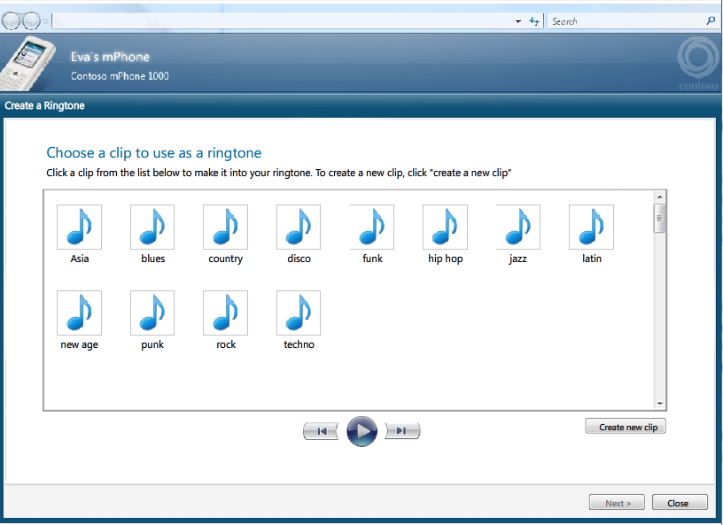

DXP Ringtone Editor
Ringtone Editor helps you create ringtones from your custom recordings or from sound files already on your PC. It also lets you preview and save a ringtone directly to your phone, set it as a primary ringtone, or assign it to one or more of your contacts.

Multifunction Printers (MPF)
When you connect to a multifunction printer with Windows 7, you’ll see a single, photorealistic image of the device itself. You can easily configure print, fax, and scan functions using the intuitive interface. You’ll see both status information and links to the device manufacturer. Some printer manufacturers enhance the Windows 7 experience by adding links to their site for support, updates, and supplies, such as ink and toner.

Location Aware Printing
Do you print to multiple printers – one at home and another one at work? With Windows 7, you no longer need to select the printer to match your location. When you change network locations – move from work to home with your laptop – the default printer setting in Windows 7 also changes. So when you print at work, it will automatically print to your work printer. And when you print at home, your Windows 7 will automatically select and use the printer in your home.

Bluetooth 2.1
Windows 7 supports Bluetooth 2.1 for enhanced productivity when you’re using Bluetooth devices. Improvements in Bluetooth 2.1 include Secure Simple Pairing (analogous to simplified association from Wi-Fi Alliance) and Sniff Subrating (the ability to decrease power consumption by 2-4 times).

Wireless Device Experience (aka Bluewire)
No wires? No worries. You can install and use a certified Bluetooth, wireless USB, Windows Connect Now, or network-connected device in just a few minutes. Simply choose a device, enter a pin number, and start using it.

Ultra Wideband (UWB) and Wireless USB (WUSB)
Support for UWB and WUSB in Windows 7 lets you take advantage of new wireless devices and wireless USB hubs, eliminating cable clutter and giving you access to more devices to use with your PC. UWB and WUSB are new technologies that are intended to be a wireless replacement for USB. Windows 7 supports the UWB/WUSB Wireless Host Controller Interface (WHCI), Device Wire Adapter (DWA) controller and native WUSB devices.

Virtual Wi-Fi
With Windows 7, you can connect your Wi-Fi devices directly to your PC while you stay connected to the Internet. You can connect devices, such as a wireless printer or camera, no matter where you are, without needing an access point. You can establish a secure connection between your wireless-enabled devices and your PC.

Storage Device Support
Windows 7 supports advances in USB storage devices such as flash drives and external hard disks. It supports new standards (IEEE 1667) and a wider range of devices that enable new features, such as password protection and certificate-based authentication.

Blu-ray Disc Write Support
PCs running Windows 7 that include a Blu-ray drive enable you to burn data files such as documents, photos, movies, music, video and other data files to Blu-ray discs. (Watching movies on Blu-ray discs isn’t supported.)

Fingerprint Readers & Logon
Fingerprint scanners are becoming more common, and Windows 7 ensures they will work seamlessly and consistently. It’s easy to setup and start using your fingerprint reader, and logging on to Windows using your fingerprint will be more reliable across multiple hardware providers. You can control all of the fingerprint reader settings so you can change how you log on to Windows 7 and manage the information that is stored about your fingerprint. You can also delete this information when you no longer need it or when you get a new PC.

High Fidelity Media PC

Windows 7 brings your media world together, whether you’re listening to music, watching TV and movies, playing games, or creating rich photo experiences. Windows 7 delivers the outstanding multimedia experience you expect, with many pleasant surprises when it comes to playing music, TV, games, and other rich media:
- It’s easier to create a high-fidelity media experience in your home that gives you quick access to your music library and control over your TV programming.
- Crisp, clear audio turns your home into a concert-like experience.
- Remote Media Access let’s you enjoy your music library even when you’re away from your PC.
- Graphics enhancements make the details in pictures and games pop on your screen, bringing photos and game experiences to brilliant life.
- Sharing all of this is easier, too, and you’ll really appreciate how the new Destination Menus give you quick access to all of these activities.

Media Center
Media Center is an integrated part of Windows 7, and with itwatching TV on your PC gets easier than ever before. You can watch analog and digital TV from satellite, cable, or terrestrial broadcasts, including premium channels previously available only with set-top boxes. In Media Center, you can easily browse through broadcast or broadband TV to find the shows, movies, or videos you want to watch or record. You can watch recorded TV shows on your PC or a big-screen TV, and easily synchronize them to a laptop or a portable device to enjoy them on the go. With touch-enabled controls, a streamlined user interface, all the latest codecs, and support for new content types and digital TV, it is the perfect way to power a compelling media and entertainment center experience throughout your home.

Broadband TV
Windows 7 integrates the growing amount of Internet media content into the Media Center experience. It makes it easy for you to see and select links related to something you’re currently watching. For example, when you watch a TV show you’ve recorded, you’ll notice that the program information includes links to the Internet site for that show, along with links to related information, such as Internet movie trailers or other on-demand episodes that are available. You can also search for other Internet media content from within Media Center.

Recorded TV Sharing
You can use Media Center to record live TV to your computer’s hard drive. And if you have a homegroup with multiple PCs with Media Center, anyone can watch these recordings from connected computers in the home network.
- All unprotected DVR-MS recordings can be discovered, played, and copied by any PC running Windows 7 in the homegroup.
- "Copy Freely" protected DVR-MS recordings can be discovered, played, and copied using Windows 7 Media Center
- "Copy Once" protected DVR-MS recordings can be discovered, played, and copied using Windows 7 Media Center
- Enables viewing of unprotected recorded TV on remote PCs in a homegroup

Broader Support for Global TV Standards
Windows 7Media Center includes support for a wider range of TV standards to meet the needs of television viewers around the world. Digital TV in Windows 7 works in over 20 global markets, with certified support for Japan's ISDB-T TV standard, DVB TV standards (DVB-T, DVB-S), and Premium Satellite TV standards.

Windows Media Player
Enjoying multimedia experiences in Windows 7 is simple and delightful. Whether you want to listen to your favorite songs while you’re working, or watch a DVD in full screen, playback is fast to start, the experience is consistent, and the focus is on what you’re playing. You can easily find what you want to play, or you can have Windows 7 play just the music you love. Windows 7 can play the most common types of media, including songs from your iTunes library and TV shows using Media Center, so you don’t have to spend time installing any special software.

Optimized DVD Playback
Improvements in performance and playback make watching a DVD movie in Windows 7 smooth and enjoyable. When you insert a DVD movie, it will start quickly and transition directly into full screen mode.

Listen To and View More Media
Are you tired of having to use different media players to listen to, view, transfer, and manage different media formats? Windows Media Player (WMP) in Windows 7 expands the media formats it supports to make it easier for you to listen, view, and manage all of your popular media from one place. Built-in support for common media formats, including WMV, WMA, MPEG-4, AAC, AVC and H.264, means you can use Windows Media Player to play back and transfer your media content across a broader range of devices.

Destination Menu Integration
In Windows 7, you’ll be impressed by how quickly you can get to your favorite songs, movies, and radio stations. New Destination Menus on the Start Menu and taskbar give you quick access to media you’ve used recently. Windows Media Player takes advantage of the new Destination Menu support in Windows 7 and adds common tasks to these menus—playing a video or a playlist, listening to a radio station, and so on. These items are tailored for you based on the most frequent things you do with media using Windows 7.

Internet Radio
In Windows 7, WMP helps you quickly find streaming radio stations. You can find the radio stations that matter to you, save them for future listening, manage your list of radio stations, and quickly play your favorite stations. Useful integration with the Radio Guide on http://windowsmedia.com is also available.

Lightweight Playback Mode
WMP includes a new lightweight playback mode that includes rich visuals, animation, and touch interaction. This new lightweight mode makes it easier for you to interact with your media and quickly witch to other tasks.

Taskbar Thumbnail Toolbar
When you’re watching a movie or listening to a song, you can quickly see what song or video is playing by hovering over the WMP icon in the taskbar. The improved WMP Toolbar gives you instant access to playback controls, so you can quickly adjust the volume or stop media from playing.

Push to Play Media
Do you have music or photos on your computer that you want to listen to or display on your home entertainment system? Windows 7 makes it easy for you to use your TV and home audio system to play music, watch videos, and view photos from your PC. You can share these experiences directly to your home audio video system, another PC running Windows 7, or other DLNA v1.5-compliant devices, such as the Sonos digital music system. You can do all of this over your home network—no more complex cabling.
Windows 7 supports the DLNA v.1.5 standard so you more device choices to use for advanced media streaming scenarios. Windows Media Player Windows 7supports:
- Digital Media Server (DMS), which provides the capability to stream media to a DMR
- Digital Media Render (DMR), which provides the capability to play back media streamed from a Digital Media Server
- Digital Media Controller (DMC), which provides the capability to select content from a DMS and control its streaming to a selected DMR.

Media Sharing
Have you wanted to share media around your home but were confused by all of the devices and settings you need to change? With Windows 7, you won’t need a media professional to set up media sharing in your home. The new media sharing experience in Windows 7 has been improved to simplify media sharing and reduce complexity for managing devices. You’ll find that it’s easier to find the settings you want to change and understand your choices. When you bring home a PC running Windows 7 and set up a hHomegroup, your music, pictures, and videos are immediately available on the other PCs and devices that are part of your home network. You can easily add new PCs, media servers, and players and instantly begin enjoying your media throughout the home. You can also restrict access to pictures or media you want to keep private, and easily authorize specific devices or people in your home to play restricted content.

Remote Media Access
When you’re on the go, you can easily access music, video, and photos from your home network. For example, on your next trip, you can access music or photos that are saved on your Windows 7 home PC. The experience you’ll have is the same as being directly connected to your home network.

Outstanding Sound
When you play music, watch a video, or just want to hear notifications from your computer, you need a quality sound experience. Windows 7 always sounds great and the sound always does what you expect. For example, if you’re playing music and get a voice call on your phone, the playback pauses when the call arrives and starts again when the call is done. If you’re using a headset and speakers, you can easily control the volume of each device independently – either using Windows 7 or the device itself. And you can control the kind of sounds that go to each device – for example, you can set Windows 7 so that you don’t hear system sounds or beeps when making voice calls. When you start your laptop in a meeting, you can mute the sound at any time by pushing the mute button.

Bluetooth Audio
With Windows 7, you can easily attach a Bluetooth headset to your PC to make voice calls or listen to music. To connect the headset, you run a simple wizard to install Bluetooth devices and pick the device out of a list. When you turn it on, you hear sound; when you turn it off, the sound reverts to your main speakers. You can control Windows 7 system sounds and music so you don’t hear them when when taking a call. You can also independently control the volume for your headset and other speakers.

Audio Stream Management
Windows 7 automatically routes sounds such as music, voice calls, and computer beeps to the right devices and eliminates mixing these sounds. For example, a communications headset will only receive audio for Voice over IP (VoIP) calls such as those from Live Messenger. When a VoIP call is started, other audio music will fade out and pause. It resumes and fades in when the call is completed. Audio works logically and automatically with devices that can frequently connect and disconnect.

HDMI Audio
PCs are the greatest place to store your digital media collections, and now you can easily connect your PC to the best screen or the best speakers in the house with one HDMI cable. When you connect your PC to a home audio/video device using a HDMI cable, it automatically detects the capabilities of the device and adjusts the sound mixing for the right format and number of speakers.
Once connected, you can stream audio to your home audio system, TVs, and audio/video receivers without having to install additional drivers. Using a single HDMI cable, you can stream audio ranging from simple, single-channel content to multi-channel, high-definition audio for a range of playback experiences.

High-Fidelity Graphics
PCs running Windows 7 that contain high-fidelity graphics hardware give you the best graphics experience possible on computers today. You’ll notice crisp details in photos and even text. Digital pictures on high-bit color displays or TVs show great depth and detail. If you’re a gamer, you’ll be delighted by advanced graphics technologies and hardware acceleration features.

Improved Support for External Displays
As more people buy mobile PCs and take them with them to work and home, they also often need to connect to monitors in many of those places. Windows 7 makes it much easier to connect to various displays. Several improvements have been made to simplify connecting and configuring monitors and projectors and make the experience more consistent and reliable. Display in Control Panel has been improved to consolidate all of the common display-related features in one place.
Having trouble remembering what keys to press to switch between your laptop screen and an external screen? When you’re using Windows 7, you just press the Windows key+P to toggle between your laptop screen and the connected monitor.

Display Calibration Wizard
Ever wonder why colors appear differently on different devices, monitors, or when printing? The color profiles used by all of these devices vary dramatically. The Display Calibration wizard (DCW) in Windows 7 is a tool to adjust the display as close as possible to the sRGB color space. For laptop computer displays that lack front-panel controls like a standard monitor, the Display Calibration Wizard also presents on-screen controls that guide you through picking the right settings.

High DPI Support
Native resolution is increasing in LCD displays. You’ll notice this because it causes the size of text and images to be smaller, often making them harder to use. You might try to solve the problem by reducing the resolution, but then text and graphics often look fuzzy. Windows 7 automatically sets your display in its native resolution and then uses DPI as a way to improve readability. DPI will be set properly when you first use Windows 7, and it can be easily adjusted in Control Panel later. Windows 7 supports 4 display scale levels:
100% (96 DPI)
125% (120 DPI)
150% (144 DPI)
200% (192 DPI), if your PC supports a minimum resolution of 1600x1200

High Color
Windows 7 has more vibrant colors, greater contrast, and overall smoothness of high-fidelity images. As HDTVs gain popularity and still cameras support smaller and more efficient RAW formats, you’ll notice the wider availability of images that have greater detail and colors. Windows 7 provides support for high color through the use of 10-bit color depth and wide color spaces.

DirectX 11
Windows 7 provides an unprecedented visual experience for next-generation games on new hardware. It’s an experience that accelerates elegantly across multiple processor cores, display resolutions, memory configurations, and graphic adapters.

ClearType Tuner
ClearType is a technology for displaying fonts so that they appear clear and smooth. ClearType makes on-screen text more detailed and easier to read for long periods of time. The ClearType tuner is a tool that helps you choose how to best display text on your screen to suit your own preferences and work best with your hardware. Windows 7 automatically ensures your monitor or monitors are running in the most optimized resolution.

Going Mobile

Today’s connected world is also a very mobile one. More people take their computers with them when they leave the home more than ever before, and it’s easier for them to connect to the Internet no matter where they go. In 2007, mobile PCs accounted for 42% of all computer purchases. By 2009, more than 50% of all PC purchases are expected to be mobile PCs. Windows 7 optimizes your experience on the go by:
- Keeping you connected no matter where you are
- Helping your battery last longer
- Providing more languages for Tablet PCs
- Including the capability to Windows 7recognize math expressions (so taking notes in algebra class is a breeze)
- Instilling confidence that your data is safe because Windows 7 uses advanced encryption to protect sensitive information on mobile PCs and external storage devices

Better Tablet PC
Windows 7 improves the Tablet PC pen experience and recognizes your handwriting with greater accuracy and speed. You’ll also find support for more languages. For greater input speed, the Text Input Panel (TIP) offers predictive text to help you quickly complete your entry. Handwriting accuracy is improved with personalization in all languages, custom dictionaries, and breakthroughs in East Asian recognition. A great interaction model makes it easier to read text on the small, high-resolution screens that are common on many Tablet PCs today.

Text Prediction for Soft Keyboard
When typing on the soft keyboard in Windows 7, you can complete your text entry tasks more efficiently with the text prediction feature. When you start typing a word, you are offered a list of the words beginning with those letters. Based on the words you frequently use in e-mail and corrections to the TIP, Windows 7 becomes better at predicting what you are typing.

Math Recognition
Math experts will be especially pleased with the new Math Input Control in Windows 7. This new control recognizes handwritten math expressions. It also integrates math handwriting recognition into other programs. Programs that don’t include math recognition functionality can leverage the Math Input Control directly in their features.

Text Prediction for Pen Input
Windows 7 expands the language support for Text Prediction beyond the support for US English and UK English. New language support includes East Asian languages (Korean, Chinese Simplified, Traditional Chinese, and Japanese), French, German, Italian, Spanish, Dutch, Portuguese (Brazilian), Danish, Norwegian, Swedish, Finnish, Portuguese (Iberian), Polish, Russian, Croatian, Serbian Latin, Serbian-Cyrillic, Czech, Romanian, and Catalan.

New Language Support for Handwriting
Windows 7 also supports handwriting in more languages for Tablet PCs. Windows 7 adds handwriting support for Swedish, Danish, Norwegian, Finnish, Portuguese (Portugal), Polish, Russian, Romanian, Catalan, Serbian Latin, Croatian, Serbian-Cyrillic, and Czech. Languages currently supported for handwriting recognition includes US English, UK English, German, French, Spanish, Italian, Dutch, Portuguese (Brazilian), Chinese Traditional, Chinese Simplified, Korean, and Japanese.

East Asian Language Recognition
Accuracy in handwriting recognition for East Asian languages improves to 95% in Windows 7. Supported Languages include: Chinese Simplified, Chinese Traditional, Japanese, and Korean.

Handwriting Submission Feature
People all around the world have unique and personal handwriting styles. You can use to personalize your handwriting in all supported languages. You can anonymously send Microsoft your handwriting samples to improve the handwriting recognition features in future versions of Windows

Improved Battery Life
Windows 7 takes advantage of the latest, most energy-efficient hardware and helps extend the battery life of your mobile PCs and devices. Fewer activities are running in the background and it’s easier for processors to reach an idle state and stay there longer. Your display will dim when appropriate, and DVD playback time is improved while running on battery. The result is noticeably longer battery life on your mobile PC while still delivering high performance.

Auto Dimming Display
The displays on a typical mobile PC use more battery power than any other part of the computer. Windows 7 automatically dims the display, much like cell phones do today, when you’ve become inactive on your computer. However, Windows 7 intelligently adapts this to your activity. For example, if the screen dims after 30 seconds and you wake it up at 45 seconds or so two times in a row, the next time it will wait 60 seconds before dimming the display.

Smart Network Power
Today, your mobile PC sends energy to parts of your computer even when you’re not using them. For example, even when you aren’t using an Ethernet cable, your computer still send power to the network adapter. Windows 7 automatically turns off power to the network adapter when the cable is disconnected and restores power to the hardware when the cable is reconnected.

Wake on LAN for Wireless
Wake on LAN is a popular feature that helps computers save energy. Wake on LAN lets your computer go into sleep mode, which requires less power, but allows it to resume when it receives a request from a network. For example, if you have a PC in your kitchen and want to view a photo on it from your laptop in the bedroom, the computer in the kitchen will wake-up to allow you to see the photo. Windows 7 offers this feature on both wired and wireless network adapters.

Get and Stay Idle Longer
Windows 7 reduces background activities and supports the trigger starting of system services so processors can get idle more often and stay idle longer. Idle processors reduce battery consumption, helping your battery to last longer.

Power-saving DVD Playback
DVD playback in Windows 7 has been improved to save power while you watch a DVD movie. Windows 7 requires less processing power and is more efficient when it spins the disc.

Battery Life Notification
You’ll see an improved low-battery notification in Windows 7, giving you more accurate information about the status of your battery.

BitLocker for Removable Drives
In Windows 7, content stored on removable drives, such as a USB flash drive or a USB hard drive, can be protected in the event the drive is lost or stolen. You can help secure these drives by requiring a passphrase to access them. If the device is lost or stolen, the information is not accessible by anyone who doesn’t have the passphrase. On a PC you use regularly, you can choose to unlock the device automatically without re-entering the passphrase You will also be able to access a protected drive on Windows XP and Windows Vista.

Lights up on the Web

Browsing the web is already the most popular activity on the PC, and yet people are still spending more and more time on the Internet and using it to do a wider range of things—for school, work, and personal activities, or just for fun. The web has grown into an expansive network of experiences and services, with vibrant communities where people connect with each other, buy and sell merchandise, and tell the world about themselves. Content on the web is rapidly updated, and people are finding more local and personal relevance across the entire experience. Windows 7 provides the best way to engage and participate in all of the amazing experiences on the web. It makes it easier to connect to people, connect to work, and explore the world because you can get to your stuff anywhere and at any timeWindows 7.

Internet Explorer
Internet Explorer makes surfing the web safer, easy, and fun. In late 2006, Internet Explorer 7 introduced important security improvements, the flexibility of tabbed browsing, the convenience of a built-in Search box, and the power of integrated RSS Feeds. And more than 100 million people have downloaded that version of the browser and taken advantage.
Now, with Internet Explorer 8 in Windows 7, Microsoft reinforces its commitment to giving you the best possible web experience. To meet the growing demands of both the web and its expanding worldwide user base, Internet Explorer 8 (IE8) delivers advances in each of the following five areas.

Safety and Trust
The web can be a dangerous place. There are sites out there that attempt to trick us or to run malicious code on our computers to steal our data or track our actions. Safety continues to be a major priority for Internet Explorer, and IE8 bolsters security by including a set of core protections to prevent attacks and a new filter to identify malicious sites and block the download of malicious software.
Privacy is another key aspect of safety. IE8 helps protect our privacy from sites that attempt to track us as we browse the web and from other users of the PC that we might not want to see our web history.
Confidence and trust also come from knowing that the browser will work reliably and will recover easily. IE8 builds on security and privacy protections with significant improvements in browser stability, reliability, and recovery.

Speed and Efficiency
When you upgrade from a previous version of Internet Explorer to IE8, you’ll immediately notice a big improvement in performance. IE8 is faster to start up, creates new tabs instantly, and loads and runs websites much more quickly. The whole web surfing experience feels more immediate.
In addition, IE8 has significant improvements to the Address Bar, Search, Tabs, and Favorites Bar to reduce the number of clicks it takes to get to sites. As a result, using the browser is faster and more efficient.

Reaching Beyond the Page
Most of us use several websites and services each day to get the information we need. IE8 introduces Activities and WebSlices – innovative features created do you can reach beyond the page that you’re currently browsing to more efficiently track and use your favorite sites and services.
You can use Activities to take direct action on information as you encounter it on the web – a definition, a search, a map – and with WebSlices you can easily monitor information on key sites that are important to you.
The Search Box in IE8 has been improved to allow search providers to deliver rich results and suggestions to us in real time as we type. These new features are easy to use and, together, they allow you to better take advantage of the resources of today’s web.

Productivity for Developers
When web developers’ jobs get easier and more interesting, the web gets better for everyone. To keep up with the rapid pace of change on the web, and to help developers get the most out of their talent and effort, IE8 includes a new layout engine, an improved JavaScript engine, and a new set of tools for web developers.
Taken together, this work delivers on Microsoft’s commitment to embrace web standards and provide a platform on which developers can create innovative and effective sites. This work benefits all of us because it ensures that IE8 will provide great experiences on the newest and most powerful sites.

Compatibility
None of the improvements or new features in IE8 will matter if websites look bad or work poorly. IE8 ensures full compatibility with the existing web by including the IE7 layout engine in addition to the new engine. Websites and developers can choose the appropriate engine to ensure compatibility.
More information about all the new features can be found in the IE8 product guide at:

Windows Live
Sharing life as it happens and staying in touch with the people important to us are two of the most popular things people do on the Internet today. When you add the Windows Live services to Windows 7, you’ll have everything you need to share your experiences and connect quickly with your family and friends. Windows Live gives you message and mail services, storage space for your photos and files, tools for creating blogs and web spaces, and rich programs for sharing photos and making movies. It also helps you keep their PC and family safe on the Internet, and gives you access to your information from anywhere. When combined with Windows 7, Windows Live uses many of the new experiences in Windows 7, like the new Windows Taskbar (SuperBar), Destination Menus, Windowing Capabilities, Touch, and Activities Everywhere.

Messenger
Windows Live Messenger is much more than the best way for you to quickly connect with someone. You can stay in touch with what people are doing and see snippets of information they want to share with you no matter where they are. Move the people you chat with the most into your favorites—they’ll always be at the top of the list. Create a group and chat with several people in one conversation window. Or send your photos in Messenger and chat with a friend as you scroll through them together. And if you’re using a microphone or webcam, improvement in audio and video quality make it easier to hear and see people in your conversations.

Mail
Tired of managing multiple e-mail accounts in just as many websites or mail programs? Windows Live Mail brings all of those accounts into a single, rich experience. Now you can stop logging in to multiple mail accounts and typing in passwords over and over. You can track all of your accounts in Windows Live Mail—that includes your Hotmail, Gmail, AOL mail, and many others. Create and manage multiple calendars right in Mail. You can get your calendar anywhere—your calendars and events sync with the web calendar. Or you can even start an instant message conversation right from within Windows Live Mail.

Calendar
The Internet is not only a great way to stay in touch with people, but it’s also a great way to coordinate and plan with them. Maybe you’re on a softball team or need to track the busy schedules of your family. Windows Live Calendar offers you great tools to manage multiple calendars and gives you instant access to them from anywhere. You can share calendars with other people or coordinate a calendar with a group, like your softball team. You can even coordinate your home and work schedules in one place.
Add iCal subscriptions for your favorite events, such as movie releases or team schedules, and your calendar is synchronized and always up to date. New print views have all the schedule details that you need so you easily reference them on the go.

Contacts
Windows Live gathers together all of the people most important to you. You can manage the contact information for those people in one place, too. Whether you use e-mail, instant messaging, or connect with people in web groups, Windows Live Contacts makes is easy for you to manage the details and access the info you need to stay in touch no matter where you are.

Toolbar
Windows Live Toolbar gives you quick access to your entire Windows Live world. All of the Windows Live services on the Toolbar start up right when you sign in. You can get to your calendar without leaving the webpage your viewing—it’s right there on the Toolbar. Preview content like maps or weather just by highlighting text on the page. And you can customize the buttons to make the experience just right for you.

Photo Gallery
Windows Live Photo Gallery makes it easy to organize and share your photos. You can touch your screen to move pictures around or add special effects and music to the experience. Tagging your photos with information about who is in them and when or where they were taken makes it easy to arrange pictures and then find specific ones later. When you tag people in your photos, face detection makes it super easy to find pictures of your favorite people. Photo Gallery also shows you information about your photos, including ISO, focal length, and what brand and model of camera you were using when you took the picture.
Best of all, Photo Gallery makes is very easy for you to share your pictures by integrating with Skydrive. Or you can send them in Windows Live Messenger and chat as you click through them. You can also publish them to various photo sharing sites on the internet or even your personal web space where you can blog about them, too. If you’d like, Windows Live can notify your friends that you have new pictures to share.

Movie Maker
Windows Live gives you a great tool for managing, editing, and sharing your movies. You can use Movie Maker to combine movies with pictures, add music or special transitions, and quickly publish them to a website. You can even tag people and places in your movies, just like you can with your photos. If you add pictures to a movie or slide show, Movie Maker automatically recognizes and saves the tags that are associated with those pictures. Then you can easily create credits at the end of your movie, highlighting the cast and crew.

SkyDrive
Skydrive is your personal storage site on the Internet. You’ll have plenty of room for posting documents, photos, design plans, or anything else you want to store there. It’s really easy for you to collaborate with people on projects for school, work, or fun. Maybe you’re writing a report for a class you’re taking and you need a friend to give you feedback or verify your data. Windows Live Skydrive makes is really easy for you to share that report and exchange comments with each other.
You can access Skydrive no matter where you are, and you can control who else can see your files or make changes to them. You can move or copy files within SkyDrive and you can see the folders and files that other people have shared with you.

Family Safety
While parents want their families to take advantage of all of the amazing things that can been done and seen on the web, they also want to ensure their children have safe experiences interacting with friends or exploring information. Family Safety gives you tools for managing and monitoring what your children do on the web. You can control what sites they can see and manage their contacts for communicating with others. You can customize the settings according to the age of your child and your own guidelines and preferences. Activity reports tell you how you’re children have been using the computer and what websites they are visiting. You can view these reports or change Family Safety settings even when you’re away from home—so you stay connected and aware of your child’s activities anytime, anywhere.

FolderShare
Windows Live FolderShare is a free service that you can use to access your files no matter what computer you use to store them. FolderShare uses peer-to-peer technologies to synchronize your files between your computers so you can access them anywhere. FolderShare even works with Live Photo Gallery to sync your photos across multiple PCs. You decide who can see your files or folders or change them. You can even change these privileges remotely--grant or limit access over the Internet when you’re away from all of your computers.

Windows Online
Windows Online makes it clear why you want Windows 7. It can help you choose the best hardware and software for you. When you visit the site, it recognizes whether you’re running Windows 7 and, if not, it invites you to explore the benefits of extending your Windows experience with Windows Live and a Windows Mobile device. It wants to inspire and surprise you with the things you can accomplish with a new PC, and it shows you how you can connect the Windows experience to your day-to-day life.
Once you decide to upgrade or buy a product, shopping is easy and you’ll be able to provide feedback on the quality of your experience.
Windows Online offers exciting ways for you to enhance and personalize your PC experience, including setup tips and downloads. If you have a task you need help with, Windows Online provides you with quick and accurate solutions. You can search the site for help using non-technical language and see results that reflect the real problems that other customers have faced. Help is offered to you through conventional written instructions, and multimedia demos and tutorials. And if the self-help solution doesn’t address help you, Windows Online makes it easy to get advanced technical assistance by contacting someone in customer service directly.

Discover Windows
The Discover Windows area on Windows Online describes the key scenarios and features that you can experience with Windows 7. You’ll see clear, end-to-end descriptions through videos and content that makes it easy to understand how to get the most out of Windows 7. It helps you accomplish more of your everyday tasks by showing you how Windows 7, Windows Live, and Windows Mobile integrate together so you can get more done. Discover Windows contains Windows 7 version comparisons to help you decide which version of Windows is right for you and what hardware is needed. You can also purchase and upgrade Windows from this area of the site.

Customization & Downloads
With this centralized online portal for Windows customization and downloads, you can get programs, services, updates, and content to extend your Windows 7 experience. It contains an easy-to-navigate system to get everything needed to enhance and personalize your PC, including Windows Live products, IE Add-ins, Media player skins, gadgets, themes, wallpapers, and more. Now you have a single place to go to find the Windows downloads you want.

Shop & Buy
Windows Onlne provides clear guidance on finding the PC and version of Windows that’s right for you. Windows Online asks you clear questions to help narrow your PC options, and then presents you with the right version of Windows and accompanying software. The shop & buy section of Windows Online also shows you partner PCs that work seamlessly with Windows 7 so you can have confidence in your purchase.

Help and Support
The Help and Support section of Windows Online contains comprehensive demos to help you understand how to make the most of Windows 7. Columns and articles help you learn about new things and to feel confident when trying them. You’ll find clear problem-solving steps categorized by area so you can quickly find help performing your tasks. When you’re unable to resolve a problem, you have options to explore solutions in the Windows community or to contact support for further assistance.

Search
A consistent search experience based on Windows Live Search technology appears across all pages in Windows Online. It’s easy to quickly find the information you need from anywhere in Windows Online.

Feedback system
Windows Online wants your feedback about the quality of the content, and the site is constantly updated and improved based on what you tell us. You’ll directly benefit from the feedback you and every other Windows customer provides.

Easy to Own for Everyone

Responsive and Ready
Less waiting means you get more done and have more fun. Windows 7 is a more responsive operating system, designed to work well on an increasingly wide range of computer systems. You’ll notice that browsing the web is much faster (IE starts quickly and webpages load fast), programs start instantly, and music and video play more smoothly. Windows 7 makes it easier to move windows around, perform actions on your desktop, and search for what you need. You’ll especially appreciate the responsiveness when you start your computer, turn it off, or resume from sleep. When you close the lid on Windows 7a laptop or other mobile PC, go to another location, and open the lid again, the system is ready for you to use within seconds.

Startup and Shutdown
Windows 7 starts faster with more consistency across a wide range of computers. Depending on the class of hardware installed, Windows 7 takes between 20-35 seconds to start. The majority of PCs running Windows 7 will shut down in about 7 seconds.

Resume from Standby
When coming out of standby mode, Windows 7will be ready to use in 2 seconds. Using Windows 7, you won’t have to wait to reconnect to the wireless network, either—it will be connected when you log on. You’ll spend even less time waiting for your computer to be ready if you use the sleep and hibernate modes.

Internet Explorer
Internet Explorer 8 starts faster, instantly creates new tabs, and loads and runs websites much more quickly. The whole web browsing experience feels more immediate and satisfying.
You’ll see improvements to the Address Bar, Search, Tabs, and Favorites Bar to reduce the number of clicks it takes to get to websites. Overall, the browser is faster and you’ll be able to use it more efficiently.
IE 8 also makes significant improvements to its script engine. Many of the most interesting and popular websites are using JavaScript to dynamically bring content into the page, and that can slow down your browsing experience. The new script engine in IE8 significantly increases site performance on these dynamic, heavily scripted sites.

Search & Indexing
Searching and indexing in Windows 7 is much faster. Improvements in search and indexing reduce processor usage by 30%, indexing time by 15%, and make sorting and grouping search results up to 38% faster.

USB Device Insertion
Windows 7 recognizes USB devices such as thumb drives and makes them ready to use in about 3 seconds.

ReadyBoost
ReadyBoost provides consistent PC responsiveness, even when the system is low on memory or when disk performance is slow. ReadyBoost improves your computer’s responsiveness by using flash-based devices to cache data that it needs to frequently access. This is especially noticeable when your computer is working on memory-intensive actions because it can read more quickly from flash memory than from a traditional hard drive. In Windows 7, ReadyBoost also supports multiple devices and caches larger than 4GB.

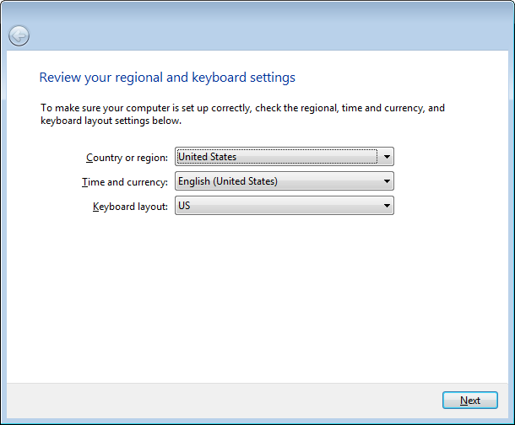
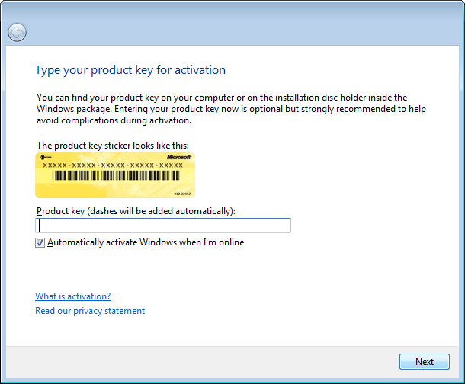
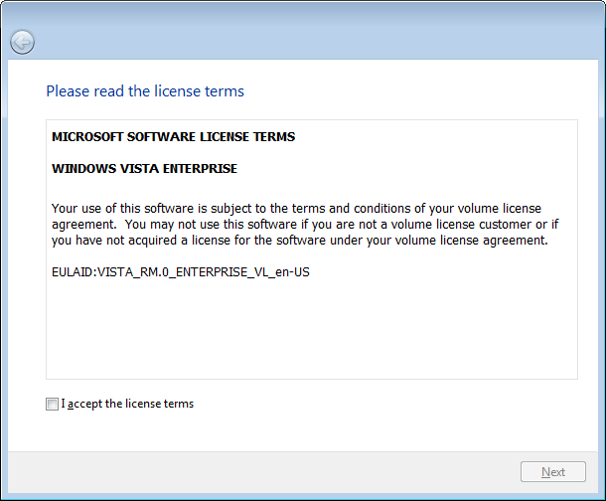
Get Going Quickly
You’ll get through the Windows 7 setup experience and reach the desktop in about ten minutes without multiple restarts. Your first experience focuses on getting the PC running and on a network. After completing the setup experience, the desktop feels organized and clean.

Faster Initial Setup Experience
In Windows 7, WinSAT – the tool that assesses the hardware performance of your PC – no longer runs during setup, shaving minutes off the overall time to set up your computer. Tasks that aren’t vital to getting you set up and connected to a network have been removed. After setup, you’ll have opportunities to personalize your experience and change things like glass color, login screen background, sounds, and desktop background slideshows.

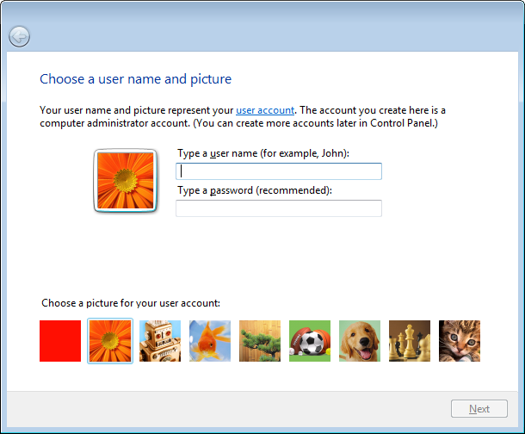
First Experience
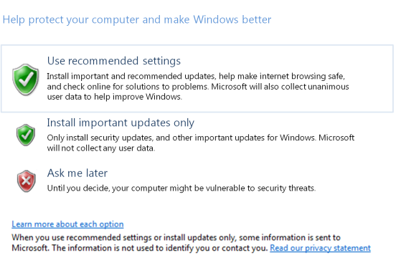
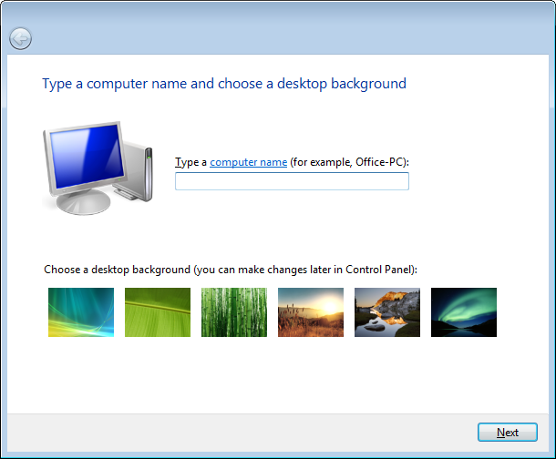
You’ll be guided through a set of choices for choosing a language, creating an account, accepting the licensing agreement, choosing regional settings and your time zone, and turning on Windows Update. If your computer has wireless network capabilities, you’ll be able to connect to your wireless network. After connecting to a wireless network or if the PC already had a network connection, you can also create or join a homegroup. The network connection will have been made and you can start sharing files and printers with everyone in your home network.

Windows Easy Transfer
Windows Easy Transfer (WET) in Windows 7 makes it easy for you to move files, folders, program settings, and system settings from your old PC to your new one. You can choose individual files to move, and Windows 7 even tells you how to get the latest version of programs that you’re using on your old PC. If you’re adding a second computer to your home, the new file explorer in WET let’s you see files on other computers and pick and choose only the ones you want to copy to your new PC.
Maybe you want to copy some files from your old PC to a secure file archive and only move recent content over to your new computer. WET makes it easy for you to make those choices and put some data in storage and move other files to your new PC. If anything fails to copy properly during the migration, WET shows you a complete report and gives you the option to try again. When you’re done, WET gives you a list of all of the files that have been transferred and their new locations. You can even save the report on your new PC so you can refer to it later.

Windows Anytime Upgrade
You can easily add features available in premium versions of Windows 7 even if those versions didn’t come with your original computer and without performing a major upgrade. All Windows 7 features come wrapped within a single package on your PC, so upgrading is just a matter of unlocking those features. For example, if you purchased a PC with Windows 7 Home Premium edition and want some features that are available in Windows 7 Ultimate edition, you can upgrade without needing additional discs or performing a complete system upgrade. You simply need to get a key to unlock the new features – you can purchase one on the web from Windows Online, or you can buy one from a retail location. Once you get your key, Windows Anytime Upgrade helps you quickly unlock the new features you want and within a few moments you can start using them.

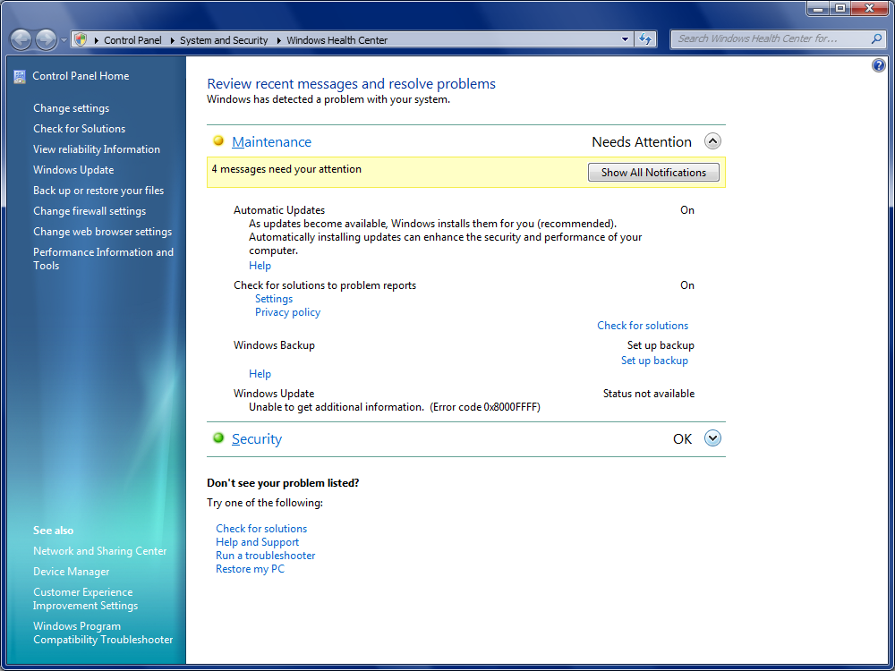
Windows Solution Center
Finding out what to do when there is a problem with your PC is much quicker and easier in Windows 7. The Windows Solution Center is a new, integrated experience in Control Panel that gives you a central place to go for tasks and notifications associated with keeping your computer running smoothly. The Windows Solution Center makes it easier for you to fix problems yourself by providing a new streamlined experience for addressing notifications and including links to relevant tasks so you can quickly find the right solution. You’ll notice a new icon in the System Tray of your computer. This icon indicates when there is a new issue that needs your attention. You can find out more about the problem by clicking the icon, or you can go to the Windows Solution Center where you can view other notifications and options.
You’ll see fewer notifications on your desktop in Windows 7 because the Windows Solution Center consolidates alerts from ten existing Windows features into a single location. Alerts and information are gathered from Security Center; Problem, Reports, and Solutions; Windows Defender; Windows Update; Diagnostics; Performance Tools; Reliability Monitor; Backup and Restore; Recovery; and User Accounts.

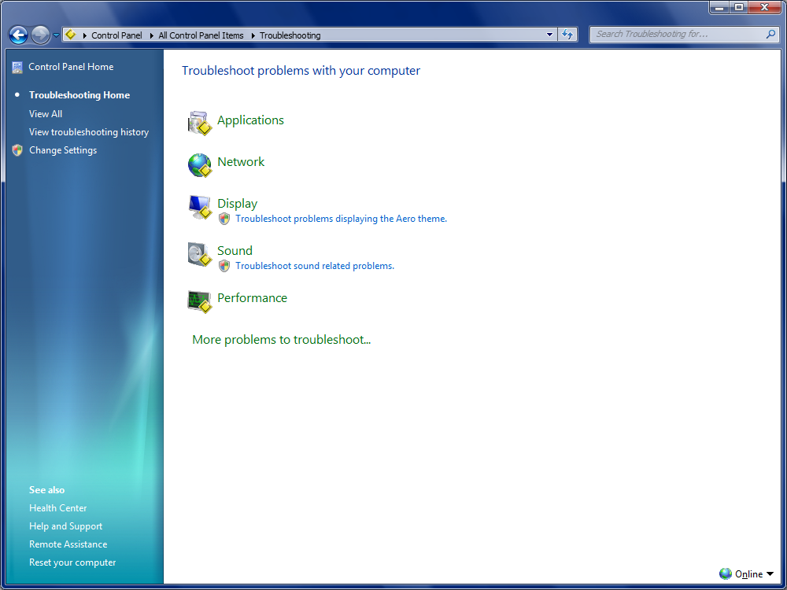
Windows Diagnostics
The Notification Center is a new feature that guides you through steps to diagnose and resolve common computer problems. It also offers you diagnostic tools to troubleshoot PC problems. If you don’t find a solution, you are guided to other resources like Help and Support, Windows Community, Remote Assistance, or System Restore to help you resolve the problem.
In addition to the diagnostics that are included with Windows 7, the notification center will show you new and updated diagnostics available on the web. These updates are provided by Microsoft or other hardware and software providers.

Scheduled Diagnostics
Some diagnostics that come with Windows 7 will run automatically in the background and on a scheduled basis. These tools will let you know if they discover a problem and offer potential solutions in the notification center.

Reliability Diagnostics
If a reliability issue occurs on your PC (if your computer shuts down unexpectedly or becomes unresponsive), you can download a diagnostic from Microsoft which can run on your PC and, in many cases, fix the issue that is causing the problem.

Problem Reporting and Solutions
When you receive an error message that offers you the option of telling Microsoft about the error, just one click sends a report to Microsoft. If a solution is available for the error, Microsoft will tell you how to apply that solution to prevent the problem from happening again. Windows 7 makes it even easier for you to see the list of reports you’ve sent by integrating these reports with the notification center.

Improved Backup and Recovery
It’s very important to back up your data on a regular basis, and Windows 7 helps you set up backup settings in three quick clicks, capturing all your personal files and system files. You can easily set a regular schedule, so you no longer have to remember to back up your PC. You can back up everything or just specific files, and you can choose a number of advanced backup options, including backing up files to a network and doing ad-hoc system backups to DVD.
Windows 7 has also improved the restore experience. You can restore individual files, selected folders, or all your personal files. Windows 7 also lets you reimage or restore your entire PC from a recent backup in the event of a hard drive failure or the presence of malicious software..

System Restore
System Restore provides a non-destructive way to return your PC to a previous point in time without deleting any of your personal files. System Restore is more reliable, predictable, and effective that ever before. When you use System Restore in Windows 7, you’ll see a list of programs that will be removed or added, giving you clearer information about which restore point to choose. Additionally, system restore points are not only stored on the internal drive, but are also available in your backups, giving you a larger list of points in time to roll-back to.

The State Of Consumers and Technology Benchmark, Forrester, 2006.

