

Windows

Internet Explorer® 8

NOT LCA APPROVED
NOT FINAL ART
NOT FINAL FEATURE NAMES
Last updated: 6/18/08

Introduction

Browsing the web is the most popular activity on the PC, and both the amount of time people spend browsing and the range of things they’re doing are increasing. And this growth seems only to be exceeded by the rate of the web’s change itself. It’s moved from a collection of mostly static pages to a dynamic network of interwoven services characterized by communities of users, the lightning-quick exchange of information, rich and interactive experiences, rapidly updated content, and more local and personal relevance.
In late 2006, Internet Explorer® 7 introduced:
- Security improvements
- The flexibility of tabbed browsing
- The convenience of a built-in Search box
- The power of integrated RSS Feeds.
And more than 100 million people have downloaded the browser and taken advantage.
Now, with Internet Explorer® 8 (IE8), Microsoft reinforces its commitment to the Windows community by creating the best possible web experience and delivering advances in each of the following seven areas:

Safety and Trust
The web can be a dangerous place. There are sites out there with bad intentions that attempt to trick us or to run malicious code on our computers to steal our data or track our actions. Safety will always be a priority for Internet Explorer, and IE8 bolsters security by including a set of core safeguards to prevent attacks, including a new filter to identify malicious sites and block the download of malicious software.
Privacy is another key aspect of safety. IE8 helps protect our privacy from sites that attempt to track us as we browse the web and from other users of our PC that we might not want to see our web history.
IE8 builds confidence and earns trust with its significant improvements in stability, reliability, and recovery. IE8 works reliably, and it’ll recover easily and quickly if a problem ever occurs.

Speed and Efficiency
When you upgrade from a previous version of Internet Explorer to IE8, you’ll immediately notice a big improvement in performance:
- Startup is faster
- New tabs are created in a snap
- Websites load and run much more quickly
Less waiting means the whole web browsing experience is more immediate—friends and family feel closer, information appears faster, and getting to the content that’s personal and relevant to you is easier.
IE8 makes this all happen with significant improvements to the Address Bar, search capabilities, Tabs, and Favorites Bar. A faster browser combined with less effort getting to sites means you’ll be more efficient.

Reaching Beyond the Page
Most of us use several websites and services each day to get the information we need. IE8 introduces Activities, WebSlices, and real-time search results – three innovative features that reach beyond the page we’re currently browsing to the larger network of our favorite sites and services. Here’s how:
- Use Activities to take direct action on information as you encounter it on the web – a definition, a search, a map
- Make WebSlices monitor the information on key sites that’s important to you
- Take advantage of the improved Search Box. IE8 now lets search providers deliver rich results and suggestions as we type.
These new features are all easy to use, either separately or together, and they make finding information faster and more fun.

IE for Everyone

Productivity for Developers
When web developers’ jobs get easier and more interesting, the web gets better for everyone. To keep up with the rapid pace of change on the web, and help developers get the most out of their talent and efforts, IE8 includes a new layout engine, an improved script engine, and a new set of tools for web developers.
Taken together, this work delivers on our commitment to embrace web standards and provide a platform on which developers can create innovative and effective sites. This work benefits all of us because it ensures that IE8 will provide great experiences on the newest and most powerful sites.

Compatibility
None of the improvements or new features in IE8 will matter if websites look ugly or don’t work properly. IE8 ensures full compatibility with the existing web by including the IE7 layout engine in addition to the new engine. Websites and developers have the ability to select the appropriate engine to ensure compatibility.

IE at Work
People use the web wherever and whenever they use their computers: home, work, and almost anywhere in between. The security, performance, and user experience improvements in IE8 can benefit everyone, including IT professionals and
system administrators who have unique software deployment, security, servicing, and customization needs. IE8 has a range of improvements directed at business use and browser management in corporate environments, from new installation methods to increased customization control through policies. IT pros have the level of control they need to help make the best decisions for their environments.

Read on for more detail—feature descriptions, usage scenarios, and (of course) pictures – about each of these seven major areas. By the end you’ll understand just how IE8 will improve by changing the way you experience the web.

Safety and Trust

Your web browser must be a tool you can depend on every day: one that safeguards your web browsing, is fast and resilient, and works the way you’d expect it to.
IE7 included a number of security advances, but for every advance there are hackers that attempt to defeat the protective measures, confuse users, and compromise private data. IE8 marks the next level of our commitment to safety with stronger security and privacy measures, and increased stability and reliability.

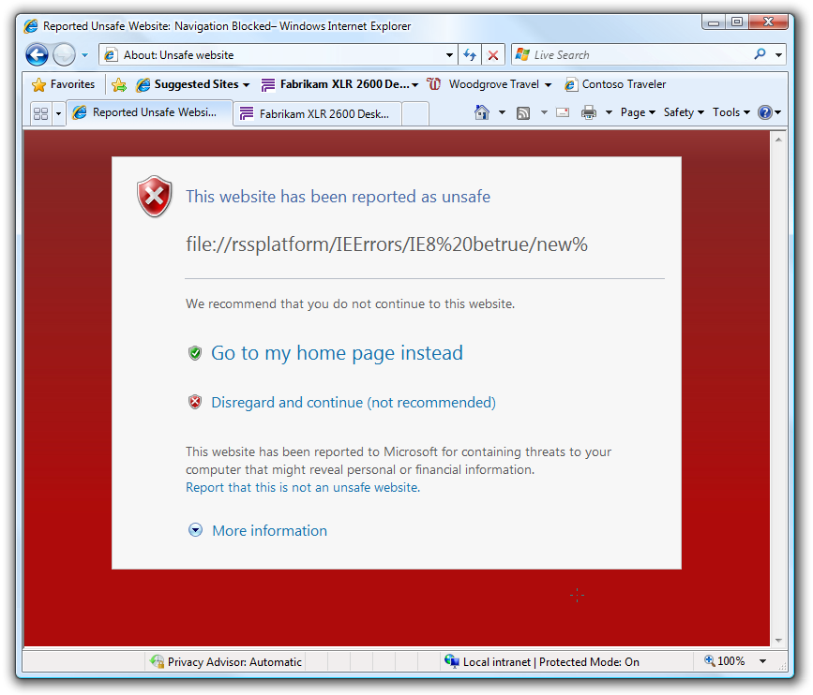
Security
Here’s a closer look at the numerous security
enhancements in IE8.

Safety Filter
IE7 introduced an anti-phishing filter that helped people avoid fraudulent websites. IE8 increases protection by pairing our anti-phishing protection with an anti-malware tool we call Safety Filter. It warns you if you’ve reached a site that is known to distribute malicious software. And if you think you’ve come across a website that’s up to no good, you can use the tool to help improve the web for everyone by reporting sites that have malicious downloads.
IE8’s new SmartScreen helps you avoid
unsafe sites.

ActiveX Protections
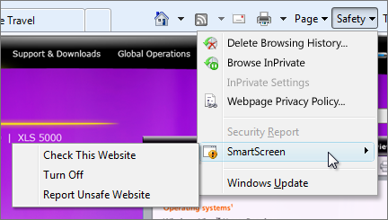
ActiveX controls are add-ons for Internet Explorer that many popular sites use to provide features such as media playback, animations, and interactive experiences. They’re powerful and useful, but some add-ons can also be used maliciously by some sites. IE7 improved security by asking your permission before installing ActiveX controls. This let you decide to accept ActiveX controls only from sources that you trusted. However, once a control was installed by a trusted site, malicious sites could access and use that control. In IE8, ActiveX controls are only available to the site that downloaded them. Other sites will have to ask your permission before accessing these controls.
There will be an exception list for the most widely used legitimate ActiveX controls. .
In corporate environments, IE8 makes it possible for ActiveX controls to be managed on a per-user basis, without security or administrative prompting. This improvement allows IE8 to be deployed and managed more easily in these environments.

Address Bar Domain Name Highlighting
When you launch IE8 and go to any webpage, you’ll see that the domain name is bold in the Address Bar. The domain name is the core part of the web address that identifies the true source of the page, and the bold text makes it easier to distinguish legitimate web addresses from fraudulent sites that use confusing domain names to try to trick you into visiting and giving you’re your personal information. For example, http://www.fabrikam.com is the real site for the company named Fabrikam, while http://www.evil.com/fabrikam is fraudulent. This is a simple thing, but it provides clarity and a first level of protection between you and malicious websites while you’re browsing.

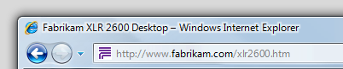
Domain highlighting makes it easier to confirm legitimate web addresses.

Additional Security Protections
As web technologies increase in complexity, so do the number of ways malicious hackers attempt to seize control of your PC and get to your personal data. IE8 improves safety by including protection from three of these types of security attacks:
- IE8 protects against Cross-Site Scripting (XSS) attacks in which one site attempts to introduce script code into another site using your computer
- IE8 uses Data-Execution Prevention (DEP/NX), which makes it impossible for a site to download an executable program file disguised as a picture or video and then secretly run it on your computer
- Some websites use information from more than one source (domain), which can compromise security, so IE8 uses Cross-Domain Requests (XDR) in a way that allows sites to better safeguard private data.
IE8 protects against these types of attacks without compromising your ability to freely browse and interact with the web, and now you can feel a little safer while doing so.

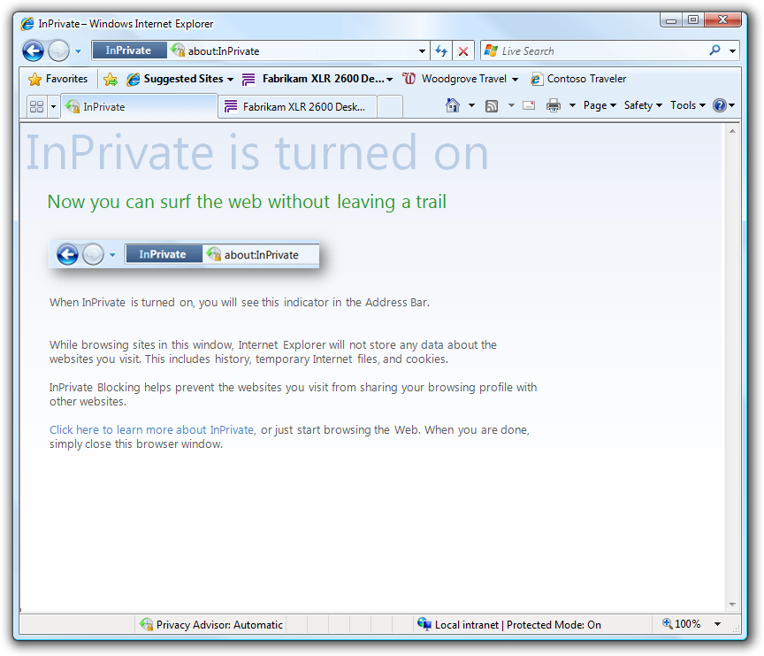
Privacy
Most people understand that websites track the use of their pages and content. Often, this has no impact on your web browsing. But what if you’d like to use the web to shop for a gift and you’d prefer that no record is kept so the surprise isn’t spoiled for a family member? And what if you’d just rather have more control over which sites track your usage?
With more and more webpages using dynamic content on their sites, increased hidden connections exist among webpages and between webpages and databases. These connections are behind the scenes. No one asks if you care about being tracked, and you’re not aware of what the sites might do with that data. IE8 makes you more aware and gives you greater control over how your web use is tracked so that your web browsing can be entirely your own.

Caption goes here

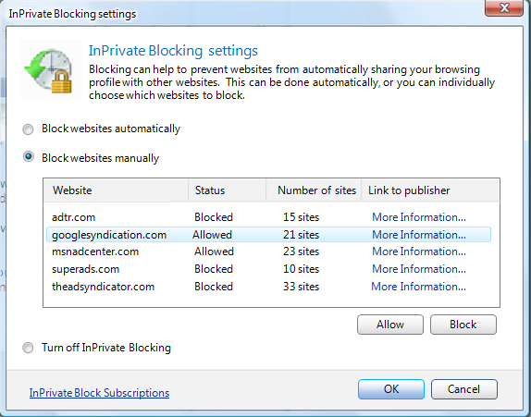
InPrivate
Imagine you want to shop for a gift on your family PC and leave no evidence of the search – no history, no cookies, no ruined surprise. IE8 has a new privacy mode that will respect Parental Controls settings and keep your family safe, but won’t record any session information and leaves no evidence of searches or page visits. You just open a new tab, and then select Private Browsing. All your actions while browsing using that tab will not be recorded.
IE7 had a robust Delete Browsing History feature to clean up the browser. Users could choose which browser content to delete or to delete it all – cookies, add-ons, history, and temporary files. In IE8, deleting content is improved so that it is more respectful of your preferences. When you delete in IE8, you can choose to preserve the data from the sites in your Favorites. That way, the cookies and temporary files you rely on most stay in the browser and don’t impact your day-to-day use of the web.

Privacy Advisor
A subtle form of privacy loss can come from surveillance of web usage. While you might expect that a site knows when you visit, the site can include content from other websites that might also track your visit without any indication that they are doing so. . As a result, a website can track your browsing behavior across those sites and build a rich history of your web browsing – without your awareness or consent.
IE8 includes Privacy Advisor, which assesses your exposure to third-party content. When a site passes a certain threshold for exposure, you’ll receive a notification and a privacy report. The report shows the sites that are delivering content to the site you are viewing. You can choose to learn more about those sites, or block certain content providers on a particular site or for any site, or to turn Privacy Advisor off.

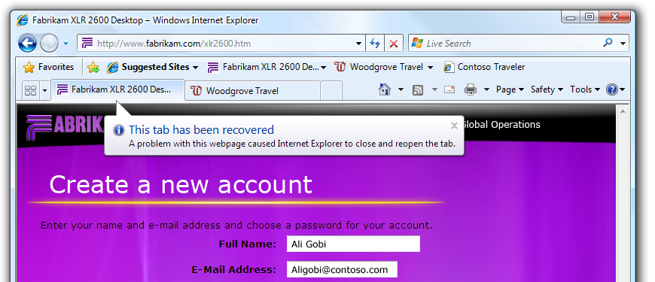
Stability and Reliability
IE8 is the most stable browser, period. While IE8 reduces the likelihood that you’ll experience a crash, the web still has many malicious sites, errors in the computer code used to create websites, and unstable add-ons that can cause the browser to crash or hang. IE8 is often able to withstand unstable webpages and to recover from crashes gracefully and automatically.

Tabs recover automatically in IE8

Resiliency
If a bad add-on or an error on a webpage caused a crash in IE7, it generally caused the entire browser to crash; all open tabs were affected.
IE8 was created so that the tabs and the program’s “frame” are largely independent of one another. This means that if a site or add-on causes a tab to crash, only that tab is affected. The browser itself remains stable and usable, and other tabs remain unaffected.
The Automatic Crash Recovery feature in IE8 does just what it says: a tab that crashes will be restored to its original state automatically. If the browser were to ever crash or close unexpectedly, all tabs will be restored. And if you are entering information on a webpage, such as writing an e-mail or filling out a form, and the page crashes, IE8 will recover the information you’ve entered when it reopens the page. And what if you close a tab accidentally? IE8 reduces that frustration by restoring recently closed tabs from the New Tab page.

Management of Add-Ons and Toolbars
Add-ons, including ActiveX controls and toolbars, are extensions to IE that can be distributed by websites. Most add-ons are useful and of high-quality, but the occasional improperly written or dated add-on can cause performance and stability problems. And once a bad or older Add-on is installed and running, it can be difficult to get rid of. IE8 helps in two ways.
For toolbars, IE8 adds a close button. Any active toolbar will have a close button, just like any window. This is particularly useful if you accidentally download a toolbar that you don’t want or if you find yourself with more than one toolbar turned on at the same time. Click the close button, and the toolbar both closes and is disabled. Disabling stops the toolbar from performing tasks that might be invisible to you but which could slow down your PC or track where you go and what you do on the web. Some toolbars come with additional add-ons, and IE8 will ask if you’d like to disable those, too. If you accidentally close and disable a toolbar, it can be always be turned on again.
In rare cases, an add-on can cause the browser to crash every time it’s launched. IE8 includes an improved No Add-ons Mode to allow you to break such a cycle if you encounter it. When you start IE8 in No Add-ons Mode, it launches in a stable state. From there, you can select Manage Add-ons from the Tools menu and determine the cause of the problem.
The best way to reduce exposure to out-of-date ActiveX controls and toolbars is avoid them from the beginning. When you upgrade from IE7, the IE8 Upgrade Advisor will notify you if any of your add-ons are out of date and help you install the latest ones. This will make IE8 faster and more stable right from the start.

Speed and Efficiency

As we spend more time online doing new and creative things, the importance of speed can increase exponentially. Speed has a big impact on your web browsing experience. A simple task like checking your e-mail – open the browser, open a new tab, go to your e-mail site, log in, and check your inbox for new messages – can feel interminable with a slow connection or a slow browser. Multiply this slowness by the numerous tasks that you do online each day, and the importance of speed becomes very clear. A faster browser not only saves you time, but it replaces frustration with satisfaction and gives you a much greater sense of efficiency and satisfaction.
This section is called “Speed and Efficiency” because overall speed is both the cumulative effect of the raw performance of the browser and the directness with which it allows you to get things done. IE8 delivers on both with significant improvements in browser performance new features and improvements in navigation.

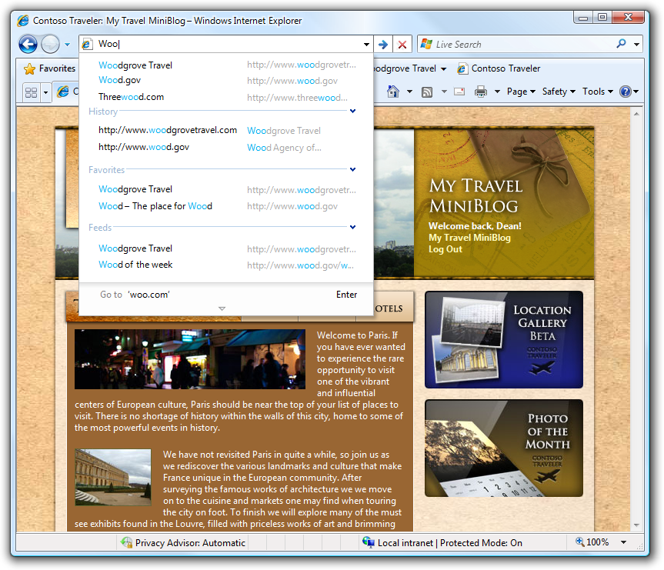
Performance

Performance improvements are hard to quantify in a product guide: how can we convey speed to you with a still image? But when you use IE8, you will notice that it is significantly faster than IE7 in the areas that matter the most – initial progam launch, opening a new tab, loading pages, and executing script. These improvements in browser responsiveness and site performance make web surfing feel more smooth and satisfying.
The address bar suggestions help
you get to sites quickly.

Scripting
For IE8, script execution is particularly important because of the prevalence of scripts on the web. A script is a set of instructions that can customize or add interactive features to a program, such as a browser. Increasingly, the most interesting and popular websites are using scripts to bring content into the site dynamically. That means that the browser has to do more than show static text and images, it has to be able to read and act upon the scripts for each webpage. The improvements to IE8 allow it to work even better with scripts, and this significantly increases the performance of dynamic, heavily scripted sites.

Faster Pages
[Need description of networking improvements].


An Efficient Experience
[NEED new Level 2 Head = “An Efficient Experience” = which will cover the UX improvements that make for a more efficient browser]

Need a screen and caption for this

Address Bar

At its core, the Address Bar in IE8 works as it did in IE7. You enter a web address (URL), click the Go button, and the page loads. But the Address Bar in IE8 has been improved to make navigation easier and to minimize the need for you to enter full web addresses to get to your destination.
In IE7, the Address Bar included a drop-down window that matched the address you typed with sites that you had been to before. As you typed, the list was narrowed to include just the sites that matched each character, and you could then click on a site from the list and go there directly. That worked well, but it has a drawback: sites had to match the characters from the beginning of the address (after the www). For example, suppose you had been to the site http://www.contoso.com/travel/cruise last week. Now, you want to go back to the site to continue your vacation planning. In IE7, you could enter the word “cruise” and not get any results in the Address Bar drop-down menu because those letters do not appear at the beginning of the URL.
IE research tells us that a lot of navigation in the Address Bar is to sites that the user has been to already. And because it’s hard to remember addresses precisely, there were many times where the IE7 Address bar was not helping people reach their destination quickly. In IE8, the Address Bar drop-down menu includes matches from anywhere in the address (not just the beginning) or the site’s title, and it also searches your Favorites, RSS Feeds, and History. So, if you enter “cruise” into the Address Bar of IE8, you’ll see the site you visited last week (http://www.contoso.com/travel/cruise) plus any others where the word cruise is included in the address or site title. And as you type in the IE8 Address Bar, the matching characters in the drop-down menu are highlighted in blue so you can see the match at a glance.
There’s one additional improvement to the Address Bar. If you type an address incorrectly in IE7, you will continue to see wrong address in the Address Bar drop-down menu. There’s no way to get rid of such a mistake once you make one without deleting every address that’s been stored. But in IE8 you can mouse over any address in the drop-down menu and delete it. This might seem like a small thing, but it eliminates a real annoyance and makes browsing much more pleasant.
The Address Bar is now a powerful and friendly search tool for your Favorites, History, and RSS Feeds. .

Favorites Bar
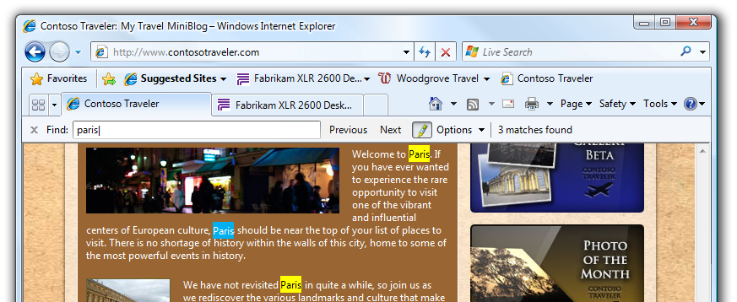
The Favorites Bar appears across the top of the browser, just below the Address Bar, and you can use it to directly and quickly access the sites you use most often. Think of it as a place for your favorite Favorites.
The bar is on by default and the Favorites button is more clearly labeled than in IE7.

In addition to links to Favorites, you can now add RSS Feeds and WebSlices (discussed below)to the Favorites Bar, making it the most useful spot to get directly to the sites and content you care about most.

Find on This Page is now
integrated.

Find On This Page

IE8 includes a completely redesigned Find on This Page feature. The Find dialog box in IE7 worked, but it often obscured the page. The new tool is a seamlessly integrated bar below the tab row, so it does not block any of the page. And instead of waiting for you to type the entire search term and press Enter, IE8 searches on a character-by-character basis as you type. The total number of matches is shown on the bar, along with buttons to navigate to the next or previous match, and the matches are highlighted in yellow so they are easy to spot.
The new Find on This Page feature is also linked to the Search Box in IE8. A common search activity is to enter a term in the Search Box, look at the search results, click the one that looks promising, and then try to find the original search term on that page. When you open the Find on This Page tool in IE8, the last term you entered in the Search Box is automatically copied to it and the matches on the page are highlighted. This streamlines a common search task and makes browsing the web a little more efficient.

Tab Groups
As people become more accustomed to tabbed browsing, they’re more likely to have multiple tabs open at the same time. Often, a link from one webpage will open a new tab, and it can become difficult to understand which tabs are related and which are independent. IE8 introduces Tab Groups to reduce this confusion and increase the benefits of tabbed browsing.
In IE8, when a new tab is opened from a webpage, they’re grouped. That is, the new tab opens beside the first tab, and both are marked with a color bar on the tab row. You can quickly see which tabs have related content. If you close a tab that’s part of a group, you will stay within the group and within the context of your current task rather than find yourself suddenly looking at an unrelated tab.
If you right-click any tab, you can close it or the whole group. From that same right-click menu, you can also reopen the last tab you closed or see a list of recently closed tabs and reopen any of them. This comes in handy if you accidentally close a tab.

New Tab Page
When you open a new tab in IE7, you get a New Tab page that looks similar to a 404 website error page. It makes sense that when you open a new tab, your next step will be to navigate to a page. So in IE8, the New Tab page has been redesigned to offer a number of useful actions to help you take that next step.
From the New Tab page, you can connect directly to any Activity (more about this below) or you can start a Private Browsing session. Just click Private Browsing and that tab will be a self-contained session that doesn’t leave any tracks (but does respect Parental Controls).

Dynamic Content: A Better Back Button
If you use the web frequently, you’re experiencing more and more websites that use AJAX technologies. Sites that use AJAX use JavaScript and XML (the J and X in AJAX) to make websites more interactive and dynamic. These sites function more like programs than static webpages. For example, many mapping sites use AJAX for panning and zooming their maps smoothly and without having to reload the webpage.
But if you’ve ever tried to use the Back button after you’ve panned across a map and zoomed in and out a few times, you know that it doesn’t work as expected. Rather than take you back to your last view of the map, the Back button takes you off the map completely and back to the previous webpage you were viewing. And if you then use the Forward button, you’ll be at the starting point on the map rather than the place where you left off.
IE8 fixes this problem If sites comply with the HTML5 standard, the Back button in IE8 will bring you back to your last action, just as you’d expect.

Zoom
The Zoom control in IE7 is optical, which means that it increases the page as if you were looking at it through a magnifying glass. This works fine, but it causes the dimensions of the page to increase so that it no longer fits in the browser window. Zooming in IE7 often involves using a combination of vertical and horizontal scroll bars to reach all the zoomed content.
In IE8, the Zoom control is not optical. Instead, it resizes the text and images and then arranges them so they fit in the original dimensions of the page. As a result, a zoomed page is easier to read and use. No more scrolling!

Import Settings
IE8 makes it fast and easy for Firefox users to get up and running. As part of Setup, IE8 can import your Firefox Bookmarks into Favorites. If you miss your chance in Setup, you can always import your settings later.

Reach Beyond the Page

Today’s web is about a lot more than just finding or browsing information. Sites have services that help you get things done and communicate with anyone in the world. Web searches, auction sites, web-based e-mail and calendars, social networks, photo sharing sites, stores, mapping sites, blogs, news and weather sites, games – there are now web counterparts to almost every traditional activity. IE8 takes you beyond static webpages and kicks open doors to new web services, resources, and experiences.

Effective Search

When you enter a search term in IE7, it’s passed from the Search Box to the search engine of your choice and you see the search results page from that provider.
The Search Box in IE8 looks very similar, but it’s much more helpful. As you type a search term you’ll see real-time search suggestions from the provider. These suggestions show you common searches related to the words type. You can click the suggestion at any time and immediately perform the search (without having to type the entire word or phrase). Not only does this save typing time and a click or two, but it’s more likely your search result will be what you’re looking for, and that’s going to save you even more time.
IE8 allows the search provider to deliver more than just suggested terms as you type. The provider can also deliver direct results and images that can give you immediate answers. For example, if you enter a stock ticker symbol, the search provider could give you a stock quote with a chart right there in the Search Box drop-down menu. IE8 provides the technology, but the choice of what to show is made by the search provider. This allows the providers to innovative, and that’ll create a greater web experience for you.
If you know you’ve been to a website before and your search provider’s results are helping you find it again, IE8 includes result matches from your history in the bottom part of the Search Box drop-down, just below the search provider’s suggestions. As in the Address Bar, you’ll see matches from either the address or the site title.

Activities: Easy Access to Relevant Services

With the huge increase in web services and sites that do amazing things and present information and ideas in exciting new ways, you’re less likely to sit back and passively let the website control what you see and how you interact with the information. It’s much more likely that you’ll want to take action on what you are reading, seeing, or hearing. You might find an address and want to see it on a map or come across a distance in kilometers and want to convert it to miles. You might see a product and want to check its price, or read an unfamiliar word and want to look up a definition.
Today you can do these things on the web pretty easily. You select the text you’re interested in, copy it, go to the service you want (such as a mapping site or an image search site), paste in the information, click a button, and then see the result. You can return to your original page and get back to what you were doing.
Activities are a way to automate this process by integrating services right into IE8. Instead of doing all those steps, you just select the text you’re interest in, click the Activities symbol, and then select the desired activity. For example, you might select a street address, click the Activities symbol, and then select Map It.
Some Activities give you the information you want in place, in a little fly-out window that appears over the page. For these, you just hover over the Activity in the list and the fly-out will appear with the requested content. If you click an Activity, you go directly to the site and see the information.
You control which Activities are turned on and which service providers are used. You might prefer to get image searches from one provider, maps from a second provider, and e-mail from a third. No problem. It’s easy to create, change, remove, and edit these choices in IE8.

WebSlices: Easy Access to Relevant Information
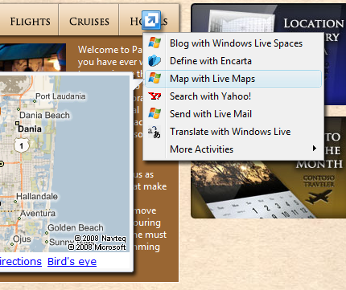
How many times a day do you use the web to check for information you’re going to want to know on a regular basis? Maybe it’s the weather, a sports score, your e-mail, a stock quote, an auction, a blog, or the news. It’s a manual process. You don’t know if there’s anything new, so you have to go to the sites and check. It can steal your time.
A few years ago, an important, new technology standard called Really Simple Syndication (RSS) was introduced that delivers web content directly to you. With an RSS Feed you can subscribe to content from a site. Most new sites and blogs have RSS Feeds that send you story headlines or blog subjects. When you subscribe, IE8 (or a specialized RSS Reader) polls the target site periodically to see if new content has been posted. If it has, then that content is delivered to you. .
IE8 builds on the IE7 RSS platform with a new feature called WebSlices. WebSlices are an easy way for you to get relevant information. You can these if the sites you check frequentlyhave changed, right on the Favorites Bar. And previewing the new information will help you decide whether to visit the site.

WebSlices bring content to
you in context

In IE8, WebSlices use the same underlying technology as RSS. But the difference is that a WebSlice lets a site mark up a slice (or piece) of a page for subscription, and the slice can include visual elements from the page.
For example, eBay has created a WebSlice to monitor auctions. If you’re interested in following an auction, you can subscribe to the eBay WebSlice and get periodic updates on the auction status and see a portion of the auction webpage. For a WebSlice from a weather provider in Barcelona, it might include the latest conditions and an image from a weather camera. If you click the preview, you go directly to the site to see more details.

Sites can create WebSlices with the addition of just a few lines of markup code to their existing pages. As with RSS, IE8 will indicate the availability of WebSlices on a page and allow you to subscribe to them and add them to the Favorites Bar with just a couple of clicks. If you no longer want to monitor a site, it’s easy to delete WebSlices.
Activities allow you to take content that you encounter and go out to web services to take action on that information. WebSlices allow you to monitor important sites by actively bringing status updates to you. In each case, IE8 has integrated with web services in way that allows you to reach beyond the page and more effectively use the power of the web.

IE8 for Everyone
As the Internet expands its reach – both geographically and the total number of people that use it – web browsers have an increased responsibility to ensure that everyone with a PC and an Internet connection has a great web experience. IE for everyone is a statement of purpose for people from locales around the world, as well as for people of varying visual abilities. IE8 ships in XXXX languages and locales to ensure web browsing is as familiar as the local language. And IE8 has increased support for accessibility standards that improve web browsing for the visually impaired.

Accessibility

When we talk about accessibility in the browser, we mean the set of assistive technologies that make it possible for people to use the browser and have a great experience on the web. Specifically, it has been difficult for people with vision impairments to use the web.
People with vision impairments can use assistive technology software called screen readers to help them user computers. Screen readers analyze the elements on the screen and read the content to the user, including the choices users have to navigate. Until now, it has been difficult for these tools to understand and correctly identify elements on a webpage. For example, an image on a webpage can sometimes be a button, sometimes it’s a picture of a person, and sometimes it’s an advertisement.
IE8 includes support for two important accessibility frameworks: Accessible Rich Internet Applications (ARIA) and UIA (User Interface Automation) Express. ARIA is expected to become a W3C standard in 2008, and UIA Express is a .Net-based solution that is supported by Microsoft.
IE8 supports both frameworks, giving developers of both assistive technology software and of websites the tools they need to better help people with visual impairments. Many assistive technologies already use Microsoft Active Accessibility (MSAA) program interfaces to help users. IE8 will expose ARIA through MSAA, meaning that existing assistive technologies that use MSAA will be able to quickly and easily take advantage of ARIA to deliver more powerful tools that result in more accessible websites.

Productive for Developers

Web developers create the amazing sites and services that define today’s web. To get these great experiences, IE has to be a great browser for developers.
IE8 makes web development easier and more efficient in ways that enhance the web experience for everyone. IE8 focuses on interoperability – on making it easier for developers to write one set of code that works great on many browsers. IE8 has a new layout engine that is compliant with today’s web standards and a developer toolbar that delivers a suite of powerful tools to aid in the creation and optimization of webpages.

Browser Interoperability

When different browsers interpret webpage code (markup, style sheets, and script) in different ways, a website can look great in one browser and broken in another. Developers want their sites to work well for all browsers. This requires developers making choices between coding that is unique for each browser – a lot of extra work – or limiting themselves to code that behaves consistently across browsers, which limits the experience. The greater the differences between browsers, the more extra work they have to do or the greater the limitations they have to accept.
Web standards have emerged to address this problem. If all the browsers interpret pages in a standard way, and if developers write their code according to the standards, then developers aren’t forced to make choices between efficiency, productivity, and building great experiences. They can spend more time building great experiences that work as expected in any browser.
One of the most important web standards is CSS2.1, which describes the style of a webpage, including fonts, colors, and (most importantly) layout.
IE8 includes a new layout engine that is fully compliant with the CSS2.1 standard. This means that websites written to the CSS2.1 standard will have consistent layout in IE8 and in other standards-compliant browsers. This is what we mean by browser interoperability. Web developers will write code once, and it will work consistently in all browsers. IE8 users will experience rich and high-fidelity websites that are in no way compromised by the browser.
IE8 standards compliance is evidenced by passing the Acid2 test, a web-based test page that uses a wide array of HTML and CSS commands to expose layout errors in browsers. While passing this test is an important indicator of compliance, we have encountered some places where the standards, as published by the World Wide Web Consortium (W3C), are ambiguous or confusing. So as a demonstration of our commitment to and support of web standards, the IE8 team has handed off more than 1,000 certification test cases to the W3C for use by any web developers or browser manufacturers. We’re sharing our interpretation of the standards specifications with the web community to invite discussion and advance the goals of a standardized set of certification tests and a fully standardized web.

Performance and Memory
IE8 has changed many of its browser subsystems (for example, the HTML parser, CSS rule processing, and markup tree manipulation) and overhauled the script engine to improve overall browser performance. Memory management in IE8 now mitigates memory leaks previously created by circular references between script objects and document object model (DOM)objects. The result is a faster, more stable web experience.

Developer Toolbar
IE8 has a new and comprehensive developer toolset for editing webpages and debugging and profiling web applications. You can access the Developer Toolbar by pressing Shift+F12 or clicking the Developer Tools icon in the Command Bar.
The toolbar gives developers the ability to edit and view CSS and HTML/XML, to test and debug script, to profile script performance, and to view and change the document object model (DOM). Instead of just the source view, you can get a view into the browser’s internal representation of the site, view script changes as they affect the DOM tree, examine applied rules, and trace the origin of style values.
In addition, the Developer Toolbar includes a down-level compatibility toolkit, which makes it easy to toggle between the new layout engine and the IE7 layout engine. You can now quickly identify changes that must be made to make sites work well with older versions of IE.
With these tools, you can iterate rapidly within IE. It’s easy to edit an attribute in the tree or change a style rule and see the results right away in the browser. By removing the need to move between applications, save, and refresh, the IE8 Developer Toolbar makes it easier to test designs, debug a problem, or just experiment and learn more about web development.

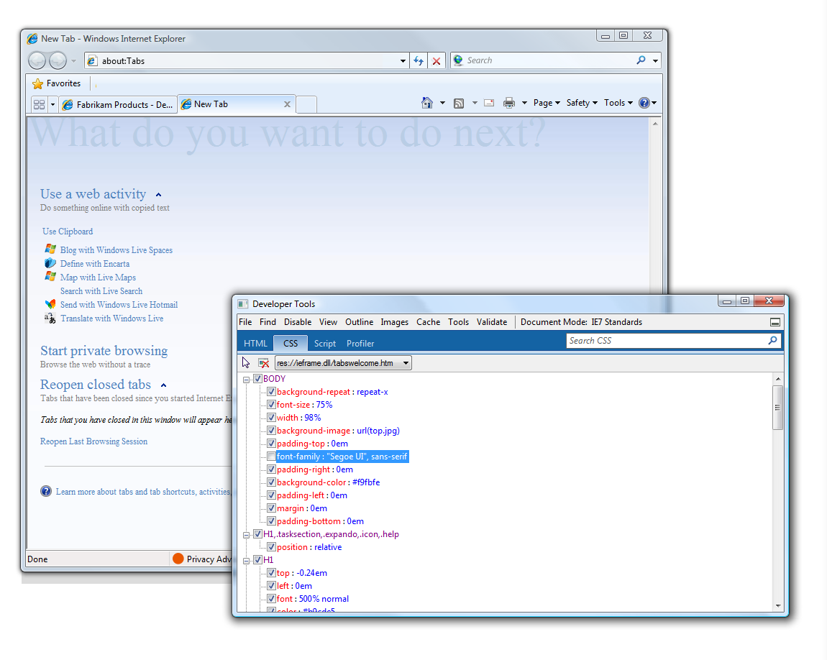
The Developer Toolbar will benefit everyone by making it easier for you to create, test, and fine-tune great websites that everyone can use.

Built-in developer tools in IE8

Activities and WebSlices
Earlier in this guide, we discussed two new IE8 features called Activities and WebSlices. Both of these features allow users to reach beyond the page by integrating web services into the browser.
But for Activities and WebSlices to deliver on their promise, web developers must build them and associate them with interesting and relevant websites and services. And for that to happen, the features need to be flexible and easy for web developers to create.
In IE8, Activities connect content from webpages to relevant web services. From a developer point of view, an Activity is defined with just a few lines of XML code. A developer of a web service can create an Activity in just a few minutes and make it available from their webpages through a script API (called AddService) and a pointer to the XML file.
It’s also easy to create WebSlices in IE8. Just a few lines of markup code on an existing webpage can create a WebSlice, and then existing RSS technology delivers the content to users who have subscribed to the WebSlice. Developers don’t have to create add-ons, and users don’t need additional code running on their computers to take advantage.
+ Resources
Web developers can visit the Internet Explorer Developer Center* to find white papers, sample code, and other information they need to use these new tools. http://msdn.microsoft.com/en-us/ie/default.aspx

Developers can easily associate their web services with an IE8 Activity and make it available from the Activities menu.

Compatibility

The new IE8 layout engine takes a leap forward by complying with web standards, which means you can create websites more efficiently, and they’ll operate more predictably. We built this new layout engine so that users will have the smoothest web browsing experience and developers can write one set of code that will run on the largest number of browsers.

IE8 includes two layout engines: the new standards-compliant engine and the existing IE7 engine. By default, IE8 will be in Standards Mode and use the new layout engine. The IE7 Mode will be there to ensure that any website that works in IE7 will continue to work in IE8.
There are several ways to invoke the IE7 Mode. A site developer can request to use IE7 mode with a single line of markup in their code. If an organization has an internal web-based tool that worked well in IE7, they can deploy IE8 with settings to use IE7 on internal sites and Standards Mode on the internet. You will be able to change the mode if you encounter a page with broken layout.
Over time, we expect more sites to comply with standards and IE7’s layout engine will be less necessary. Developers will be able to write one set of code that works great on all browsers, reducing time spent bending the markup to the idiosyncrasies of any browser (including, admittedly, older versions of IE), increasing the time available for innovation and the number of people that have a quality experience on the web.

IE8 at Work

All of the investments in security, performance, navigation, service integration, and code development and debugging in IE8 will benefit customers using the browser at home or at work. A more secure browser is a more secure workplace. A more efficient browser is a more productive workforce.
But IT departments also have unique security, customization, deployment, and management needs for desktops. IE8 can be deployed as a standalone program or as part of the operating system, and it has greater customization and management flexibility through policies.
IE8 also maintains Microsoft’s strong commitment to support. IE is supported for the life of the operating system, with dedicated, enterprise-level hotfix and security responses.

Standalone Installation
IE8 can be installed as a standalone program through a custom IE package (including an MSI installer) and deployed through a distribution service, such as Active Directory, WSUS, or SMS. The IE Administrator Kit (IEAK) provides you with all the tools and documentation you’ll need.
System administrators can choose to deploy:
- The full IE package (including IE8, customizations, and the MSI installer)
- A configuration-only package (including customizations and the MSI installer)
- ACD package (including CD Auto-run, IE8, and customizations)
IT departments can customize their version of IE8 –including the home page, Favorites, search provider, Feeds, and Activities – by adding IE8 customization settings to the Unattend.xml file that Windows uses for unattended setup.

Slipstream Installation
Slipstreaming is the process of integrating IE8 into a Windows install image. System administrators can now create a Windows image that includes IE8, so that computers throughout the organization get a Windows installation that includesIE8, and without any post-install work. IE8 installation uses the Windows Vista®/Windows 7 CBS install method, meaning IE8 slipstreaming is supported on both versions Windows.
Slipstream installation means that individual users will not be able to uninstall or manage IE8 as a separate program, improving the consistency and manageability of your organization’s computers. The Windows Automated Installation Kit (WAIK) has all the tools and documentation for slipstream installation.

Managing User Settings Post-deployment
You can centralize management of user settings by changing machine and user policies on existing deployments of IE8. By creating an IE Administrators Kit (IEAK) configuration-only package, system administrators can update security settings, user settings, and customizations, such as branding and other defaults.

Group Policy Enhancements
New features in IE8, such as the Developer Toolbar, will be configurable using Group Policy, as you’d expect. IE8 installs an ADMX/ADML file as part of the full package (XML version of the ADM files from previous operating systems), which allows system administrators to access the full range of IE8 policy settings and apply them within their organization through Group Policy Object (GPO).
IE8 has a number of additional Group Policy enhancements to simplify deployment, configuration, and customization:
- You can use Group Policy to determine whether IE runs in IE7 Mode or IE8 Standards Mode. This can be configured for specific websites and for security zones.
- You can support Activities and search providers using Group Policy, which allows you to configure customized Activities and search providers for all IE8 deployments or to entirely disable the feature.

Administrator Kit Enhancements
You can use the IE Administrators Kit (IEAK) to configure IE8 settings for your deployments. There are three licensing modes for the IEAK – Independent Content Provider (ICP), Independent Service Provider (ISP), and Corporate – to ensure you;ve got aversion that aligns with your specific customization needs.
All licensing modes benefit from IE8 improvements in the IEAK customization workflow, including the ability to customize a single setting, independent of a setting group.
You can use the IEAK to create custom, branded versions of IE8 that can be delivered as standalone packages or with other software or services, without having to install an operating system at the same time. You can update these custom versions without having to reinstall IE8.

