Internet Explorer 10
  - The entirely new Windows 8 browser
Tablets are here to stay, but until now no one has delivered a great browsing experience for them. Often, the focus has been on mobile devices themselves, the strengths and weaknesses of operating systems, and the plentiful world of apps. The browser is largely absent from the device discussion, but the web is actually more important than ever on mobile devices. The web on tablets has been an underwhelming experience: it’s slow, with features more closely aligned with phones than what people usually expect from a desktop browser. While most tablet browsers work with touch, they aren’t “touch-first browsers,” so the browser and the web don’t work great with your finger. Despite being one of the top activities, browsing the web has been a second-class citizen on tablets. Internet Explorer 10 changes all of that.
Internet Explorer 10 is the entirely new Windows 8 browser that is fast, fluid, and perfect for touch. It makes sites on your new Windows 8 device a first-class experience, right alongside apps. This is a first for tablets and it’s just one of the many things that differentiates Internet Explorer 10 from the browsers on other devices and the browsers that have simply been “made to work” on Windows 8. Internet Explorer 10 and Windows 8 provide a new experience that offers the best of the web and the best of apps on one device.
[image]

Contents
Fast and fluid 4
Perfect for touch 4
Easy 5
Safer 6
HTML5 8
Application Cache API (AppCache) 9
Asynchronous script execution 9
Drag and drop 9
File API 9
Forms 9
Parsing 10
Sandbox 10
Spellcheck 10
Video 10
Web Workers 10
WebSockets 10
CSS3 11
Device adaptation 11
Exclusions 11
Flexbox layout 11
Grid layout 11
Multi-column layout 12
CSS Regions 12
3-D transforms 12
Animations 12
Fonts 13
Gradients 13
Text 13
Transitions 13
Scrolling and zooming with touch 13
Specifying selectable text 14
Removal of style sheet limits 14
DOM 14
JavaScript 15
Typed arrays 15
SVG 15
Compatibility 15
F12 Developer Tools 15
Performance 16
Windows 8 integration 16
Invoking apps directly in Internet Explorer 10 16
Using link previews 16
Connecting a website to a Windows Store app using the Windows Runtime 17
Adding pinned site notifications 17
Security 18
Enhanced Protected Mode 18
SmartScreen Filter 18
Browser deployment and management 19
Internet Explorer Administration Kit 19
Windows Server Update Services 20
System Center Configuration Manager 21
Group Policy 21
The best browser for the enterprise 22

Internet Explorer 10 for consumers

Fast and fluid
Built for speed, Internet Explorer 10 is fast at loading sites and fluid as you navigate through them.
With performance that matches what you find in desktop apps, Internet Explorer 10 loads pages fast and runs your web apps like native Windows apps. According to independent research conducted by Strangeloop Networks, Internet Explorer 10 on Windows is the fastest browser when real-world site performance is measured. Strangeloop found that Internet Explorer 10 rendered the top 2,000 leading retail websites faster than other browsers – including serving pages 8% faster than Chrome 20.
Beyond page load time, Internet Explorer is fully integrated into Windows 8, which makes browsing sites as fast and fluid as enjoying apps. Sites can be pinned right alongside apps, and Internet Explorer 10 takes full advantage of Windows 8 search and share functionality – just like apps. And because Internet Explorer 10 has extensive hardware acceleration support, graphically rich games, videos, and sites can run just as fast as their desktop counterparts.

Perfect for touch
Internet Explorer 10 has an entirely new, touch-first user interface.
From the new user interface designed to work easily with your finger, innovative features like flip ahead, and multi-touch support, Internet Explorer 10 has a touch-first experience that exceeds what’s been done with a browser on a tablet. Internet Explorer 10 delivers touch browsing, not just browsing on a touch-enabled device.
Internet Explorer 10 takes a different, more modern approach to browsing. It puts the focus squarely on the websites you browse rather than the tab and window management activity that previously defined browsing. From tiles on the Start screen for websites to the immersive full screen web experience, we designed IE in Windows 8 to be your daily browser for the real web.
With Internet Explorer 10, you’ll notice something different about the web—it’s bigger, bolder, and optimized for touch. Tabs, buttons, and toolbars are now easily accessible when you need them, but quietly get out of the way when you don't. By learning a few simple actions, you'll be able to comfortably use your new browser. Everything you want to do on the web is a swipe or a tap away, and feels instant.
[Image]
You can feel it in the stick-to-your-finger responsiveness of the touch support for panning and zooming, swiping back and forward for page navigation, and double-tapping to zoom in and out of content. Context menus and form controls are optimized for touch, the browser responds fluidly to landscape and portrait screen layouts, and snapping Windows 8 apps. If you choose to use a mouse and keyboard, Internet Explorer 10 also improves that experience by including a full range of keyboard shortcuts and mouse controls.
The Tabs bar shows sneak peeks of the webpages you already have open. You can use one-touch controls to easily open a new tab, close tabs, or switch between tabs. Open an InPrivate tab by tapping or clicking the Tab tools button . You can also quickly close all the tabs you have open (except the one you're on) by tapping or clicking Close tabs.
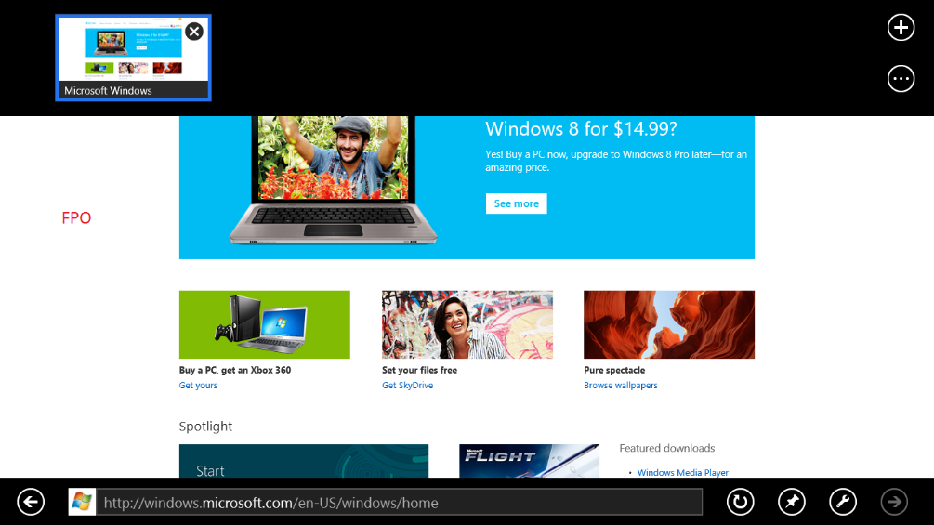
Whether you enjoy reading the news with your morning coffee, or relaxing with a lengthier article after work, turning on flip ahead makes going from page to page and article to article more fluid. Let's say you're reading an article on a news site that supports flip ahead. You can swipe across the page (or use a mouse to click the Forward button ) to go to the next page of content.
The Navigation bar in Internet Explorer 10 appears when you need it, which keeps the focus on websites. The Navigation bar includes easy-to-use controls (either touch or keyboard and mouse) for common operations like back, forward, stop, refresh, and pinning sites to the Start screen. The address bar shows badges and coloring for secure sites, SmartScreen Filter, and InPrivate browsing. It also supports auto-complete, as well as web search, matching the behavior of Internet Explorer on the desktop. The address box shows a progress indicator when a page is loading, and it includes indicators for site compatibility and tracking protection. The Navigation bar includes commands for Find on Page, and View on the desktop, for compatibility with sites that require older plug-in technologies.
Internet Explorer 10 works great with physical keyboards as well as the Windows 8 touch keyboard, which it automatically adjusts to make your experience easier. For example, when you set focus in the address bar, the “/” and “.com” keys become available to quickly enter URLs.

Easy
Internet Explorer 10 is clean and uncomplicated.
Internet Explorer 10 features are there when you need them and out of view when you don’t. It’s easy to use, yet it includes a comprehensive set of features that people need for heavy-duty web browsing: great touch keyboard support for forms, integrated spell checking with AutoCorrect, finding text on the page, and more.
Internet Explorer 10 just works the way you expect it would in Windows 8. Quickly find sites by pinning them to your Start screen—or add a site to your favorites and access it from anywhere in Internet Explorer 10. You can easily share sites with embedded, high-fidelity content directly from Internet Explorer 10 with the Windows 8 sharing features.
Snap makes multitasking across sites and apps easy. For example, you can enjoy music or read your mail in an app and browse the web side-by-side. . The browser adapts to the narrow “snap” size and automatically undock when you need it. All of the core browsing capabilities are available when snapped – panning, pinch and double-tap zooming, and following links.
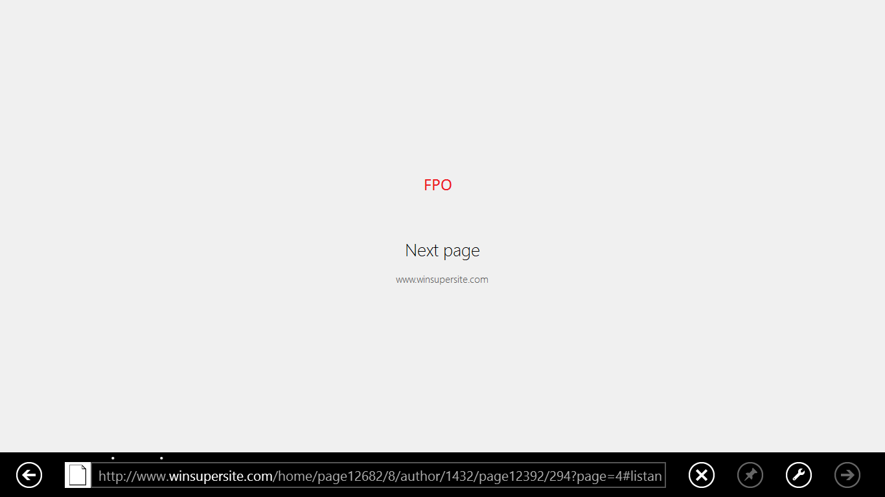
Internet Explorer 10 builds on the innovations earlier versions and includes the features you know, including a One Box address bar for navigation with quick search and automatic site suggestions.
With site pinning, you can personalize your Windows Start screen with the sites you use all the time. You can pin any website to the Start screen from Internet Explorer 10, so you have one place to access all the things you care about.
The tiles for pinned sites reflect the site’s color and icon. With Internet Explorer 10, sites can provide background notifications for new messages and other activity from the website straight to the tile on your Start screen. The site can offer additional commands that appear in the Internet Explorer Navigation bar in a touch-friendly way, the same way that sites can program Jumplists for Internet Explorer on the desktop.
With Internet Explorer 10, you can quickly switch between tabs and access your favorite sites. Browsing multiple web pages is core to any good web experience. The Internet Explorer tab switcher appears when you swipe in from the bottom or top of the screen with touch, right-click with the mouse, or press the Windows key+Z.
Internet Explorer 10 takes a non-intrusive approach to notifications. All alerts appear in the Notification bar at the bottom of the screen. And some include the flyouts used in Windows 8..

Safer
Internet Explorer 10 gives you peace of mind.
Socialize, shop, study, share, work—these are all things you do daily on the web that might make your personal info available to other people. Internet Explorer 10 helps protect you with better behind-the-scenes security and more control over your privacy.
Internet Explorer provides the best protection from socially-engineered malware. If a site seems suspicious, you probably shouldn't be downloading apps from it or providing your account or personal info. But sometimes it's hard to tell whether or not a site is legitimate. SmartScreen helps you identify reported phishing and malware sites and also helps you make informed decisions about app downloads. With industry-leading SmartScreen security technology built-in, Internet Explorer 10 helps protect from online threats like no other browser.
Support for Do Not Track privacy protection is built into Internet Explorer 10. The Do Not Track header sends a signal to websites that you prefer not to have information collected about your visit used to track you as you browse the web. How the sites you visit choose to respond or interpret Do Not Track requests is subject to those sites' privacy practices. Do Not Track is easily enabled with just one click in Internet Explorer 10. And like previous versions, Internet Explorer 10 supports InPrivate browsing and Tracking Protection too for additional privacy protections.

Internet Explorer 10 for developers
Internet Explorer 10 continues to focus on HTML5 & CSS3 web standards technologies that allow you to build cross-browser, cross-device experiences for the web and as Windows Store apps in Windows 8. We introduced the idea that the browser could be hardware accelerated in Internet Explorer 9 – taking full advantage of a PC’s underlying graphics hardware. Internet Explorer 10 continues this work by offering better performance than previous versions. Internet Explorer 10 in Windows 8 is also perfect for touch across a range of devices, allowing developers to build experiences that make touch a first-class experience on the web.
In this section you’ll find a brief overview of the new features for web developers. For the latest info, , check out the Internet Explorer Developer Center and read the Internet Explorer 10 Guide for Developers.
Internet Explorer 10 has many new and updated features based on the following standards:
- HTML5
- CSS3
- DOM
- ECMAScript
- SVG
- Indexed Database API (“IndexedDB”)
- Web Performance
You’ll find out more about each in the following sections, as well as info about updates to compatibility features and F12 Developer Tools, and Windows 8 integration.

HTML5
Internet Explorer 10 supports several exciting, new HTML5 technologies, including HTML5 drag-and-drop and WebSockets. This section provides a brief overview of each of the new HTML5 technologies in Internet Explorer 10:
- Application Cache API (AppCache)
- Asynchronous script execution
- Drag and drop
- File API
- Forms
- Parsing
- Sandbox
- Spellcheck
- Web Workers
- WebSockets
Internet Explorer 10 also includes or enhances support for these HTML5 technologies:
- Channel messaging
- History
- Changes to video support

Application Cache API (AppCache)
Internet Explorer 10 supports the HTML5 Application Cache API (AppCache) that enables web developers to create offline web applications. AppCache allows webpages to cache (or save) resources locally, including images, script libraries, style sheets, and so on. In addition, AppCache allows URLs to be served from cached content using standard Uniform Resource Identifier (URI) notation.
By using AppCache to save resources locally, developers improve the performance of a webpage by reducing the number of requests made to the hosting server, and they also enable offline access to cached resources. For more detailed info, see Application Cache API.

Asynchronous script execution
Internet Explorer 10 introduces support for asynchronous script execution, as defined in the HTML5 specification. This enables a script (for instance, a JavaScript script) to load and execute asynchronously with respect to the rest of the page. That is, the script loads and executes in the background while the page continues to be parsed.

Drag and drop
Drag and drop is something that computer users have come to take for granted as "just working," and there are a few ways to enable it within the browser. Internet Explorer 10 adds support for the draggable attribute as defined in the HTML5 specification. Applying the draggable attribute to any HTML element makes it able to be dragged on the page. Internet Explorer 10 also adds the files attribute to the dataTransfer object, which enables drag-and-drop support for one or more files from the desktop to a webpage.

File API
File API is an HTML5 specification for representing file objects in web applications, as well as programmatically selecting them and accessing their data. Now that Internet Explorer 10 supports File API, web developers can access local files on the client machine in a secure way without the need for extensions or plugins.
For more detailed info, see File API.

Forms
Internet Explorer 10 adds additional support for HTML5 Forms, which enables developers to easily provide user prompting, input validation, and feedback to users on form elements while using a minimal amount of script. Support for HTML5 client-side form and input validation enables the developer to concentrate on other tasks instead of building validation functions.
The breadth of new HTML5 Forms support in Internet Explorer 10 is significant. For information about all of the new features, see Forms. You can also check out HTML5 Forms in action on the IE Test Drive.

Parsing
Internet Explorer 10 now follows all HTML5 parsing definitions and applies these rules to innerHTML, as well. In addition, Internet Explorer 10 improves parsing error reporting in F12 Tools and removes several legacy features that were incompatible with HTML5.
For more detailed info, see Parsing.

Sandbox
Internet Explorer 10 introduces support for the HTML5 sandbox attribute, which enables security restrictions for iframe elements that contain untrusted content. These restrictions enhance security by preventing untrusted content from performing actions that can lead to potentially malicious behavior.
For more detailed info, see Sandbox.

Spellcheck
Spellcheck and autocorrect are now included in Internet Explorer 10, as defined by HTML5. Web developers simply have to add the spellcheck attribute—set to true—to either a text input field or textarea element. Internet Explorer 10 includes the autocorrect feature for commonly misspelled words (such as "teh" instead of "the"), and the familiar red squiggle on other unrecognized words.
For more detailed info, see Spellcheck.

Video
Support for HTML5 Video has been updated in Internet Explorer 10. Video now respects recorded video orientation (such as videos recorded by a mobile phone in portrait mode versus landscape). Internet Explorer 10 also includes support for the track element, which enables developers to add timed text tracks such as closed captioning, translations, or text commentary.
For more detailed info, see Video.

Web Workers
Internet Explorer 10 introduces support for the HTML5 Web Workers API, which defines a way to run scripts in the background. The Web Worker API provides a way for web application authors to spawn background scripts that run in parallel with the main page. Several threads can be spawned at a time to use for long-running tasks.
For more detailed info, see Web Workers.

WebSockets
Support for WebSockets technology in Internet Explorer 10 provides a new JavaScript API and protocol for two-way communication over the Internet. This new protocol makes it easier to work directly with fixed-data formats, and it bypasses the slower document-based HTTP protocol.
The WebSocket API is uncomplicated, requiring very little code. Developers can easily take advantage of low-latency bidirectional data interchanges that will help them create faster online games, instant social network notifications, real-time displays of stock and weather information, and other timely data.
For more detailed info, see WebSockets.

CSS3
Internet Explorer 10 supports several new CSS3 technologies, including new advanced layout techniques such as Flexible Box (Flexbox) layout and Grid layout, and visual effects, such as 3-D transforms, transitions, and animations. This section provides a brief overview of each of the new CSS3 technologies in Internet Explorer 10:
- Advanced layout
- Visual effects
- Scrolling and zooming with touch
- Specifying selectable text
- Removal of style sheet limits

Device adaptation
Support for CSS Device adaptation in Internet Explorer 10 enables you to optimize the layout of sites and apps for different devices with minimal effort. This is intended to help solve a classic dilemma: Code your site to work with as many devices, sizes, and resolutions as possible, or risk alienating users by potentially allowing your content to be either clipped (in fixed layouts) or jumbled confusingly (in fluid layouts).
For more detailed info, see Device Adaptation.

Exclusions
CSS Exclusions are new in Internet Explorer 10. With CSS Exclusions, you can now wrap text so that it completely surrounds elements, which avoids the traditional limitations of floats. Instead of limiting elements to floating either to the left or right relative to their position in the document flow, CSS Exclusions can be positioned at a specified distance from the top, bottom, left, or right sides of a containing block while remaining part of the document flow.
For more detailed info, see Exclusions.

Flexbox layout
Internet Explorer 10 introduces support for the CSS Flexible Box Layout Module (Flexbox). Flexbox adds to the four basic layout modes defined in CSS2.1: block layout, inline layout, table layout, and positioned layout. Flexbox layout is intended for laying out more complex webpages. It's especially useful for making the relative position and size of elements stay constant, even as screen and browser window sizes vary and change. Flexbox can lessen the reliance on floated elements, which are more complicated to position and size correctly.
For more detailed info, see Flexible box ("Flexbox") layout.

Grid layout
CSS Grid layout (the Grid) is new in Internet Explorer 10. Like flexbox, the Grid enables more layout fluidity than is possible with positioning using floats or script. It enables you to divide space for major regions of a webpage or web application, and to define the relationship between parts of an HTML control in terms of size, position, and layer. This removes the need to create a fixed layout, which cannot take advantage of available space within the browser window.
For more detailed info, see Grid layout.

Multi-column layout
Internet Explorer 10 introduces support for the CSS Multi-column Layout Module. Multi-column layout enables content to be flowed into multiple columns, which retain a gap and an optional rule between them. It also makes it possible to vary the number of columns based on the size of the browser window.
For more detailed info, see Multi-column layout.

CSS Regions
CSS Regions is a new page layout feature for Internet Explorer 10, and is defined in the CSS Regions specification. With CSS Regions, developers and designers can take a single HTML content stream of text and images and segment that stream into multiple empty containers defined in a standard HTML template. HTML templates are documents that are mostly empty of original content, but are instead composed primarily of empty containers that are sized and positioned to give incoming content a specific layout. This allows for a continuous content stream to be restructured into a layout more suited, for instance, for tablet consumption.
Within a single page, CSS Regions allows web developers to develop complex content layouts equivalent to what might be seen in a magazine or newspaper, where multiple regions of the same flow of content (text, related pictures, video, and so on) are shaped around unrelated content elements, such as alternate stories or advertisements.
For more detailed info, see CSS Regions.

3-D transforms
Internet Explorer 10 adds support for CSS3 3-D transforms to the existing support for 2-D transforms introduced in Internet Explorer 9. Transforms enable translation, rotation, and scaling of elements in 2-D and 3-D space without the need for a plug-in. Plus, because support for 2-D and 3-D transforms is built into the browser, you can take advantage of the speed improvements provided by hardware acceleration with no extra work. CSS3 3-D transforms are defined by the W3C in the CSS 3D Transforms Module Level 3 specification.
For more detailed info, see 3-D transforms.

Animations
Internet Explorer 10 supports CSS3 Animations, as defined in the CSS Animations Module Level 3 specification. CSS3 Animations enable developers to create visually appealing apps with smooth, fluid, animated experiences, all while taking advantage of the built-in hardware acceleration in Internet Explorer 10.
CSS animations are similar to CSS transitions in that they animate elements as they change position, size, color, and opacity; and as they rotate, scale, translate, and so on. And just as you can with transitions, you can specify timing functions to control the rate of progression of an animation.
However, with CSS3 Animations, you can also use keyframes, which specify the values for the animating properties at various points during the animation. This way, you can define the behavior of an animation not only at the beginning and end of the animation, but in between as well. Animations can also have iterations and reverse-direction capability, and can be made to pause and resume.
For more detailed info, see Animations.

Fonts
Web developers can now control low-level OpenType layout features in Internet Explorer 10. The font-feature-settings property, defined in the CSS Fonts Module Level 3 specification, enables developers to specify glyph substitution (such as ligatures, small capitals, and stylistic sets) and positioning (such as kerning) in fonts that include OpenType layout features.
For more detailed info, see Fonts.

Gradients
Internet Explorer 10 supports specifying CSS3 gradients in any CSS property that accepts images. Gradients act as specified in the Gradients section of the CSS3 Image Values and Replaced Content Module.
Gradients are images that transition smoothly from one color to another. Internet Explorer 10 supports linear, circular, and elliptical CSS3 gradients, each of which are specified by a gradient line and two or more stop points. Each stop point has its own color, and Internet Explorer fills in the area between each set of points with a continuous color transition from one to the other.
For more detailed info, see Gradients.

Text
Internet Explorer 10 supports two essential components of the CSS3 Text Module: the text-shadow property and automatic hyphenation.
The text-shadow property enables developers to add drop shadows to text. Automatic hyphenation can be applied using a built-in dictionary with default settings, or you can fine-tune when and under what conditions words are hyphenated using several CSS hyphenation properties.
For more detailed info, see Text.

Transitions
Internet Explorer 10 supports CSS3 transitions, as defined in the CSS Transitions Module Level 3 specification. Transitions enable you to create simple animations by smoothly changing CSS property values over a specified duration of time. For instance, you could vary the size and color of an object over a period of 10 seconds. What you might have previously accomplished using a complicated combination of CSS and JavaScript, you can now do using just CSS.
For more detailed info, see Transitions.

Scrolling and zooming with touch
Two key components of touch interactions are scrolling (or panning) and zooming. Touch-enabled webpages and apps use scrolling and zooming to enable users to access more content, move through items in a list, view more detail in a photo, and much more.
Scrolling and zooming views are a quintessential experience when it comes to touch. Users base their first opinions of a touch-optimized webpage depending on what happens when they first touch the screen and slide their fingers across. Keeping this in mind, there are many details and nuances to get right to provide a great experience. General interactions that users expect to “just work” include scrolling, zooming, inertia, “bouncing” when a boundary is hit, nested scrolling or zooming areas, scrolling or zooming snap points, and integrated controls.
The CSS scrolling and zooming properties in Internet Explorer 10 enable developers to fine-tune these scrolling and zooming behaviors to optimize the user’s experience.
For more detailed info, see Scrolling and zooming with touch.

Specifying selectable text
The -ms-user-select property is a new CSS property that enables you to control whether and where users are able to select text (for instance, for copying and pasting to another document) within their webpages.
For more detailed info, see Specifying selectable text.

Removal of style sheet limits
In Internet Explorer 9 and earlier, there’s a limit of 31 style sheets per webpage. There’s also a nesting limit of four levels deep for style sheets that are linked using @import rules.
In Internet Explorer 10, this limit has been removed. There’s no limit to the number of style sheets that can be referenced per webpage in Internet Explorer 10. Web developers are also not limited in the number of times they can nest @import rules inside style sheets

DOM
Internet Explorer 10 contains several new Document Object Model (DOM) features, including advanced hit-testing APIs, media query listeners, and pointer and gesture events. Check out the links below to learn more about each of the new DOM technologies:
- Advanced hit testing: New APIs that return a node list of all the elements that intersect the point at the given x- and y-coordinates or a rectangular area.
- Floating-point values in CSSOM: reports positioning and sizing metrics for the DOM by using sub-pixel precision.
- Media query listeners: media query listeners enable developers to use script to react to changes in the media or environment in which their pages are running.
- Pointer and gesture events: native support in the web platform for handling touch and pen input.
- The createContextualFragment method: parse a string of HTML into a document fragment using the starting node of a DOM Range as the parsing context.
- Using aria-haspopup to simulate hover on touch-enabled devices
- XMLHttpRequest enhancements: greater support for emerging standards and to more easily support common developer scenarios.

JavaScript
Internet Explorer 10 extends the JavaScript enhancements made in Internet Explorer 9 with new support for both typed arrays and ECMAScript 5 (ES5) strict mode.

Typed arrays
The Typed Arrays API enables web apps to use a broad range of binary file formats and directly manipulate the binary contents of files already supported by Internet Explorer 10. You can use typed arrays to handle binary data from sources such as network protocols, binary file formats, and raw graphics buffers. Typed arrays can also be used to manage in-memory binary data with well-known byte layouts. Typed arrays provide a means to look at raw binary contents of data through a particular typed view.
For more detailed info, see Typed arrays.

SVG
Support for scalable vector graphics (SVG) was introduced in Internet Explorer 9. Internet Explorer 10 introduces SVG filter effects, as defined in the Scalable Vector Graphics (SVG) 1.1 (Second Edition) specification. SVG filter effects enable you to manipulate graphics—similar to what you might do with an app such as Adobe Photoshop—directly in the browser.
For more detailed info, see Filter effects.

Compatibility
Document compatibility defines how Internet Explorer renders webpages, and it’s essential to ensure users have the best experience possible with a website. To learn more about document compatibility, see Defining Document Compatibility on MSDN. The links below provide info about the compatibility features in Internet Explorer 10:
- User-agent string: identifies your browser and provides certain system details to servers hosting the websites you visit.
- Compatibility modes: determine how Internet Explorer renders your webpages.
- Interoperable quirks mode: enables Internet Explorer to match the behavior of other leading browsers while retaining the compatibility support expected by many developers and users.

F12 Developer Tools
F12 Developer Tools were introduced in Internet Explorer 8, and then updated with new features in Internet Explorer 9. F12 Developer Tools in Internet Explorer 10 add Web Worker debugging and support for multiple script sources.
For more detailed info, see Debugging Web Workers.

Performance
Internet Explorer 10 adds support for several web performance APIs, as defined in the World Wide Web Consortium (W3C) Web Performance Working Group specification. Four new web platform features are available:
- Navigation timing: makes it easy to measure the real-world speed and performance of websites and locate problem areas that need tuning.
- Page Visibility API: provides a means for you to use programming techniques to determine the current visibility of a document and be notified when the visibility changes.
- requestAnimationFrame method: helps solve problems involved with setting timeouts and intervals in animations by enabling apps to be notified when (and only when) the browser needs to update the page display.
- setImmediate method: addresses the core performance problems involved with setting timeouts in animations without negatively impacting power consumption.

Windows 8 integration
Windows 8 and Internet Explorer 10 are tightly integrated. You can take advantage of this integration in several ways:
- Invoking apps directly in Internet Explorer 10
- Using link previews
- Connecting a website to a Windows Store app using the Windows Runtime
- Adding pinned site notifications

Invoking apps directly in Internet Explorer 10
The DirectInvoke object in Internet Explorer 10 enables apps to register their MIME types for direct invocation from a URL. When Internet Explorer 10 encounters a file type that it doesn't handle natively, it can use a handler application rather than downloading the file.
For more detailed info, see Invoke applications directly in Internet Explorer 10.

Using link previews
The link preview feature extends the Windows 8 share experience. When a user selects the Share charm, Internet Explorer 10 generates a link preview—a shared data object that contains enhanced information about the current webpage. In addition to the page's URL, a link preview includes the title for the webpage, a description, and a thumbnail image. To generate this link preview, Internet Explorer 10 looks for specific HTML tags. Developers can take advantage of this feature by including any of the supported tags in the site's HTML. These supported tags include title tags, description tags, and thumbnail image tags.
For more detailed info, see Link previews.

Connecting a website to a Windows Store app using the Windows Runtime
Windows Store apps enable you to take a website's experience to the next level. You can build experiences that are more immersive, beautiful, and better connected to other apps and the rest of Windows.
By using the Windows Runtime, you can deliver features beyond what's possible in a browser alone, such as seamless access to local files and folders, integration with Windows 8 Charms for sharing and search, and interaction with local devices. Plus, the Windows Store delivers a great user experience for browsing, finding, and buying the apps that users care about.
For more detailed info, see Connect your website to your Windows Store app.

Adding pinned site notifications
Windows 8 implements pinned sites by using tiles on the Start screen. When a user clicks the tile of a pinned site, the site opens in Internet Explorer 10. For this to happen, several pieces of information are needed, including the location of a web service to poll for notifications, an up-to-date XML file to reflect current badge state, and the frequency with which updates should occur.
For more detailed info, see Pinned site notifications in Windows 8.

Internet Explorer 10 for IT Pros
All of the investments in performance, navigation, service integration, security, and standards support in Internet Explorer 10 and Windows 8 will benefit customers who are using the browser at home or at work. A more efficient browser enables a more productive workforce. A more secure browser provides a more secure workplace.
IT departments have unique security, customization, deployment, and management needs for their desktop computers. Internet Explorer 10 has greater customization and management flexibility through group policies than other browsers.

Security
Internet Explorer 10, building on the strong security features in Internet Explorer 9, provides greater robust security with the industry-leading SmartScreen Filter, and the new Enhanced Protected Mode. With these features, IT Pros can be better assured that their clients are safer and better protected than ever before.

Enhanced Protected Mode
New in Internet Explorer 10, Enhance Protected Mode helps keep your data safer even if an attacker has exploited a vulnerability in the browser, or one of its add-ons, by providing another layer of protection from malicious attackers. Enhanced Protected Mode builds on features in previous versions of Internet Explorer by restricting additional capabilities. These capabilities focus on helping keep personal info private, as well as protecting corporate data by restricting access to intranet servers.

SmartScreen Filter
SmartScreen Filter helps detect phishing websites. It can also help protect users from downloading or installing malicious software. SmartScreen Filter protects users with a set of sophisticated tools that offer anti-phishing protection, app reputation, and antimalware protection. SmartScreen filter displays messages and warnings when it finds something that’s suspicious.
SmartScreen Filter download reputation is a groundbreaking browser feature introduced in Internet Explorer 9 that uses reputation data to remove unnecessary warnings for well-known files, and shows more severe warnings when the download is a higher risk of being malicious. Users today are conditioned to ignore the generic warnings that are shown for every download, such as: “This file type can harm your computer. Are you sure you want to run this file?” This same warning is presented whether the file is an extremely common program or a piece of malware created literally minutes ago. Other browsers leave it up to the user to decide if a program is safe to download and run from the Internet. Internet Explorer is the only browser that uses download reputation to the user to help make safety decisions.
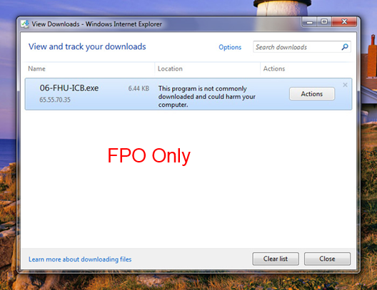
See this explanation of the different strategies that Internet Explorer 10 security features use to help keep you secure.

Browser deployment and management
Internet Explorer 10 supports the management and configuration tools that you need for cost-effective browser deployment and maintenance, such as Internet Explorer Administration Kit (IEAK), Windows Server Update Services (WSUS), System Center Configuration Manager (SCCM), and Microsoft Deployment Toolkit (MDT). Customizing and maintaining Internet Explorer is easier and more efficient than ever before.
Helping secure corporate data and ensuring good browsing experiences also involves regular maintenance, including installing the latest updates and security patches. Microsoft provides you with several tools to help manage Internet Explorer installations.

Internet Explorer Administration Kit
For corporate customers, Internet content providers, and Internet service providers, Internet Explorer 10 offers improved customization and management capabilities through the use of Group Policy and the Internet Explorer Administration Kit. The ability to slipstream security updates into the Windows image and new capabilities to manage user settings post-deployment can also help improve security and protect corporate information.
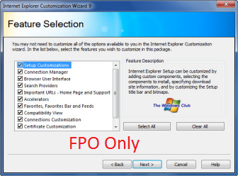
The Internet Explorer Administration Kit (IEAK) simplifies the creation, deployment, and management of customized Internet Explorer packages. The IEAK can be used to configure the out-of-box Internet Explorer experience or to manage user settings after Internet Explorer deployment. Internet content providers can use IEAK to showcase your content by customizing your user’s home page and search providers, or you can add a Web Slice for a radio station that lists the top 20 songs each day. IEAK 10 is available in 24 languages. You can use one of these versions to build custom packages in any language that Windows 8 is available in.
The IEAK provides you with all the tools and documentation you’ll need.
IT departments and original equipment manufacturers (OEMs) can customize their versions of Internet Explorer 10 – including the home page, Favorites, search provider, Feeds, Accelerators, and Web Slices – by adding the Internet Explorer 10 customization setting to the Unattend.xml file that Windows uses for unattended setup.
There are two versions of IEAK that align with different customization needs. IT Pros can use the IEAK to create custom, branded versions of Internet Explorer 10 that can be delivered as standalone packages or with other software or services without having to install an operating system at the same time. You can update these custom versions without having to reinstall the browser. Corporate administrators or IT departments should use the Internal version of IEAK 10. Independent Content Providers (ICPs), and Internet Service Providers (ISPs) can also create customized versions of Internet Explorer 10 to distribute to their customers. ICPs and ISPs should use the External version of IEAK10.
For more info, see What IEAK Can Do For You. Also, see the IEAK Information and Downloads page on the Internet Explorer TechCenter to download IEAK 10.

Windows Server Update Services
Windows Server Update Services (WSUS) enables you to deploy Microsoft product updates to computers in their organization that are running Windows operating systems. WSUS allows you to deploy Internet Explorer security updates – an important aspect of keeping up with security demands. See Windows Server Update Services on TechNet for more info.
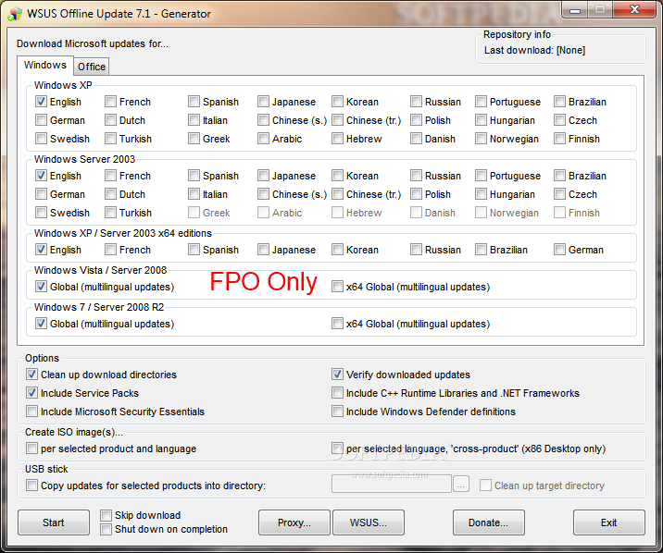

System Center Configuration Manager
System Center 2012 organizes IT assets (for example, networks, server storage, and computers) into a private cloud that’s integrated with public cloud services. You can manage both public and private services from one app.
Microsoft System Center 2012 Configuration Manager helps you to empower people to use the devices and apps they need to be productive, all while maintaining corporate compliance and control. It accomplishes this with a unified infrastructure that gives a single pane of glass to manage physical, virtual, and mobile clients. It also provides tools and improvements that make it easier for you to do your job.
When you use System Center 2012 Configuration Manager, you have greater control over your entire Internet Explorer ecosystem and have a single interface from which to manage your Internet Explorer deployment.
See Getting Started with System Center Configuration Manager on TechNet for more info.

Group Policy
You can use Group Policy to centrally change and manage PC and user settings for existing Internet Explorer 10 deployments, including settings that users can’t change. Examples include the ability to disable SmartScreen Filter, delete browsing history, change policies for security zones, add or delete sites in a security zone, or access the Security tab in the Internet Options dialog box.
New features in Internet Explorer 10, such as changes to add-on management, are configurable using Group Policy. Internet Explorer 10 installs an ADMX/ADML file (an XML version of the ADM files from earlier operating systems) as part of the full package, which allows you to access the full range of Internet Explorer 10 policy settings and apply them within your organization using Group Policy objects.
Internet Explorer 10 includes the nearly 1,500 Group Policy settings from Internet Explorer 9, and it also provides new Group Policy settings to support its new features. These include:
- Turn on Enhanced Protected Mode
- Allow websites to store app caches on client computers
- Set app cache storage limits for individual domains
- Set default storage limits for websites
- Start Internet Explorer with tabs from last browsing session
- Prevent Internet Explorer from sending shared links to an online service
- Turn off URL Suggestions
- Open Internet Explorer tiles on the desktop
- Set how links are opened in Internet Explorer
- Set the maximum number of WebSocket connections per server
- Turn off the WebSocket Object
- Don’t display the reveal password button
- Install new versions of Internet Explorer automatically
- Always send Do Not Track header
- Notify users if Internet Explorer isn’t the default web browser
- Turn off Adobe Flash in Internet Explorer and prevent apps from using Internet Explorer technology to instantiate Flash objects
- Turn off flip ahead feature
Using group policy, IT Pros can customize Internet Explorer to fit the needs of their business. For more info, see Group Policy Settings in Internet Explorer 10.

The best browser for the enterprise
Internet Explorer 10 maintains our strong commitment to providing support to IT departments. As part of Windows 8, Internet Explorer 10 is supported for the life of the operating system, with dedicated, enterprise-level hotfix and security responses. This gives businesses the predictability and consistency they need to plan deployments or business-critical technologies.
Internet Explorer 10 gives you the ability to fully customize the browser for your users while giving you the ability to maintain the safety and protection you’ve come to trust. With the IEAK and Group Policy, you can create a custom deployment enabling only those features that make sense for your organization. Features like SmartScreen Filter and Enhanced Protected Mode mean corporate data is better protected and users are more aware of threats and problems.

