How to create a Primus/EVA rule
Prerequisite: Make sure you’ve got a basic understanding of regular expression syntax. If you’ve read and understood most of Sams Teach Yourself Regular Expressions in 10 Minutes or a similar introduction, you should be prepared enough to start writing and modifying rules.
Note: We write rules that are .NET 4.0-compliant. If you’re using RegexBuddy to help write rules (and you should be ‘cuz we’ve got a few licenses for it), you can set the .NET filter so you know your rule syntax will be compliant with our system. For a ton of info about what’s supported in .NET 4.0, see Mastering Regular Expressions.
Let’s go…

Part 1: Develop the rule’s syntax and test it
- Consider the thing you want to write a rule for:
- How specific should the rule be? In general, it’s easy to find things using regular expressions, but the challenge to writing great regular expressions is not catching more than you want.
- Why do we need a rule for this? That is, what aspect of our goal for increasing content quality does this rule serve? Put another way: don’t write rules for the sake of writing rules. Write them with a clear purpose.
- And what do you want to tell people when the rule identifies a problem in their content?
You’ll need to have answers to these questions before you can turn the new rule on because you’ll codify your responses in the various pieces that make up a complete rule.
The example I’ll use for these instructions comes from the Internet Explorer 9 word list, in which there are a number of entries for various “bars,” such as the “Favorites bar” and the “Notification bar.” All of these bars have an uppercase proper name followed by a lowercase “b” in “bar.” While the source for the guidance comes from IE9, it applies to all versions of IE, and IE content appears in multiple products, so there’s no reason to scope the rule to only IE9. We want to make sure the names are cased correctly for consistency, which lowers localization costs and helps increase user comprehension. If a writer receives an error, we want to quickly and clearly tell them how to fix the problem.
- Develop the rule syntax. Use RegexBuddy to help you work out the syntax of your expression. You can ask Mary Nordstrom for a license.
- Use RegexBuddy to test your syntax against samples you create. See Figure 1.
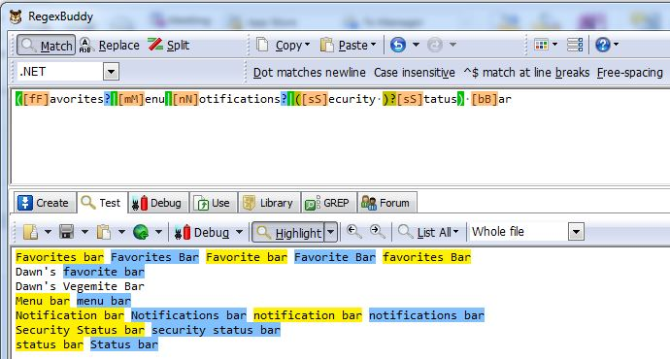
Figure 1: Test the regular expression against sample text. Highlighted strings are hits.
- When you’ve got the regex syntax working as you intend, use RegexBuddy to run the rule against the content set to see what it turns up (see Figure 2). This is where you’ll find likely find exceptions to the rule you’ve written. To run the rule in RegexBuddy:
  - Click the GREP tab.
  - In Folders, enter the path or browse to the location of the WinPub folder on your local PC you want to test.
  - In File Masks, enter *.xml.
  - Select the Recursive subfolders checkbox.
  - Click the GREP button.
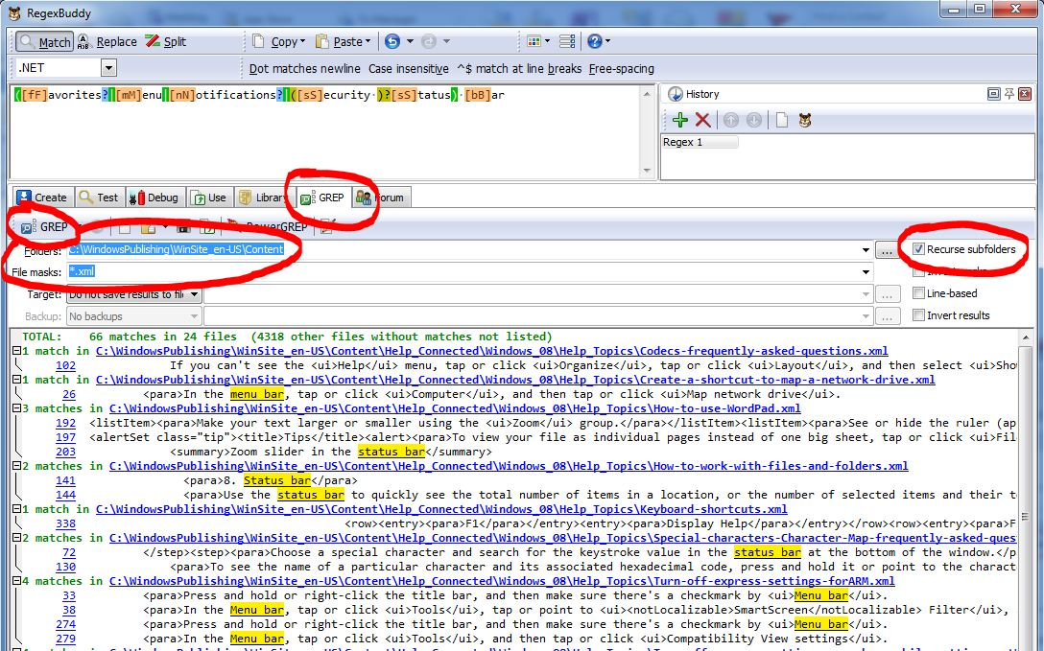
Figure 2: On the GREP tab, run the rule against actual content, and then look for exceptions
- Consider each of the exceptions you’ve discovered and decide if you’ll handle these by modifying the logic of your rule or by writing an exception to the rule. Exceptions can be regular expressions themselves, so you’ve got just as much power there as you do with the rule’s syntax. However, in general, the best practice is to put as much of the logic into the rule rather than the exceptions.
Tip: An exception can often be an integral part of the rule logic. For example, it’s often easier and less complicated to write a rule that looks for every possible variation of a string and then write an exception that excludes the correct version of the string, than it is to incorporate the logic of excluding the correct string in the rule’s syntax.
In the example in these instructions, I’ll use this technique of searching for all variants in the rule, and excluding those that are correct in an exception.

Part 2: Enter the rule in the Primus database
- Now that you’ve got the rule syntax and exceptions figured out, it’s time to create a new Primus rule. Open the Primus Test Case website: http://10.199.24.183/WSCPubRequest/PrimusTestCases.aspx.
- Click New. See Figure 3.
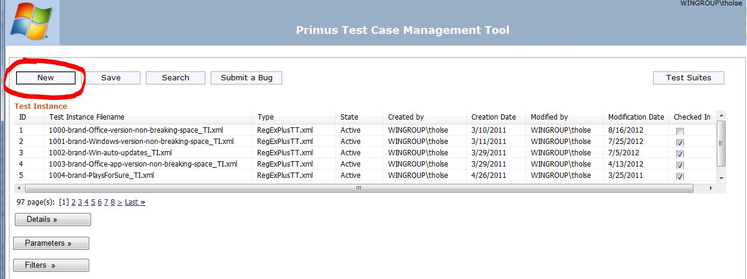
Figure 3: The web interface for the Primus database. Create, modify, and delete using this tool.
- In the Create New Test dialog box (see Figure 4), enter a name using the following conventions:
[four-digit sequential number]-[type of test]-[unique and descriptive name separated by hyphens]
There are 9 different types of tests, and each has a block of four-digit numbers assigned to it:

4-digit number | Test type
1000-1999 | brand
2000-2999 | legal
3000-3999 | code
4000-4999 | SG (short for “Style Guide”)
5000-5999 | term (short for “terminology”)
6000-6999 | loc (short for “localization”)
7000-7999 | disclosure
8000-8999 | winedit
9000-9999 | mstp (AKA the MMS)

Each time we write a new rule, we have to look at the Primus test case website (or in the test solution in WinPub) to figure out the number assigned to the last test written for a given test type, and then increment by one for the next new rule. For example, the last test written for a “terminology” test was 5273, so the next rule is going to start with “5274-term-“ followed by a unique (to the test solution) and descriptive file name:
5274-term-IE-bar-names
Together, the code, the test type, and the descriptive name make it easier to search the databases later.
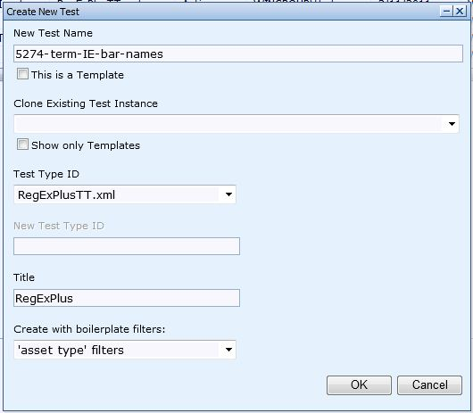
Figure 4: Use this dialog to create new tests
- Still in the Create New Test dialog box, under Test Type ID, select RegexPlusTT.xml.
The Title field is automatically filled in.
- Under Create with boilerplate filters, it’s very likely that you’ll want to select ‘asset type’ filters, but it’s not required, and it depends on the type of test you’re writing. The boilerplate filters field and values were created because they applied to many rules and I got tired of adding the filters individually, so I asked for template filters. Here’s what the three available filters do:
Filter name | What it filters for
‘asset type’ filters | If you select this filter, your rule will only be run against assets in WinPub that have an asset type value of:  - Content piece  - User documentation  - Web user documentation  That is, the test won’t be run against art, videos, page definitions, etc.  Nearly every rule written that begins with a four-digit code has this filter applied to it.
Windows Live ‘product’ filters | If you select this filter, your rule will only be run against assets that have a “Product” value in WinPub associated with Windows Live. These include:  - Windows Live  - SkyDrive  - Messenger  - Live ID  - Live Explore Dogfood  - Live Explore  - Hotmail  That is, the test won’t be run against any asset whose product doesn’t equal one of these values. This filter is handy if you want to write a test that only applies to Windows Live content.
‘asset type’ filters and Windows Live ‘product’ filters | As the name suggests, this is both of the filters described above combined.

- Click OK.
- Click the Details button to expand the section (see Figure 5).
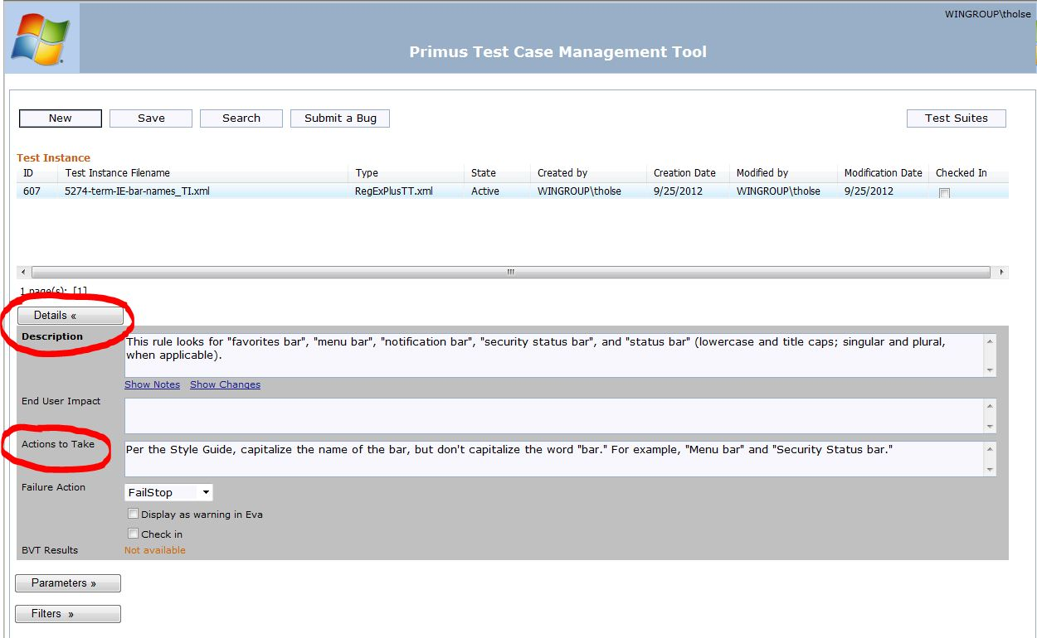
Figure 5 The Details section
- Under Description, tell the reader exactly what the rule is searching for. This description won’t always tell the reader the purpose of the rule because it’s focused on the “what” rather than the “why.” If you suspect the purpose isn’t very clear, click the Show Notes link and add explanatory text.
In general, the convention for descriptions is to begin with “This rule looks for…” followed by literal, lowercased strings in quotation marks, that are then followed by parentheses that explain the variants of these strings, if there are any. For example:
This rule looks for "favorites bar", "menu bar", "notification bar", "security status bar", and "status bar" (lowercase and title caps; singular and plural, when applicable).
- Click Save.
Warning: Saving your changes after ever change is critical. If you don’t, the values for fields can get mixed up.
- Under Actions to Take, give the message you want the EVA user to receive. This should be short, clear, and actionable. If the guidance for a rule is complicated, don’t try to explain the whole thing. Instead, provide a link where the user can find more info.
Tip: The fields in the web form have 250-character limits. Going over will cause the rule to fail BVT tests, and it won’t be run. The fields don’t have counters, so if you’ve written a long blurb, copy the text into Word and use Word Count to see where you’re at.
- Click Save.
- Click the Parameters button to expand the section (see Figure 6).
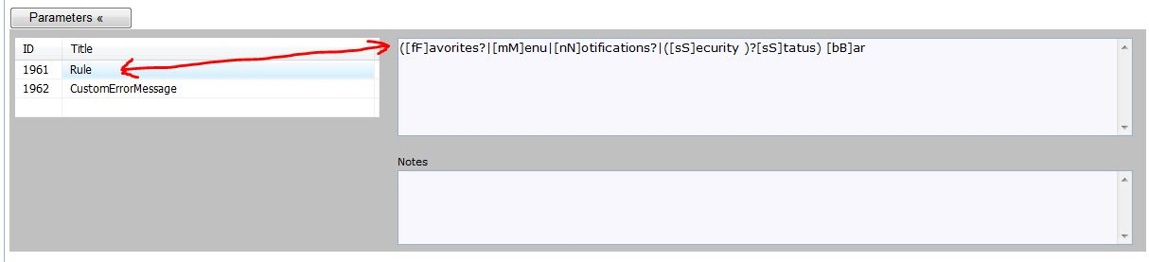
Figure 6: The Parameters section. The value for the highlighted Title is displayed in the field to the right.
- Under Title, click an empty field, and then select Rule from the list.
- Copy the regular expression from RegexBuddy and paste it into the empty field to the right of the Rule field.
If the syntax for the expression is difficult to understand, do what great coders do and comment your code by adding explanatory info under Notes.
Important: The Primus system requires that some characters have to be translated so they can be transformed correctly. Each time you use one of these characters either in a rule or an exception, you must use the translation. Here’s a list of the characters that need translating:

Character | Translation
& | Use %ampersand% to represent “&”
< | Use %lessThan% to represent “<”
> | Use %greaterThan% to represent “>”
“ | Use %quote% to represent “ “ ” (quotation mark)
‘ | Use %apostrophe% to represent “ ‘ ” (apostrophe)

- Click Save.
- Under Title, click an empty field, and then select CustomErrorMessage from the list.
- In the Details section, copy the text you wrote in the Actions to Take field and paste it into the empty field to the right of the CustomErrorMessage field.
- Press the Space bar once, and then type CONTEXT:[CONTEXT]
The [CONTEXT] variable appends—you guessed it—context from the source asset into the error message in EVA so users can tell what text is getting hit by the rule.
- Click Save.
- If necessary, under Title, click an empty field, and then select Exception1 from the list, and then add the string (which can be a regular expression) in the empty field to the right of the Exception1 field.
Repeat for as many as 12 exceptions. (The UI says 16 exceptions are available, but the number is actually 12.)
For the example rule, I added one exception: a regular expression that’s the correct name for each of the IE bars:
(Favorites|Menu|Notification|Security Status|Status) bar
Important: This system is set up so that Primus will look 17 characters to the left of the identified text for an exception, and 17 characters to the right. This default parameter is in place to try to limit the potential for multiple correct hits from being excluded by a single exclusion. For example, say you write a rule that looks for two exclamation marks, and you write an exception that says two exclamation marks are OK when preceded by the string “Super excited”. So:
- Rule: !!
- Exception: Super excited!!
- Example text: These instructions are awesome!! I can’t wait to get started!! Blah blah. Super excited!!
In the example text, Primus finds all three instances of “!!” and correctly flags the first instance and ignores the third instance because of the “Super excited!!” exception, but it incorrectly ignores the second instance. Why? Because the two exclamation points are the 13th and 14th characters to the left of the beginning of the exception string, and there’s what amounts to a 17-character force field on either side of every exception that ignores everything in it.
Fortunately, you can fine-tune the number of characters in the “force field” using the LeadingContextCount and TrailingContextCount parameters. Select one of these, and then enter a value (such as 35), add a note that explains why you needed to change the default value, and remember to click Save.
In practice, you’ll sometimes find that you need to increase the values when you write an exception for text that appears within <ui> tags because UI strings can be quite long. For example, if you wanted to exclude all instances of “!!” when they appear within <ui> tags, you’d need to increase the LeadingContextCount to 55 to account for this especially long UI string:
<ui>Check to make sure that you have correctly set the Super excited!! setting</ui>
- Click the Filters button to expand the section (see Figure 7).
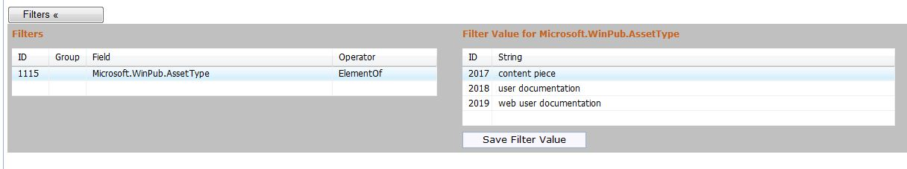
Figure 7: the Filters section
If you selected the ‘asset type’ filters option when you created the new rule, then you’ll see one filter (Microsoft.WinPub.AssetType) with three values already created for you.
- To add a filter, in the Filters section, under Field, click the next empty row, and then select one of the options.
Almost all of the options are metadata fields from WinPub and begin with either Microsoft.WinPub.[field name] or System.[field name]. Most of the time, you’ll be able to tell which field names are associated with which UI text labels in WinPub, but there are a few cases where the field name is quite different than what you see in WinPub. If you run across one of these, the folks on the Publishing team (send mail to the conpub alias) can help you map field names to UI text labels.
- Under Operator, choose an option. Here’s what they mean:
Operator | Means this
ElementOf | The asset in WinPub must include the following value(s)
NotElementOf | The asset in WinPub must not include the following value.  Only one value is allowed for this field. If you need multiple values, add more fields with the same field name.
Contains | [I NEED HELP DEFINING THIS]

- Click Save.
Important: Clicking Save now might seem strange, but the items under Filters and the values under Filter Value for [field name] behave independently. The best practice is to create the filter, save it, and then add values to it.
- Select the filter you want to add a value to by clicking the ID value (in the example in Figure 7, you’d click 1115).
- Under Filter Value for [field name], enter a value exactly as the value appears in WinPub. Everything matters here: case, spacing, brackets, whatever. It all counts.
- Click the Save Filter Value button (see Figure 7). Repeat for as many values as you need to add.
- If necessary, repeat the instructions for adding new filters and new filter values.

Part 3: Create tests for the new rule
Important: Every rule needs at least one test asset in WinPub that fails the test and one asset that passes. Every exception needs at least one asset that passes the test. These test assets are used in BVT (stands for Build Verification Test) tests that automatically run twice a day ( at about 11:00 AM and 11:00 PM). The test assets must pass or fail as they’ve been designed to or the BVT tests will fail. If BVTs fail, then the rule that’s failing the BVT test will not be allowed to run against actual content. That’s how we verify the logic and syntax of the rules and the exceptions.
- If you haven’t already, file a //wolrequest and ask for permissions to the WWL_Test project.
- Under the EN folder, load the TestValidation solution (see Figure 8).
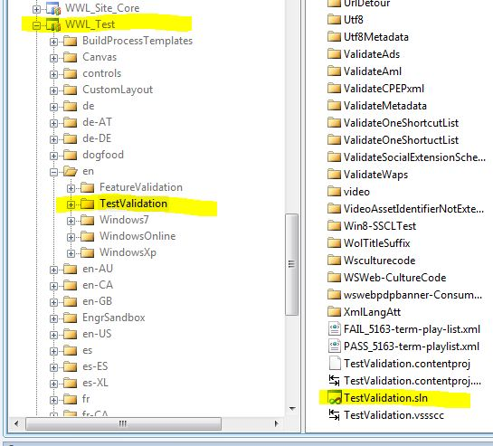
Figure 8: Load the TestValidation solution
- Do a get of the solution. Multiple people work in this solution and it can get out of sync, so doing a get before you make a change to the solution is a best practice.
- In Solution Explorer, right-click TestValidation, point to New, and then select New Folder.
- Give the new folder the exact same name as you gave the new Primus rule. So for our example, I named the folder “5274-term-IE-bar-names”.
- Right-click the new folder, point to Add, and then click New Item. See Figure 9.
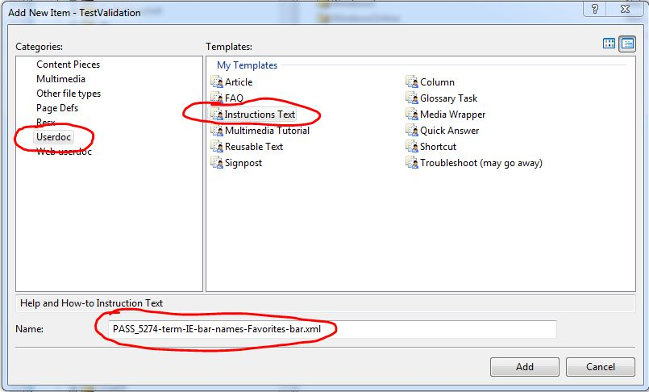
Figure 9: Add a new test
- In the Add New Item dialog box, under Categories, select an asset type for the test, such as Userdoc, which is a shortened name for User documentation.
- Under Templates, select a content type for the test, such as Instructions Text.
- In the Name field, enter a file name following these conventions:
PASS_[the name of the folder]-[unique description of test].xml
Important: Each test asset file name must be prepended with either PASS_ or FAIL_.
Note: If the folder name is long and using it will result in a really long file name, you can shorten it. The most important thing to retain from the folder name is the four-digit ID code so you know which test belongs to which rule.
- Copy everything you just entered into the Name field except “.xml”, and then click Add.
- Click Next.
- In the Create a New Asset dialog box, in the Title field, paste the text from the Name field. See Figure 10.
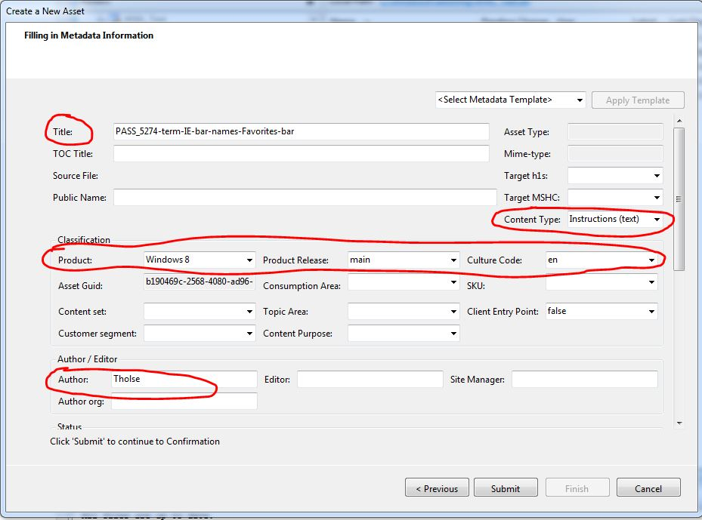
Figure 10: Create a New Asset dialog
- For Content Type, select the same content type you chose for a template earlier. In this example, it’s Instructions (text).
- Under Classification, in the Product field, select the product that the rule should apply to.
Important: If you’ve written a rule that has a filter that restricts which products the rule runs against, then the tests you create need to reflect those filters. For example, if you’ve written a rule that has the Windows Live filters applied, then you should choose one of the Windows Live products, such as SkyDrive, rather than Windows 8.
Note: If the rule you’re writing applies to all products, choose the most recent version of a product available.
- For Product Release, choose Main, if it’s an option (it almost always is).
- For Culture Code, choose en.
- Under Author/Editor, for Author, enter your alias.
- Click Submit.
- Click Finish.
- Check out and open the file you just created in XMetaL, and then add test text that ought to pass the test. See Figure 11.
It follows that if you’ve created a fail test, write text that will fail.
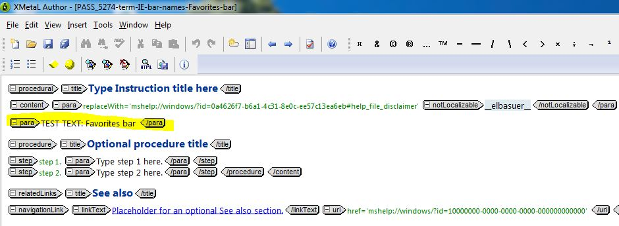
Figure 11: Test text that should pass the test
Note: The Primus system is set up so only the intended test is run against the test file, so you can leave the rest of the default text in the file alone. What I usually do is identify the text to be tested by preceding it with “TEST TEXT:” in all caps. If the test text isn’t obvious, or appears in some other part of the file, I write a note so that anyone who reads it should be able to tell where the test text is and what’s actually being tested. These notes can be especially helpful when testing link syntax or other code-related elements of the asset.
- Click Save, and then check in the asset.
- Create another asset that will fail the test.
- Create as many fail and pass assets as is necessary to thoroughly test the logic and syntax of the rule you wrote.
Note: For some rules, you have to be judicious when writing test assets or you’ll spend an inordinate amount of time writing tests when you could be writing more rules. For example, the “notLocalizable” rule searches for well over 100 different product names, but we haven’t written 100+ tests for this rule. Instead, we’ve written enough to prove that the syntax of the rule is functioning correctly, and we write at least one new test each time we add a unique exception. We can assume that if we can accurately pass a handful of assets, then the logic and syntax is sound and the other terms we’re looking for will also pass.
In the example for these instructions, I’ll write two passing test assets to make sure that the “OR” syntax of the rule is working, even though I’d need to write five test assets to test every possible “OR” case. And I’ll write two failing assets to test incorrect case and incorrect plural form, even though I’d need to write 7 tests to cover all of the variants.
- Go back to the Primus Test Case website, and then open the test you’re writing.
Tip: Click Search, and then enter the rule’s four-digit code.
- Click Details to expand the section, and then select Check in. See Figure 12.
Checking the test in indicates to the Primus system that BVT tests should be run on this new rule. The rule will get picked up by the BVTs (they run twice a day), and if the rule passes, the BVT Results status (just below the Check in box) will change to either Fail or Pass with a timestamp.
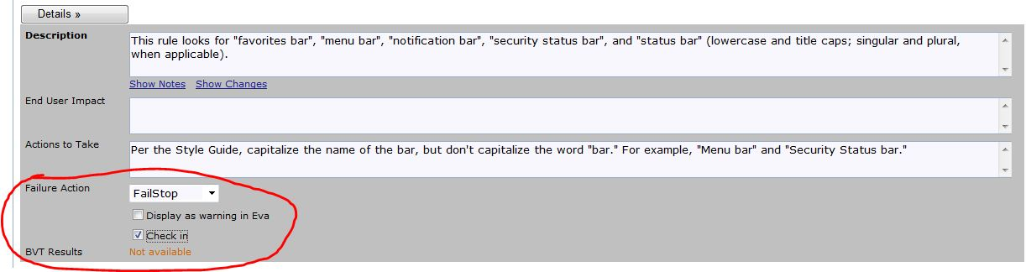
Figure 12: Check in the rule and set other options, if necessary
- Enter a check-in comment such as “Test created,” and then click Save.
- Keep the Failure Action value set to FailStop unless you know that the rule should be set to FailContinue. FailContinue is only used if the rule is going to be run by WCCE or the Production team and we know that the rule will incorrectly or unnecessarily block publishing of the content that has a hit in it. In other words, marking a test FailContinue is a group decision.
- If fixing the problem the rule identifies is suggested but not required, select the Display as warning in EVA check box, and then click Save.
Here’s some info to help you decide if the rule should be a warning:
Option | Result in EVA
Cleared Display as warning in EVA check box | The error is highlighted in red. It’s a high-severity issue, such as a branding requirement, that users should fix or file exceptions for. Users shouldn’t ignore hits for this rule.
Selected Display as warning in EVA check box | The error is highlighted in yellow. It’s a mid- or low-severity issue, such as a word choice preference. The user should fix these if they apply, or file an exception if they find they regularly choose not to fix them. The general message to users is: The fewer yellow flags, the better our content.

- Send mail to Steven Butler (sbutle) or the WCCE alias and ask to be added to the distribution of the build mail. Wait for the next BVT build mail that’s sent automatically twice a day and that will tell you if the new rule passed the tests you wrote for it.
If it doesn’t pass, you’ll be told which tests didn’t pass, and you’ll have to troubleshoot the rule, the exception, and/or the test. My experience has been that the most problems occur with exceptions.
- When the rule passes BVT tests, you need to add it to a test suite so it will run against content in EVA. Open the Primus Test Case website, and then click the Test Suites button. See Figure 13.
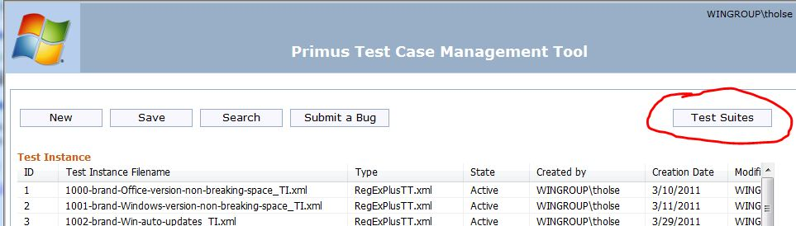
Figure 13: Click the Test Suites button
- Under Test Suite, click R_Stringy_TS.xml. See Figure 14.
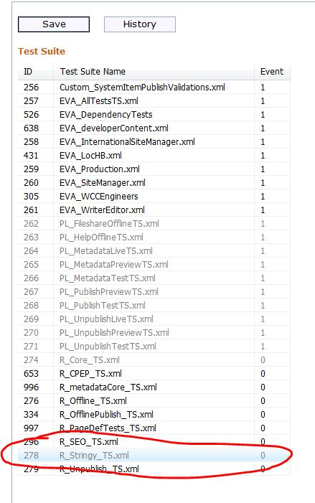
Figure 14: Select the Stringy test suite
- Under Test Suite Contents, right-click any item in the list, and then click Add Test Set.
- In the Add Test Set dialog box, under Filter, in the Test Type drop-down box, select RegExPlusTT.xml, and then click Apply Filter. See Figure 15.
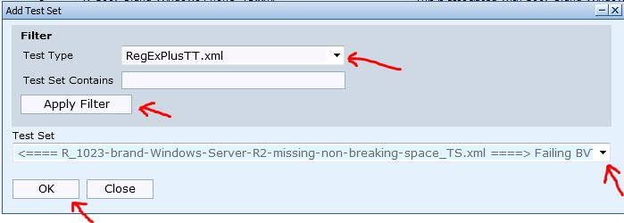
Figure 15: Find your rule and add it
- Under Test Set, select the rule you wrote from the drop-down list, and then click OK.
- Click Save.
You’re done. That was easy.

