USER EXPERIENCE AND BEHAVIORS
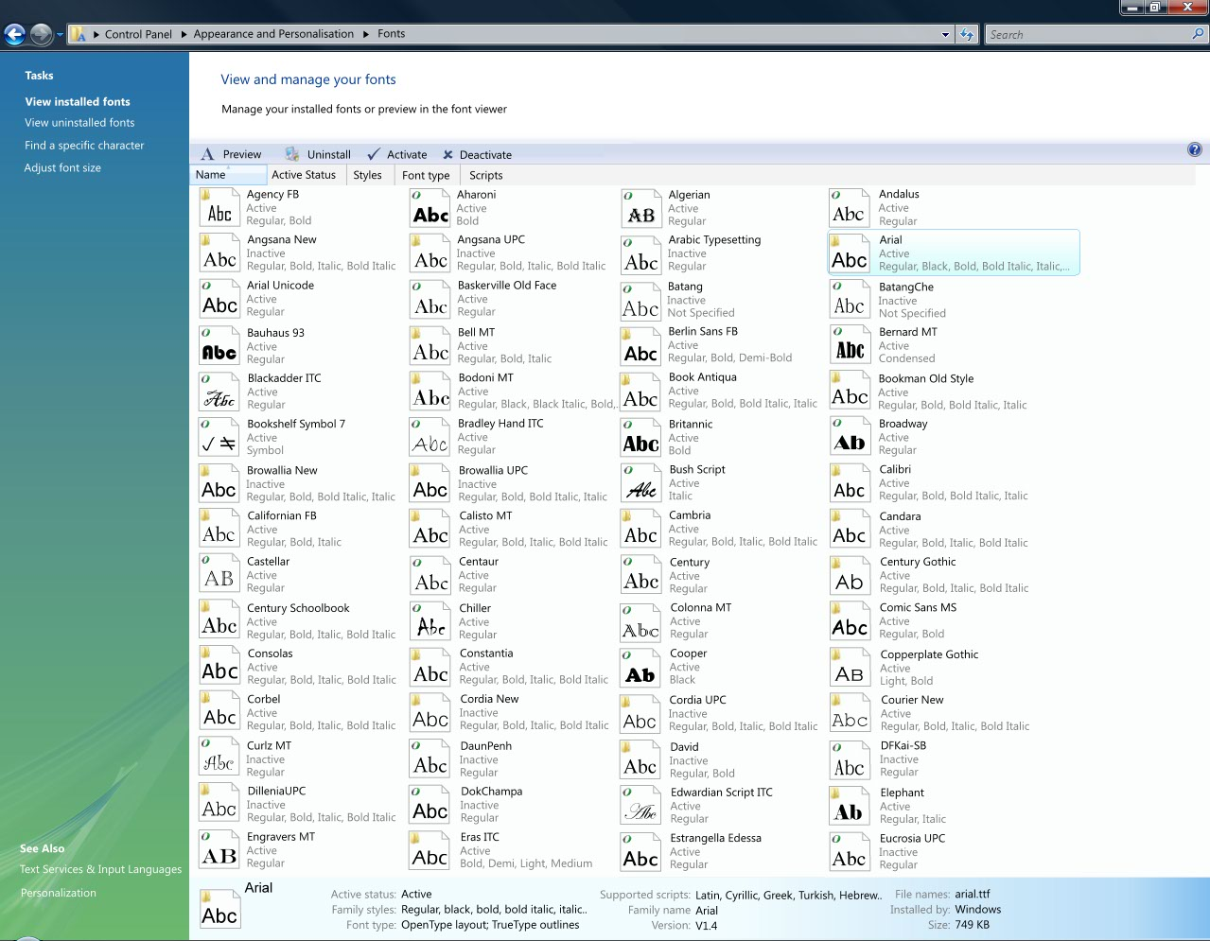
Figure: How the completed fonts control panel will look (Graphic elements not final)

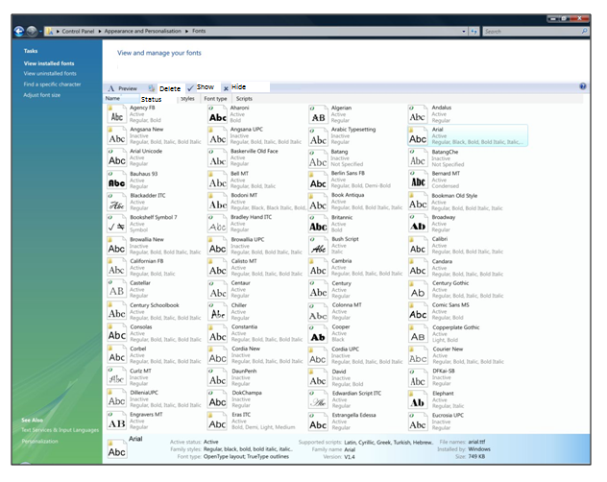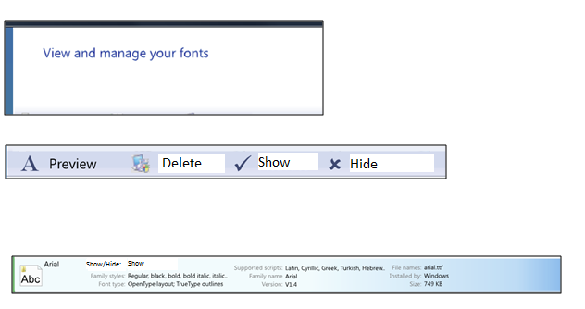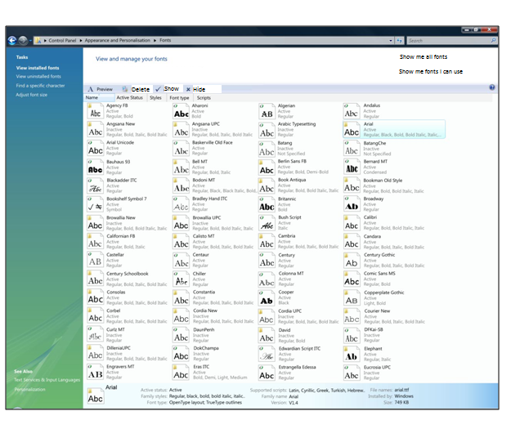Tholse: there are pronoun issues on this page. The main instruction addresses the user in the second person (your), and your proposed text uses the first person (me and I). The main instruction should be “View and manage fonts.” The next should be “Show all fonts,” and finally “Show only the fonts I can use.”

Sub-Feature 1: Move from explorer view to control panel view

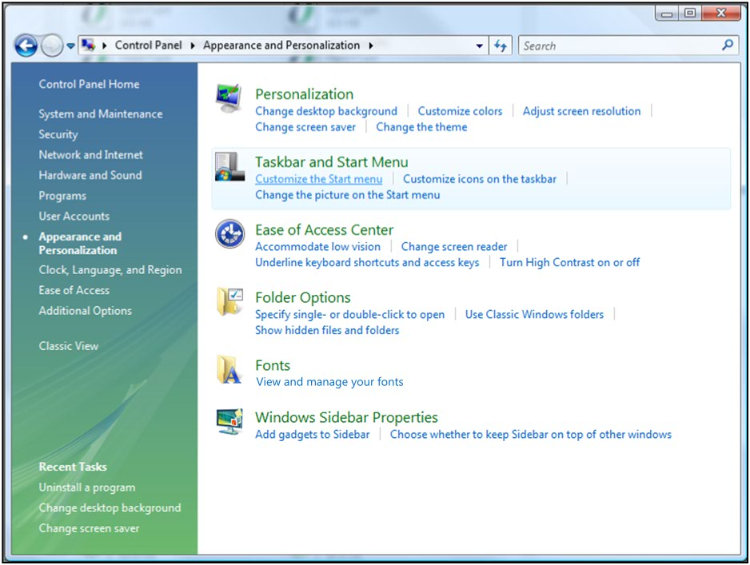
Figure: The Appearance and Personalization Control Panel Center showing the Fonts folder (updated)
Tholse: Again, this should be “View and manage fonts” (no “your”)
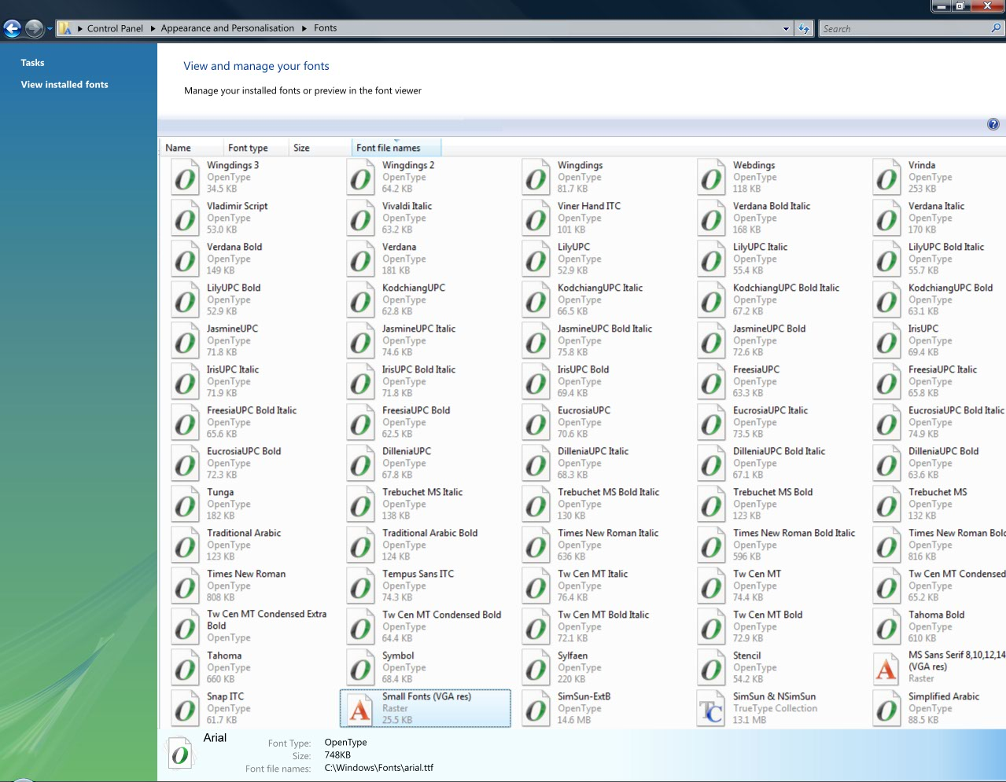
Figure: The first revision of the new control panel center
Tholse: I’m not sure what the user is supposed to do in this screen. I’m not sure why there is a link in the left pane to “View installed fonts.” Isn’t that what this page already shows? If not, then what is it showing? Another issue is what you mean by “manage:” delete, hide, and show? Finally, how does the user preview in the font viewer?

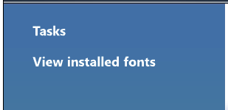
Figure: Detail of task pane showing single task selected

The following additional tasks will be added under the default ‘View installed fonts’:
- ‘Find a specific character’ (Launch C:\Windows\System32\charmap.exe)
- ‘Adjust font size (DPI)’ (Launch DPI scaling CPL)
- [‘Tune your font display’ (Launch ClearType tuner) Improve your font display or Make the text on your screen easier to read
Tholse: what do the last two items in the last bullet point to? Does the second one go to the Accessibility feature about using Magnifier? If so, is there data showing that people accidentally end up in the Fonts CPL rather than the Accessibility CPL?
The following entries will be added to the ‘See Also’ section:
- Text Services & Input Languages (Launch Cicero CPL) Tholse: I’m interested in knowing where this link will point to. The link text will probably need to be changed.
- Personalization (Control Panel\Appearance and Personalization\Personalization) tholse: I also think that this link text will need to me more specific because, without context, it’s hard to know what will be “personalized.”

Sub-Feature 2: Add Preview button & Default action

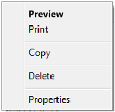
Figure: Right-click menu showing Open changed to Preview


Figure: Detail of task bar showing preview button added

The tooltip for the Preview button will be: “Open the selected files in the Font Viewer” Preview the selected files in the Font Viewer Tholse: how about “Preview the appearance of the font using Font Viewer” or just “Preview the appearance of the font” or just “Preview the font.”

Sub-Feature 3: Add Uninstall button & rename delete action


Figure: Detail of task bar showing additional Uninstall button

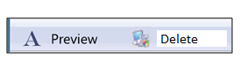
The tooltip for the Uninstall Delete button will be: “Uninstall the selected files” Delete the selected files
Tholse: out of curiosity, what happens after you uninstall/delete a file? Could you reinstall that font from your OS disk (assuming you’ve got one?)?

Sub-Feature 4: Change from flat font file list to (font family :: font file) hierarchy

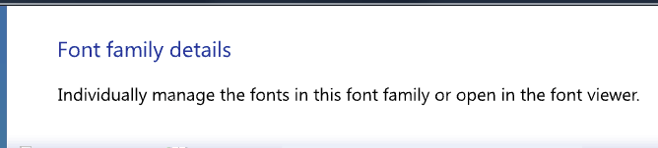
Figure: Title pane showing title text for font family view
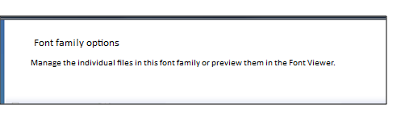

Sub-Feature 6: Add Install functionality to font viewer

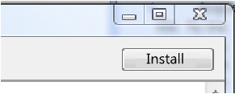
Figure: Font viewer showing new install button

Sub-Feature 10: Expose additional properties including activation status

Figure: The properties pane showing the default properties

Sub-Feature 11: Add support for manual activation\deactivation
Tholse: I’d like to see the “Family name” listed before the “Family styles”

Figure: The task bar showing the Activate and Deactivate buttons added
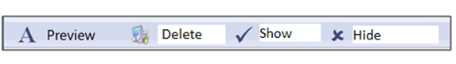

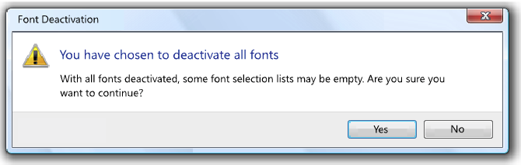
Figure: The all fonts deactivated! warning dialog
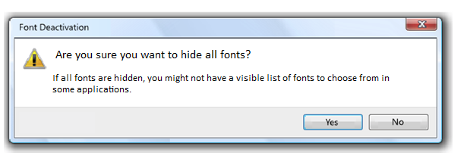Sub-Feature 13: Create settings page and add activation settings
Tholse: How about “If all fonts are hidden, you might not be able to use them in some programs.”

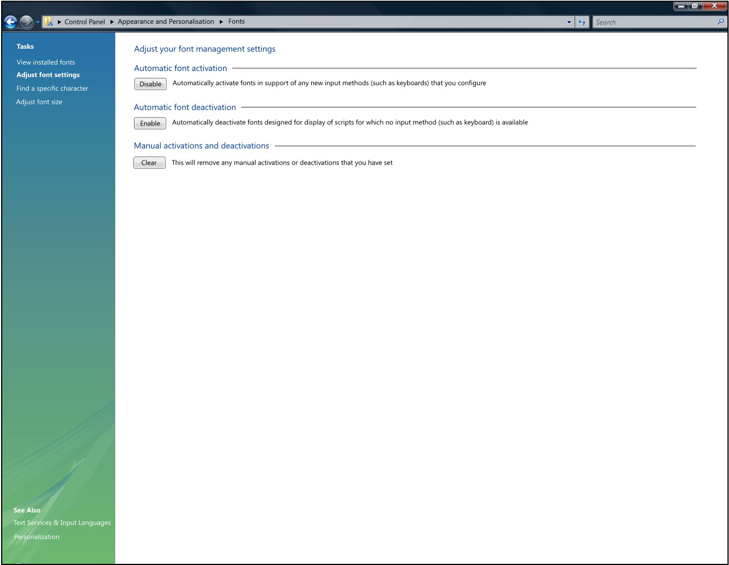
Figure: The font settings page with activation preferences added

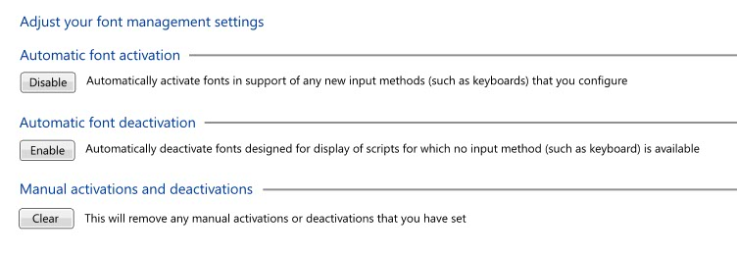
Figure: The font settings page with activation preferences added (detail)

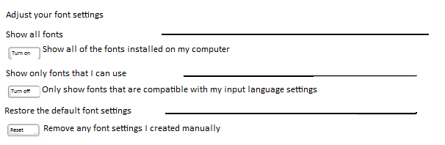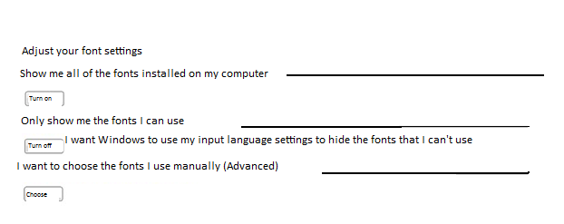

Sub-Feature 14: Clean up and condense uninstall behaviour

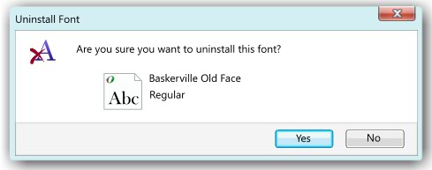
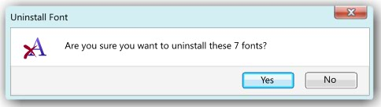
Figure: Uninstall confirmation dialogs

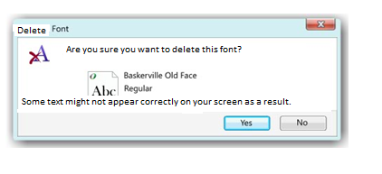
Tholse: For the last part, how about “If you delete this font, some text might not appear correctly.”
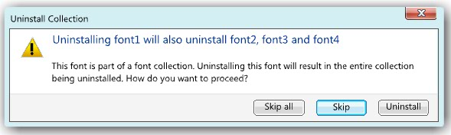
Figure: Uninstall of a single font from a collection

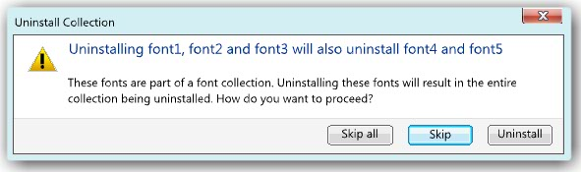
Figure: Uninstall of multiple fonts from a collection
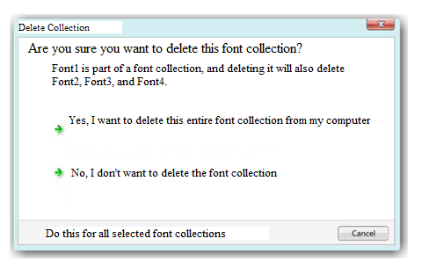
Tholse: this seems like a good rewrite to me.
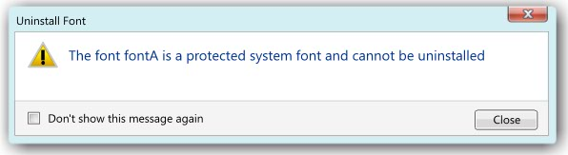
Figure: Attempted uninstall of protected font
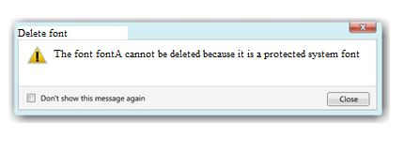
Tholse: I suggest getting rid of the first two words: “The font…”
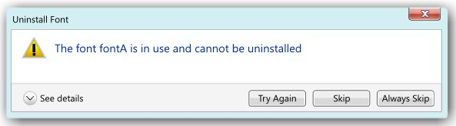
Figure: Attempted uninstall of in use font (details hidden)

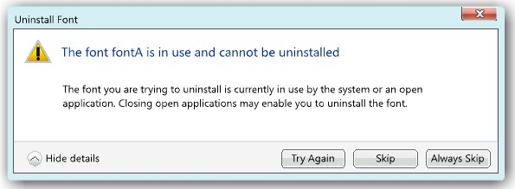
Figure: Attempted uninstall of in use font (details shown)
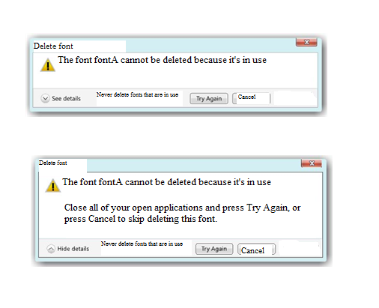

Sub-Feature 15: Install dialog with option to install font link
Tholse: I suggest getting rid of the first two words: “The font…” I’m not sure what you are trying to accomplish with “Never delete fonts that are in use.” Isn’t that the reason that the user got this error message? Also, I don’t think you need to explain the Cancel button’s function. Finally, the details should read: “Close any open programs, and then click Try again.” (Note the sentence capitalization of the button.)
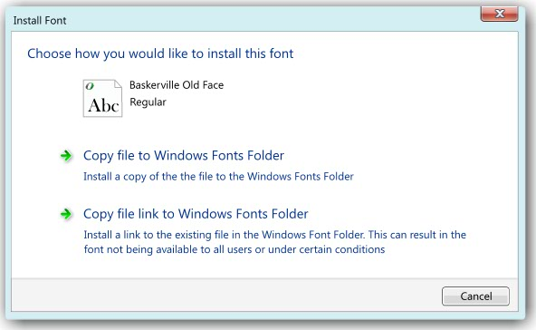
Figure: Install dialog for Single font install

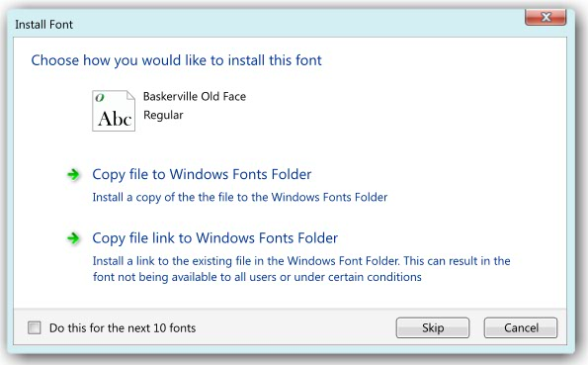
Figure: Install dialog for multiple (11 in this case) font install
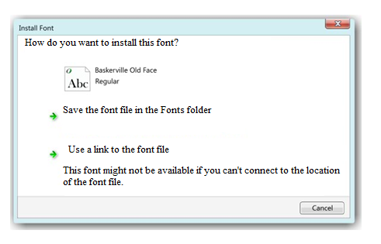
Tholse: One tweak to this: “This font might not be available in some programs if you can’t connect to the location of the font file.”
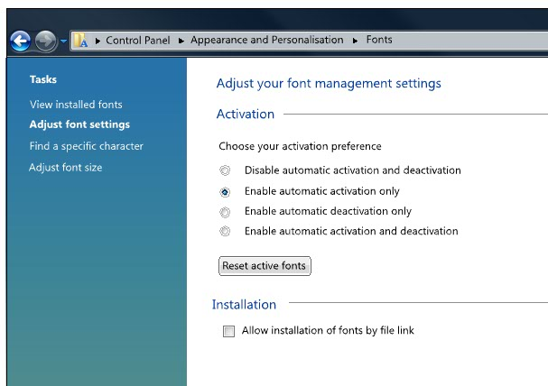
Figure: Options page with installation option added

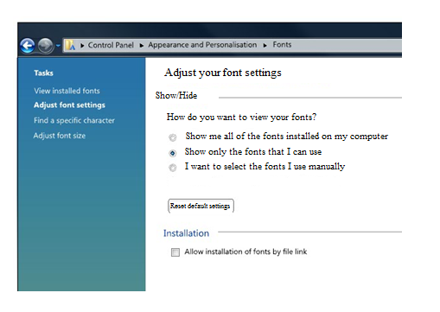
Tholse: I’m getting hung up on the notion of “Font settings” here because the user isn’t adjusting anything to do with the fonts specifically. Instead, what they are doing is deciding how they see the font files on their computer. But, hopefully, this screen and the task associated with it will go away in the overhaul….

FonT CHOOSER Common dialog – FUNCTIONAL SPECIFICATION

USER EXPERIENCE AND BEHAVIORS
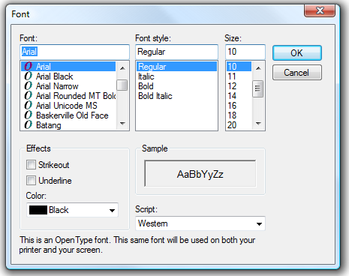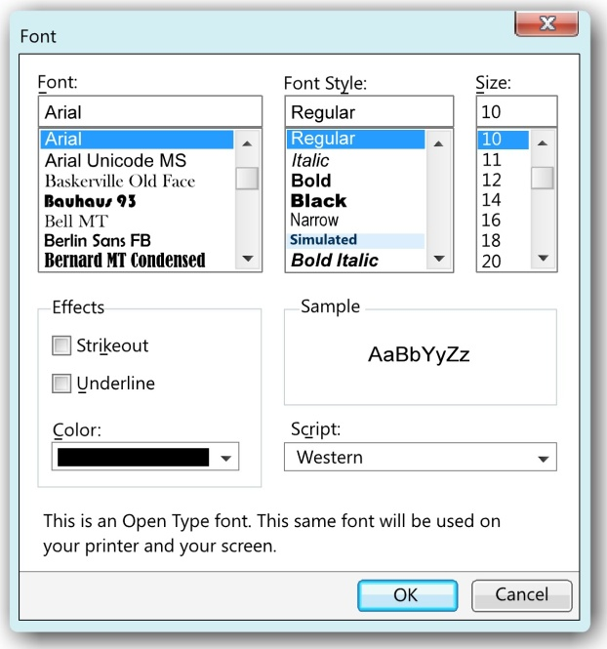
Figure: Before and after images of the font picker with elements updated and a new layout
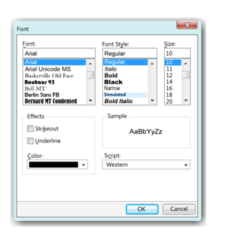
Tholse: I agree with the deletion of the text about OpenType, especially if we aren’t planning on telling the user when a font wouldn’t appear the same on the printer and the screen.
Sub-Feature 2: Turn on activation support
Application Compatibility Section 2.1 – Pre-selection specifies deactivated font

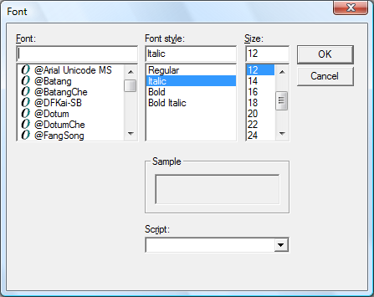
Figure: Result where pre-selected font does not exist in Font List

If the font dialog is launched and no fonts remain after filtration, an error dialog is presented:
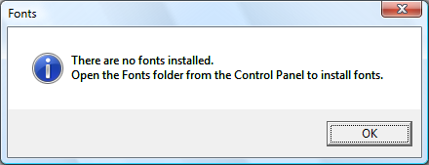
Figure: Error dialog where filtration blocks all fonts
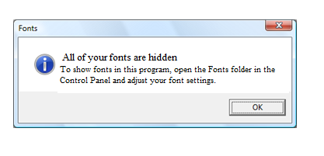
Tholse: If possible, this error message should have a link to the Fonts CPL. The curre4nt text runs into the problem I mentioned earlier about the “Adjust font settings” page not being about adjusting the font’s actual settings, but instead being about how fonts are viewed. I don’t really have a clever solution to this problem. But perhaps the text should read: “To show fonts in this program, open Fonts in Control Panel and click XXX.” (Note that we never include the word “the” before “Control Panel.”

Sub-Feature 3: Font family and styles combos to display in WYSIWYG

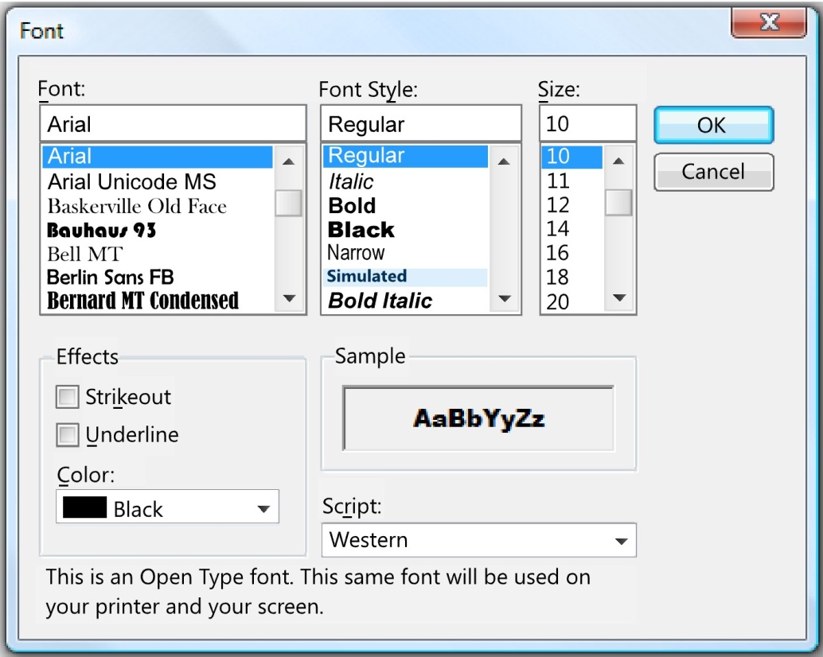
Figure: Fonts dialog showing list items drawn in appropriate font face and icons removed

Sub-Feature 5: Update the color picker

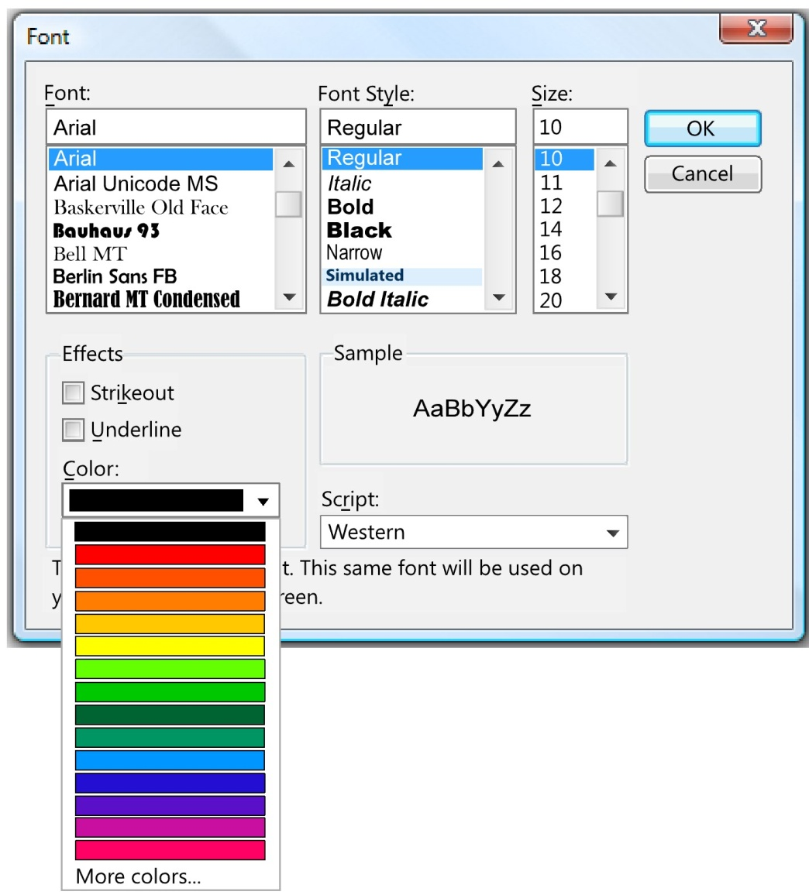
Figure: The fonts dialog with the new color picker

Tholse: I’ll be surprised if a usability test shows that this new color picker tests better than the old one.

Sub-Feature 6: Adjust dialog layout

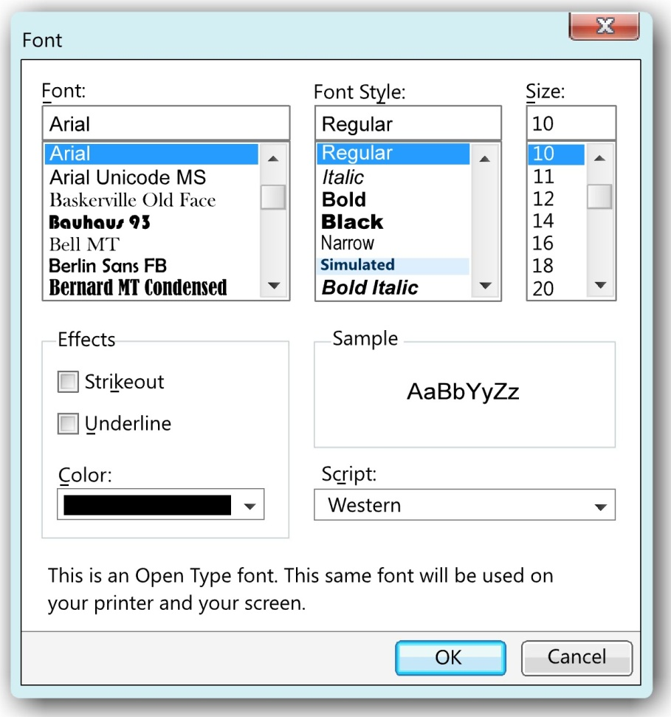
Figure: The fonts dialog with the layout improvements

