
The Windows Help and How-to website report | December, 2007
 | 2007 - The year in review
 | Site activity around the world  35% of the visits to the Windows Help and How-to (WHH) website originated from the United States. The next most frequent country was the United Kingdom at 6%, followed by Japan at 5%.  Visits by country for 2007 (source: WebTrends, Windows Help (prod) profile)  Vista about to rise  Throughout 2007, XP users were the most frequent visitors to the WHH website. But as Vista becomes more widely adopted, we expect percentages the number of Vista visitors to increase.  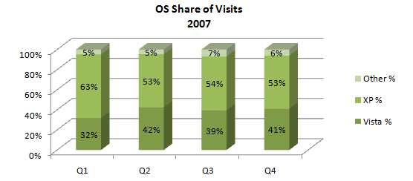  (source: WebTrends) |  |  |  | Enable Java in Internet Explorer: impact on metrics  In July 2007, Internet Explorer began linking to the Enable Java in Internet Explorer WHH help topic.  This single topic has generated 36% of the WHH average monthly site traffic, greatly skewing average topic performance. For this reason, we often exclude the “Java” topic in our site analysis. Just look for the *excludes Java footnote.
Customer interactions show favorable trends
Ratings: Average content satisfaction may range from 0 to 100%, depending on user feedback. The user also has the option to leave comments as part of the feedback.


Approximately 6% of site hits result in a content rating. Approximately 14% of the ratings are accompanied by text comments.
Over the year, satisfaction with our content has gradually increased.
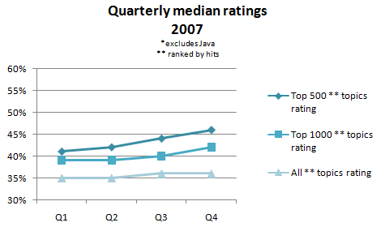
(source: AP Content Watson)
Campaign CPC
The Consumer Preference Campaign (CPC) was developed to showcase the inspirational and empowering features of Vista. Starting in autumn, writers produced 188 help topics. Those pages received 1.2 million page views in CY Q4, accounting for 4.5% of all Q4 WHH traffic, with a peak of 5.2% in December.
  - CPC topics had a 59% average rating, well above the median site average of 46%.
  - Twenty-four topics had ratings of 80% or better.
  - Three topics tied with a top rating of 84%:
    - All-you-can-eat music: Download all the music you want for the price of a single CD
    - Flat panels galore: What kind of LCD monitor should I buy?
    - Sharing photos with your friends and family
 | Trends for the year
The following table shows significant increases in the number of customers that use our content.
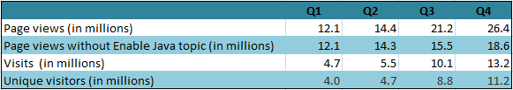
WHH: Quarter Over Quarter(QOQ) trends of 2007 (source: WebTrends)
 | Searching for success
 | Search failure rate (SFR) refers to the percentage of queries that do not result in the user clicking a search result. SFR provides an indication of search performance by assuming that users will click search results that appear relevant. The graphs below show different views into SFR for WHH, plus an indication of what action users perform when they don’t click search results – either refining their query, ending their visit, or navigating to another part of the site.
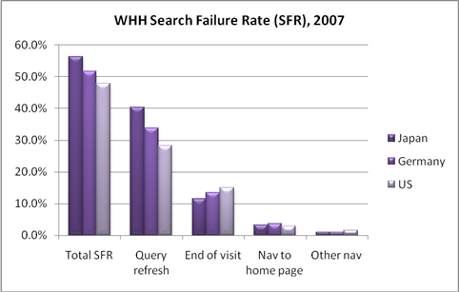
Search failure rate by country (source: WebTrends)
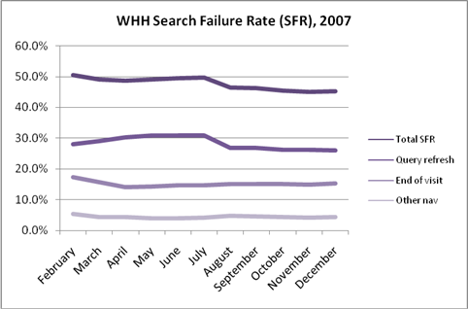
U.S. search failure rate (source: WebTrends)
 | The hot and not-so-hot topics for the year
 | The following table shows frequently viewed topics that users rate highly. and others that unfortunately are rated really low. Topics both highly rated and viewed tend to include everything from learning the basics to maintenance to having fun.
Most Satisfying Content, 2007
Topic Title | Hits for Year | Rating for Year
Demo: Desktop basics | 282,992 | 76%
Better browsing: Internet Explorer 7 offers improved security and productivity | 263,437 | 83%
Burn a CD or DVD in Windows Media Player | 167,779 | 82%
Improve performance by defragmenting your hard disk | 136,198 | 72%
Delete files using Disk Cleanup | 101,398 | 71%
Change the size of virtual memory | 92,836 | 73%
Learn about Windows games | 76,469 | 75%
Rip music from a CD | 74,645 | 84%
What is a driver? | 69,079 | 71%
Using Windows Defender | 65,246 | 71%
Top 10 topics for 2007 by highest number of hits and highest ratings (source: AP Content Watson)
The following table shows the frequently viewed topics that users gave low ratings to. The majority of these are about troubleshooting hardware, devices, and drivers.
Most Dissatisfying Content, 2007
Topic Title | Hits for Year | Rating for Year
Tips for fixing common driver problems | 327,307 | 20%
Setting up a home network | 265,903 | 29%
Troubleshoot network and Internet connection problems | 259,819 | 13%
Tips for fixing common sound problems | 196,342 | 9%
Working with Windows Mail | 140,350 | 19%
Troubleshoot network printer problems | 127,192 | 10%
Troubleshoot USB device problems | 122,004 | 13%
Add a device or computer to a network | 121,393 | 26%
Troubleshoot problems with Windows Mail | 107,619 | 8%
What to do if Windows won't start correctly | 100,213 | 28%
Top 10 topics for 2007 by highest number of hits and lowest ratings (source: AP Content Watson)

 | Resources & Links  - Need the raw data? Detailed monthly feedback and analysis reports are published in a single Excel workbook by the 10th of each month on the AST Feedback and Analysis SharePoint site. December data is located here.  - Want to participate in the discussion? Add yourself to the AST feedback alias (astfrep).  - Want to see what customers are typing and hear what they are saying? Explore their queries and comments at http://astmetrics  - Want to know more about the Customer and Feedback Analysis team? Check out our SharePoint site. |  | Contacts  Greg Koehler [gregkoe] – x65060  Senior Business Analyst  David Billick [davidbil] - x60685  Customer Data Analyst  Bob O’Brien [bobrien] - x67365  Search Analyst/Author  Caryn Hanan [carynh] - x73687  Customer Data Analyst



